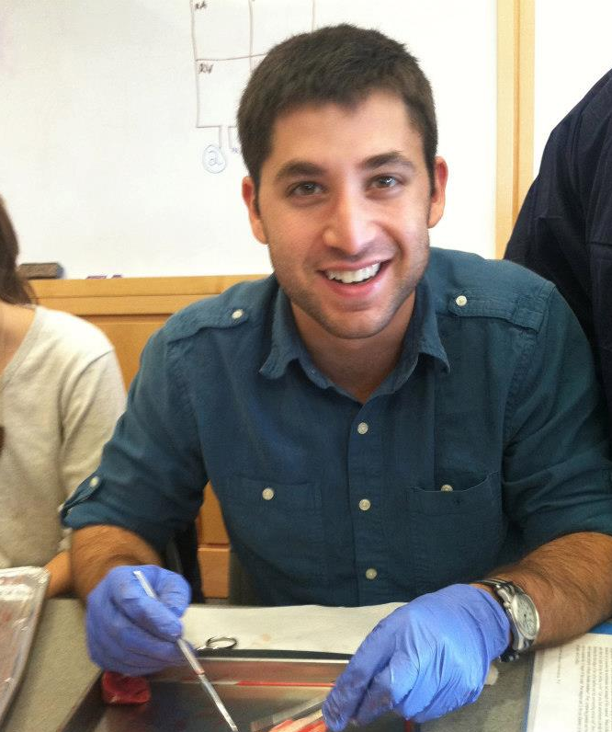
Justin Bohn recently won the prestigious scholarship award from the Alec Walker Pharmacoepidemiology Scholarship Fund. The Pharmacoepidemiology Scholarship Fund was established in 2012 through an anonymous donation in the name of Dr. Alexander Walker, adjunct professor of epidemiology at HSPH. The $10,000 scholarship is awarded each year to a student in the Pharmacoepidemiology area of interest based on academic excellence. Dr. Walker’s research involves studies of drug utilization and the intended and unintended effects of pharmaceuticals and medical procedures in non-randomized studies in routine care populations. Dr. Walker served as chair of the Harvard School of Public Health’s Department of Epidemiology from 1996 to 2002 and now actively participates in the Pharmacoepidemiology Program by advising students and teaching the School’s popular Pharmacoepidemiology course, which has been the core of the Program since its foundation. He has mentored over 50 doctoral students during his career.
Justin Bohn received the prestigious Alec Walker Pharmacoepidemiology Scholarship honor based on his academic merit and outstanding dedication to the Department of Epidemiology. He recently finished his first year as an SM2 student in Epidemiology and his concentration is in Pharmacoepidemiology.
Before coming to HSPH, he received a BA degree from Wesleyan University, where he majored in psychology and cognitive science. His first introduction to epidemiology was in an undergraduate research methods course that taught survey methodology in SAS. After completing this course he became interested in drug safety research upon learning about problematic psychiatric medications as a research assistant in Wesleyan's affective neuroscience laboratory. In addition to this, he also gained tremendous experience working two years as a research assistant in bioinformatics at Children's Hospital Boston, where he had the opportunity to study the genetic basis of Autism.
Justin is currently working on a summer project in the FDA's Office of Surveillance and Epidemiology studying the dynamics of spontaneous reporting of anticonvulsant-related adverse events and how such reporting differs between generic and branded drugs, with the goal of understanding the FDAs capacity to conduct pharmacovigilance for generic products. We will look forward to his continued success in the Epidemiology program at HSPH.

