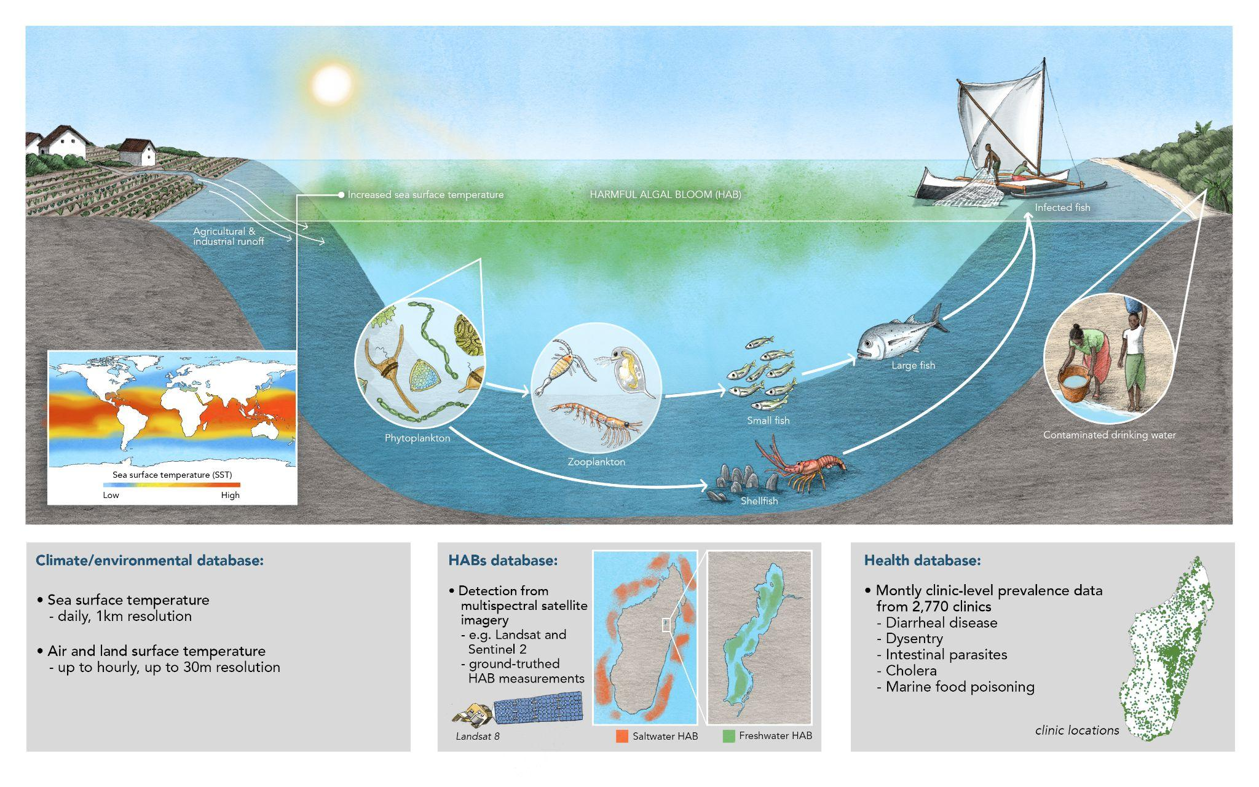
Project: Early warning systems for harmful algal blooms in Madagascar
Given Madagascar’s context as an island nation, aquatic food systems are a major food source and an important source of both calories and micronutrients for many populations. These aquatic food systems are also under threat from climate change. In particular, harmful algal blooms (HABs) are linked to sea and freshwater surface temperatures (possibly in combination with changing nutrient levels and thermal stratification) and climate change-driven increases in these temperatures will likely lead to increased frequency of harmful algal blooms. These algal blooms produce toxins that can get into aquatic foods, leading to marine food intoxication and diarrheal disease, and, over longer time scales, impacting nutritional outcomes (see figure above). Detecting and forecasting when these blooms happen will allow for public health interventions to try to mitigate some of these short- and long-term health impacts.
In order to do so, we will first need to construct a database on the occurrences of harmful algal blooms linked with remotely sensed data on water color, sea and lake water surface temperatures and environmental variables to predict and understand harmful algal bloom occurrences in the past. Using historical predictions of algal blooms back to 2010, we will then leverage a unique dataset of over a decade of clinic-based monthly health outcomes from 2,750 nationwide geo-located public clinics in Madagascar to determine thresholds at which harmful algal blooms begin to have health impact. Finally, using this information, we will work with health decision-makers to create an early warning system that will identify algal blooms in real-time or with enough advanced warning to allow for public health interventions.
Tasks:
- Literature review to compile harmful algal bloom events in Madagascar between 2009 and the present
- Creating a standardized and structured database for predicting and forecasting harmful algal blooms (HABs) prediction/backcasting. The database will be multidimensional, including features like sea surface temperature, surface reflectances, meteorology, sea surface properties, among others. These required data layers will be generated from freely accessible remote sensing data.
- Creating an AI/ML workflow to utilize historical data for building a model that retroactively estimates the occurrences of harmful algal blooms (HABs) over the entire duration covered by the available clinic dataset (2010 - present).
- Link historical HABs to health data from nationwide public clinics to determine thresholds at which HABs begin having health impacts. This deliverable will support decision making around mobilizing and scheduling interventions mitigate on HABs-related diseases outbreak.

Skills required:
- Expertise in R and/or Python for building workflows, with a preference for R
- Familiarity with remotely sensed climate data, and how to extract/wrangle them
- Experience with computer vision workflows
- Preference for someone with experience in multilevel distributed lag models
- Preference for someone with interest in ocean health/human health
Compensation:
Options for part-time salary (e.g., 25-50% FTE) or hourly research assistant payments. Compensation will be provided hourly in relation to the level of experience of the candidate, ranging somewhere between $22 – $30/hr.

