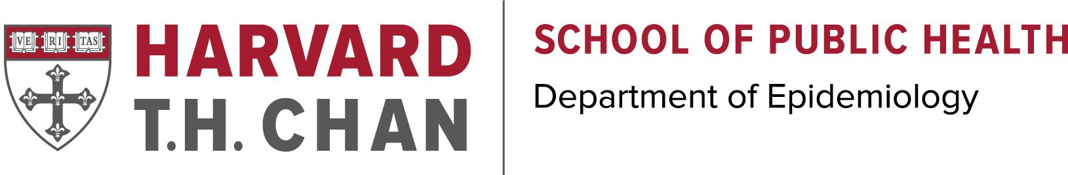
Applicants without a Prior Advanced Degree:
Which Masters Program Is Right For You?
Complete a blended online/on-campus degree with 7 weeks on-campus and the remainder of the program online
Work experience required
Complete an on-campus degree over 2 academic years (September-May)
No work experience required
2022-2023 Tuition Fee Schedule
Harvard T.H. Chan Admissions and Program Finder
80 Credit Master of Science in Epidemiology
Eric DiGiovanni
617-432-1328

Contact us:
45 Credit Master of Public Health in Epidemiology
Stephanie Lemoine
617-432-1558

*45 Credit Master of Public Health in Epidemiology (online/on-campus):
- Eligibility: Medical degree or doctoral degree in a health-related field, or Master’s degree with at least 2 years of health related experience, or Bachelor’s degree with at least 5 years of health-related work.
- Credits/Requirements: 45 credits, practicum and culminating experience
- Length/ Structure: 2 years, part-time. Online/on-campus, see Program Outline below.
Program Outline: This program requires that students are on campus for 2 June sessions (containing intensive on-campus course work), and 1 May session in which they present the culminating experience. During the academic year (September- May) students participate in online courses.
**Curriculum Guide**

80 Credit Master of Science in Epidemiology (Academic Year):
- Eligibility: Bachelor’s degree in a relevant STEM disciplines (e.g. biology, bioengineering, or related social and computational sciences).
- Credits/Requirements: Thesis required.
- Length/ Structure: On-campus, 2 years, full-time.
**Curriculum Guide**

