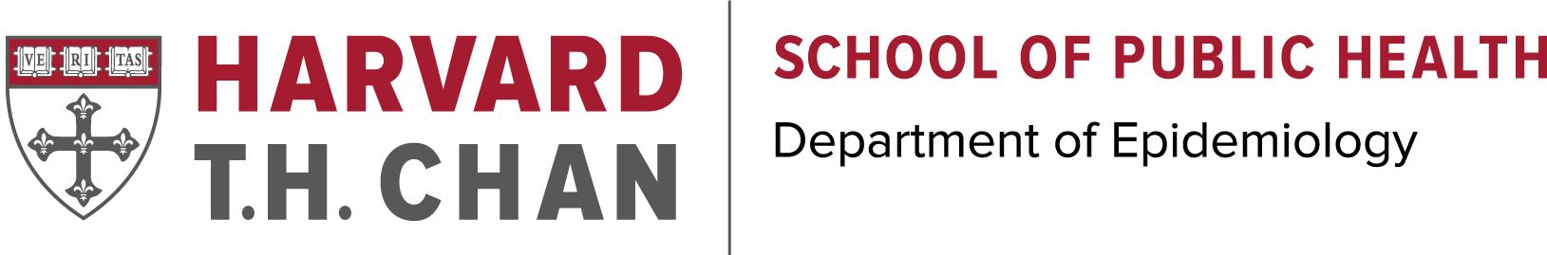
Applicants with Prior Advanced Degree:
Which Master’s Program Is Right For You?
Complete a blended online/on-campus degree with 7 weeks on-campus and the remainder of the program online

Complete your program during the summer term (July & August) with one of the following on-campus programs
Complete your program during the academic year (but may start in the summer)
45 Credit Master of Public Health (Quantitative Methods/Clinical Effectiveness)
Department Contact:
Stephanie Lemoine

Website

42.5 Credit Master of Science in Epidemiology
Department Contact:
Jeffrey Noyes

Website
45 Credit Master of Public Health in Epidemiology
Department Contact:
Stephanie Lemoine

Website

Master of Science in Epidemiology (Academic Year): *
- Eligibility: Medical degree or graduate degree in relevant STEM disciplines (e.g. biology, bioengineering, or related social and computational sciences).
- Credits/Requirements: 42.5 credits, no thesis requirement.
- Length/ Structure: On-campus, 1 academic year, full-time. (2 or 3 years, part-time).

Master of Public Health in Quantitative Methods (Academic Year): *

- Eligibility: Medical degree or doctoral degree in a health-related field; current medical/dental students after completing their primary clinical year; Master’s degree in health-related field plus 2 years of related health experience.
- Credits/Requirements: 45 credits, Practicum and Culminating Experience.
- Length/ Structure: On-campus, 1 academic year, full-time. 2 or 3 years, part-time.

Master of Public Health in Clinical Effectiveness

- Eligibility: Open to Physicians who have completed their residency, and have either completed or will start with the Summer Program in Clinical Effectiveness (PCE).
- Credits/Requirements: 45 credits, practicum and culminating experience.
- Length/ Structure: On-campus, 1 year full-time after completing the Program in Clinical Effectiveness. Or 2 - 3 years, part-time.
*May start program with Program in Clinical Effectiveness or Summer Session in Public Health

45 Credit Master of Public Health in Epidemiology
(online/on-campus):
- Eligibility: Medical degree or doctoral degree in a health-related field, Master’s degree in health-related field plus 2 years of health related experience or Bachelor’s degree with at least 5 years of health-related work.
- Credits/Requirements: 45 credits, practicum and culminating experience.
- Length/ Structure: 2 years, part-time. Online/on-campus, see Program Outline below for more information.
Program Outline: This program requires that students are on campus for two sessions during June (with intensive on-campus course work), and one 1-2 days session in May the week of the Harvard commencement. During the academic year (July- May), students participate in online courses.

Contact us
Tuition Fee Schedule
Harvard T.H. Chan Admissions and Program Finder
Masters of Public Health in Clinical Effectiveness Summer-Only
- Eligibility: Open to Physicians who have completed their residency, and have either completed or will start with the Summer Program in Clinical Effectiveness (PCE).
- Credits/Requirements: 45 credits, Practicum and Culminating Experience.
- Length/ Structure: 2-3 summer sessions.

MPH degree
MS degree
Master of Science in Epidemiology- Summer-Only
- Eligibility: Medical degree or graduate degree in relevant STEM disciplines (e.g. biology, bioengineering, or related social and computational sciences), but enter program through Program in Clinical Effectiveness or Summer Session in Public Health.
- Credits/Requirements: 42.5 credits, thesis required (thesis proposal and contact information of local mentor required at time of application).
- Length/ Structure: Completed over 3 summer sessions, some flexibility to take online courses during academic year through MPH EPI program.

