BACK-OF-THE-EVELOPE CALCULATIONS SESSIONS
2024-03-05

1. Load package
# install.packages("tidyverse")
# install.packages("patchwork")
# install.packages("zoo")
library(tidyverse)
## ── Attaching core tidyverse packages ──────────────────────── tidyverse 2.0.0 ──
## ✔ dplyr 1.1.2 ✔ readr 2.1.4
## ✔ forcats 1.0.0 ✔ stringr 1.5.0
## ✔ ggplot2 3.4.2 ✔ tibble 3.2.1
## ✔ lubridate 1.9.2 ✔ tidyr 1.3.0
## ✔ purrr 1.0.1
## ── Conflicts ────────────────────────────────────────── tidyverse_conflicts() ──
## ✖ dplyr::filter() masks stats::filter()
## ✖ dplyr::lag() masks stats::lag()
## ℹ Use the conflicted package (<http://conflicted.r-lib.org/>) to force all conflicts to become errors
library(patchwork)
## Warning: package 'patchwork' was built under R version 4.2.3
library(zoo)
##
## Attaching package: 'zoo'
##
## The following objects are masked from 'package:base':
##
## as.Date, as.Date.numeric

2. Load Brazil data
## Set the working directory: update this to the path to the folder you saved the data file in
setwd("/Users/kjia/Documents/DW/")
## Read in the data
WHO_data <- read.csv("WHO-COVID-19-global-data.csv")
WHO_data$Date_reported <- as.Date(WHO_data$Date_reported)
## Subset for only Brazil
brazil_data <- WHO_data %>% filter(Country == "Brazil")
head(brazil_data)
## Date_reported Country_code Country WHO_region New_cases Cumulative_cases
## 1 2020-01-03 BR Brazil AMRO 0 0
## 2 2020-01-04 BR Brazil AMRO 0 0
## 3 2020-01-05 BR Brazil AMRO 0 0
## 4 2020-01-06 BR Brazil AMRO 0 0
## 5 2020-01-07 BR Brazil AMRO 0 0
## 6 2020-01-08 BR Brazil AMRO 0 0
## New_deaths Cumulative_deaths
## 1 0 0
## 2 0 0
## 3 0 0
## 4 0 0
## 5 0 0
## 6 0 0

3. Explore raw cases and deaths
## Look at variable names
colnames(brazil_data)
## [1] "Date_reported" "Country_code" "Country"
## [4] "WHO_region" "New_cases" "Cumulative_cases"
## [7] "New_deaths" "Cumulative_deaths"
## Have a look at the data
p_cases <- ggplot(data=brazil_data) +
geom_line(aes(x=Date_reported,y=New_cases),col="red")+
geom_line(aes(x=Date_reported,y=New_deaths),col="blue")+
scale_y_continuous(labels = scales::label_number_si())
## Warning: `label_number_si()` was deprecated in scales 1.2.0.
## ℹ Please use the `scale_cut` argument of `label_number()` instead.
## This warning is displayed once every 8 hours.
## Call `lifecycle::last_lifecycle_warnings()` to see where this warning was
## generated.
p_cases
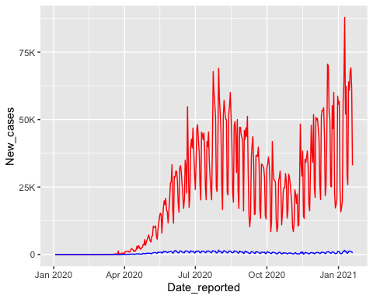
# zoom in on deaths
p_deaths <- ggplot(data=brazil_data) +
geom_line(aes(x=Date_reported,y=New_deaths),col="blue")+
scale_y_continuous(labels = scales::label_number_si())
p_cases/p_deaths
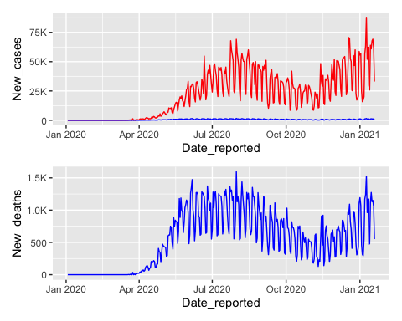

a) What striking features can you discern from visualizing the data? What might generate these?
- Cases and deaths vary within weeks (e.g., in July 2020, more died at the weekend than on Tuesday / Wednesday).
- Throughout the whole period, cases and deaths had similar trends in week-to-week variations. That is, cases and deaths both peaked at July 2020 and at Jan 2021.
- However, at the beginning of the observation period, the death-to-case ratio was higher.

4.1 Smooth the death data
- Use moving average to reduce the noise within weeks due to the Day-of-Week effect.
brazil_data <- brazil_data %>% mutate(New_cases_rollmean=zoo::rollmean(New_cases,7,na.pad=TRUE))
brazil_data <- brazil_data %>% mutate(New_deaths_rollmean=zoo::rollmean(New_deaths,7,na.pad=TRUE))
p_cases_smoothed <- ggplot(data=brazil_data) +
geom_line(aes(x=Date_reported,y=New_cases),col="red", size =0.3)+
geom_line(aes(x=Date_reported,y=New_cases_rollmean),col="purple", size =1)+
scale_y_continuous(labels = scales::label_number_si())
## Warning: Using `size` aesthetic for lines was deprecated in ggplot2 3.4.0.
## ℹ Please use `linewidth` instead.
## This warning is displayed once every 8 hours.
## Call `lifecycle::last_lifecycle_warnings()` to see where this warning was
## generated.
p_cases_smoothed
## Warning: Removed 6 rows containing missing values (`geom_line()`).
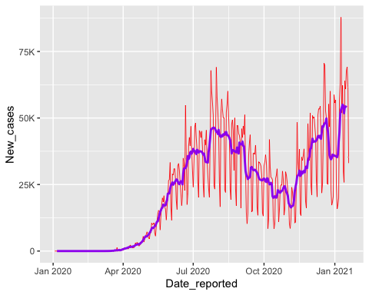

4.2 Question: can deaths provide a more accurate description of SARS-CoV-2 incidence than cases?

b) Why do we think that deaths might be more accurate than cases? What problems might there be with the way case data is generated?
- Deaths might be more accurate than cases as an indicator of the trends in SARS-CoV-2 incidence because death is a more severe outcome and is less likely to be under-reported than cases. Cases are subject to under-reporting because newly infected individuals experience mild symptoms may not test, seek care, or report their test result.

c) Discuss what you know/could find out that is important to understanding these data. How are the numbers linked? How are they generated?
- Important to know the representativeness of the data in terms of (1) whether they are in-hospital or out-hospital deaths, (2) if in hospital deaths, what are the catchment population of the hospital, (3) who has access to the hospital services (for death) and test services (for cases)?
- Also important to understand to what extent people who tested positive would attend the hospitals and show up in the death data.
- Lastly, important to know reporting process–how people get into the line list (if there is one). Hospitals have to be a reportable disease, reporting infrastructure, with lags.

d) What other data or assumptions do we need to know to estimate infections from deaths? How much precision might we have in those assumptions?
- We need clinical data informing the infection-to-fatality ratio (IFR) specific to the particular population.
- Regarding the precision, we need to acknowledge that IFR changes over time.

e) What are some other biases or problems that we haven’t accounted for?
- There is a time delay between infection and death (e.g., 21 days), so that deaths occurring today correspond to infections that have occurred, e.g., 21 days ago, accounting for the infection-to-death period.

4.3 Back calculating SARS-CoV-2 infections from deaths
IFR <- 0.01 ## Proportion of people infected that die
time_shift <- 21 ## Average interval, in days, between infection time and death time
## Shift dates back
brazil_data <- brazil_data %>% mutate(Date_shifted= Date_reported-time_shift) ## << Calculate date of infection from date of death>>
## scale up death numbers
brazil_data <- brazil_data %>% mutate(Infections_estimated= New_deaths_rollmean/IFR) ## << Calculate cases from deaths using IFR
## Plot against cases
p_cases_calculated <- ggplot(data=brazil_data) +
geom_line(aes(x=Date_shifted,y=Infections_estimated,col="Estimated infections")) +
geom_line(aes(x=Date_reported,y=New_cases_rollmean,col="Reported cases")) +
scale_color_manual(values=c("Estimated infections"="blue","Reported cases"="red")) +
ylab("Estimated infections")+
scale_y_continuous(labels = scales::label_number_si())
p_cases_calculated
## Warning: Removed 6 rows containing missing values (`geom_line()`).
## Removed 6 rows containing missing values (`geom_line()`).
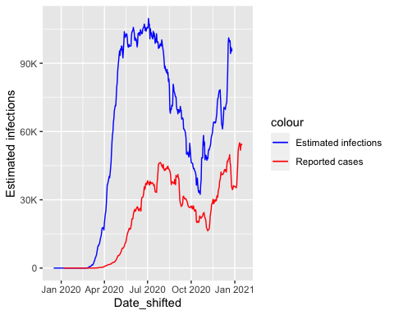

4.4 Compare reported vs. estimated infections
sum(brazil_data$New_cases_rollmean, na.rm = T)
## [1] 8320676
sum(brazil_data$Infections_estimated, na.rm = T)
## [1] 20695971
- Estimated infection is 2.5 times higher than reported cases given a IFR of 0.01. What does this tell us about underreporting?
p_report_rate <- ggplot(data=brazil_data) +
geom_line(aes(x=Date_reported,y=Infections_estimated/New_cases_rollmean),col="purple",size=1) +
ylab("Underreporting rate")+
scale_y_continuous(labels = scales::label_number_si())
p_report_rate
## Warning: Removed 54 rows containing missing values (`geom_line()`).
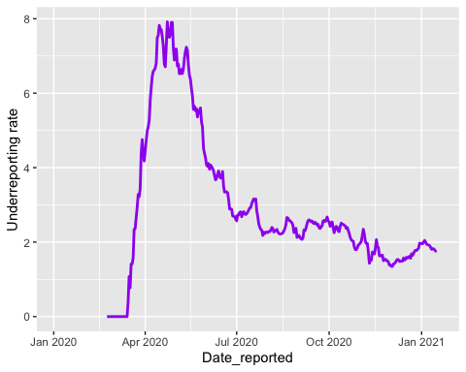

4.5 Sensitivity analysis
## Try different IFRs ##
IFR_low <- 0.001
IFR_high <- 0.03
brazil_data <- brazil_data %>% mutate(Date_shifted=Date_reported-time_shift,
Infections_estimated_low=New_deaths_rollmean/IFR_low,
Infections_estimated_high=New_deaths_rollmean/IFR_high)
## Plot against cases
p_cases_calculated2 <- ggplot(data=brazil_data) +
geom_line(aes(x=Date_shifted,y=Infections_estimated_high,col="Estimated infections (high IFR)")) +
geom_line(aes(x=Date_reported,y=New_cases_rollmean,col="Reported cases")) +
scale_color_manual(values=c("Estimated infections"="blue","Reported cases"="red",
"Estimated infections (low IFR)"="purple","Estimated infections (high IFR)"="darkgreen"))+
scale_y_continuous(labels = scales::label_number_si())
p_cases_calculated3 <- ggplot(data=brazil_data) +
geom_line(aes(x=Date_shifted,y=Infections_estimated_low,col="Estimated infections (low IFR)")) +
geom_line(aes(x=Date_reported,y=New_cases_rollmean,col="Reported cases")) +
scale_color_manual(values=c("Estimated infections"="blue","Reported cases"="red",
"Estimated infections (low IFR)"="purple","Estimated infections (high IFR)"="darkgreen"))+
scale_y_continuous(labels = scales::label_number_si())
p_cases_calculated2/p_cases_calculated3
## Warning: Removed 6 rows containing missing values (`geom_line()`).
## Removed 6 rows containing missing values (`geom_line()`).
## Removed 6 rows containing missing values (`geom_line()`).
## Removed 6 rows containing missing values (`geom_line()`).
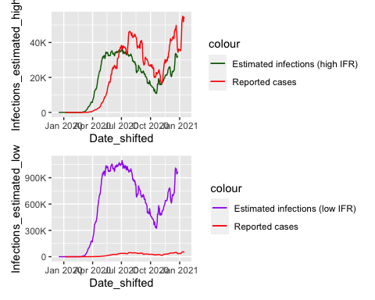
- More severe under-reporting of cases when IFR is low and less severe when IFR is high.

4.6 Look at implied total infections
## Population of brazil is ~200,000,000
brazil_pop <- 200000000
sum(brazil_data$Infections_estimated,na.rm=TRUE)/brazil_pop
## [1] 0.1034799
- Around 10% of the total Brazilian population has been infected by 2021-01-19.

f) Is 3% a reasonable IFR? Note that cumulative cases reported should always be less than cumulative infections. If cumulative cases exceeds estimated infections, then our assumed 3% IFR is not reasonable.
sum(brazil_data$Infections_estimated_high,na.rm=TRUE)/brazil_pop
## [1] 0.03449329
sum(brazil_data$New_cases,na.rm=TRUE)/brazil_pop
## [1] 0.0424405
- Note that 4.2% of the whole population had been reported cases, which exceeded the estimated total infections (3.4%), so the assumed IFR = 3% is not reasonable and the true IFR is certainly not that high.

g) Is 0.01% a reasonable IFR? Note that cumulative infections should always be less than total population for the observation period. If cumulative infections exceeds the total population, then our assumed 0.01% IFR is not reasonable.
sum(brazil_data$Infections_estimated_low,na.rm=TRUE)/brazil_pop
## [1] 1.034799
- It can’t be that low because that would mean literally everyone in Brazil was infected.

