Worksheet 7-2: Stakeholder analysis for health reform implementation
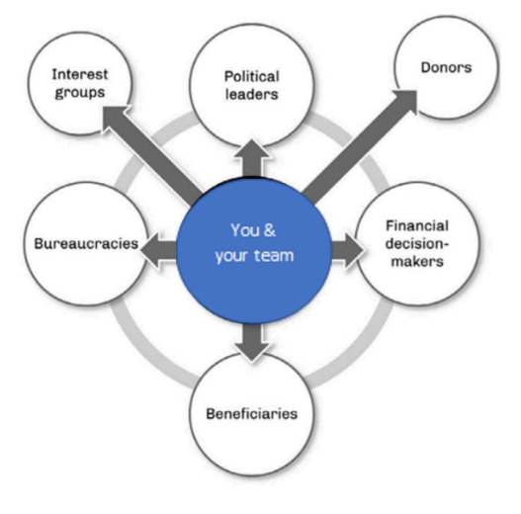
Use this table format to summarize and track: key stakeholders; any challenges you anticipate each will face (or create) during implementation; and the political management strategies you could to use to address the challenges. (You will definitely need to add more rows in each category.)
You may want to consider: have you defined appropriate strategies for managing in all six “directions” shown in the figure at right?
Stakeholders | Anticipated political challenges during the implementation | Political strategies to mitigate implementation risks
Beneficiaries
Bureaucracies
Interest Groups
Political leaders
Financial decision makers
Donors

