Connect to Harvard Wi-Fi as a visitor
- Connect your computer to the Harvard University wireless network. | 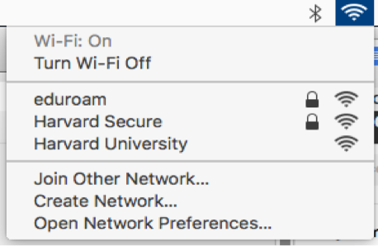
- Go to  https://getonline.harvard.edu/ in your web browser and click I am a Guest. | 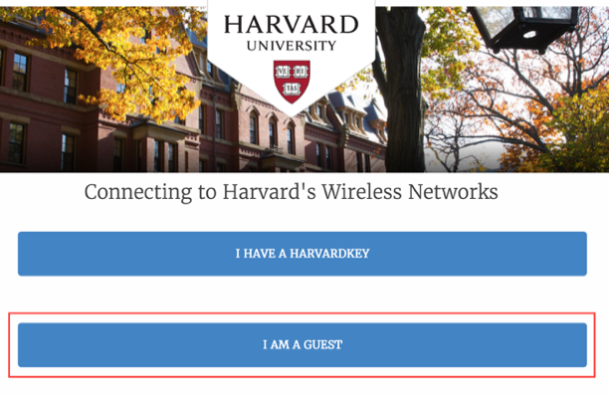
- Click Register for Guest Access. | 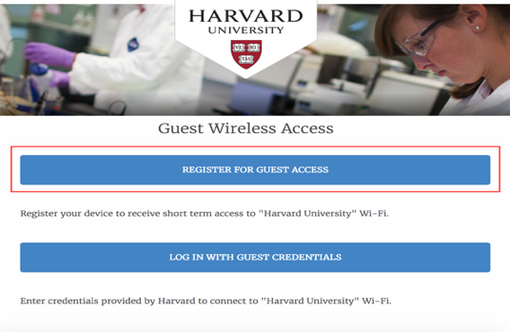
- Fill out your Name, Phone Number, and Email Address, and select the box to agree to the terms of use. Click Login to receive your credentials. | 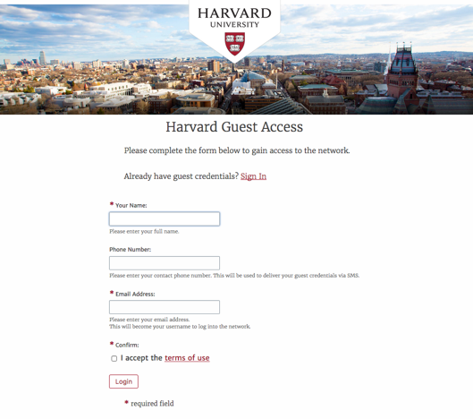
- Your Guest Credentials will now be shown and you can click login to gain network access. Once logged in you will be online and can browse the internet. | 