GENERAL NOTES FOR ADULTS' SEMIQUANTITATIVE
FOOD FREQUENCY QUESTIONNAIRE

- This codebook details the coding procedures to be used by all coders. It is important that CONSISTENCY is maintained throughout the coding process! Therefore, if you are not certain about any response, please call to ask for assistance. Accuracy of coding is of the utmost importance.

- The questionnaire will be “read” by an optical scanning machine. When the machine reads a page, it reads both sides of the page at once. For this reason, each response must not have any markings overlapping from the page behind. This may be a particular problem where an individual has written in a response, e.g., cereal or vitamin brand. To check that there is no overlap from the back page, simply hold the page up to the light and check visually. If there is an overlap of writing, record that information in an allowable space and then erase it.
Incorrect example:
Correct example:

- Use only a No. 2 PENCIL to mark the questionnaire. INK CAN NOT BE USED TO FILL IN THE SCANNING BUBBLES.

- PT = Passthrough bubble. These are the shaded bubbles, generally located to the right of each question, which you will fill-in to indicate that a section or a question has been left blank.

- If the respondent completed the questionnaire in ink, darken over their responses with pencil.

- Darken all response circles that are filled in lightly or incompletely WITH LEAD USING A NO. 2 PENCIL.

- Erase all information and remove all tape or labels at the top of each page of the questionnaire. Information removed from this section should be recorded in an allowable space.

IF QUESTIONNAIRES ARE SUBMITTED IN INK OR UNACCEPTABLE FOR SCANNING, THEY WILL BE RETURNED AT THE INVESTIGATORS EXPENSE FOR CORRECTION.
CODING DIRECTIONS FOR 22 GRID DIETARY ASSESSMENT

ID Number
- Select a 1-8 digit ID for your subjects and record it in the blank box next to term “ID”.
- Code the 1-8 digit ID number in the circles adjacent to term (ID), on page 1.
- You can use up to 8 digits. (example 1)
- Note order of ID coded so that sequential order of your ID is maintained.
- Code only the number of circles necessary to complete the ID length you have chosen. If you have 1-500 subjects in your study, you would code 001 and 500 respectively, (example 2 & 3). You do not need to code trailing zeros.
- You may utilize the 8 digits to create an ID that represents the cycle, center, year, etc. of your study (example 4).

Q1 - Multiple Vitamins
If the Participant…
- has left yes/no, (a) frequency (b) gummy (c) type or (d) brand blank then fill in the (1) PT bubble (example 5)
  - has responded no and left parts (a) frequency (b) gummy (c) type or (d) brand blank then move on to the individual vitamins section.
  - has filled in 2 or more bubbles in the frequency section, erase all except for that of the smallest value
  - currently takes multivitamins but have left frequency blank, fill in the (a) PT bubble (example 5a)
  - currently takes multivitamins but have left “gummy” blank, fill in the (b) PT bubble (example 5b).
  - currently takes multivitamins but have left the type (men, women, or both) blank, fill in the empty bubble below the “b” (example 5c)
  - currently take multivitamins, but have left the brand blank, fill in the (0) PT bubble (example 5d).
  - has a response in section (d) that corresponds with one of the multivitamin brands listed fill in that “cheat” bubble. (example 5e)
    - “Cheat” bubbles are provided for Centrum silver or Senior Vit., One-A-Day Teens or equiv., Eye Health, Centrum or generic equiv., Flintstones or Kids Multi equiv., Whole Foods/Vegetarian/Fruit Bites, One-A-Day or Equiv., Prenatal, Other Multivitamins (with minerals) or Other Multivitamins (without minerals)
  - multivitamin brands written in the brand box will not be coded.
SPECIAL INSTRUCTIONS FOR MULTI-VITAMIN SECTION:
Incorrect answers can take several possible forms. The table below groups the problems according to the type of response in the first part of the question and gives the coding rule for each combination of problems in the other two parts of the question. (GOOD=response)

No / Yes | a) -freq | b)gummy | c)type | d) -brand | Coding Directions
Blank | GOOD | Blank | Blank | GOOD | Mark “Yes” and code the Gummy and Type PT
Blank | Blank | Blank | Blank | GOOD | Mark “Yes”, and fill in Freq PT
Blank | GOOD | Blank | Blank | Blank | Erase frequency and code Q1 PT
Yes and No | GOOD | Blank | Blank | GOOD | Leave “Yes” and erase “No” and code the Gummy and Type PT
Yes and No | GOOD | Blank | Blank | Blank | Leave "Yes", erase “No”, and code the Gummy, Type, and Brand PT
Yes and No | Blank | Blank | Blank | Blank | Erase “Yes” and “No” and code Q1 PT
Yes and No | Blank | Blank | Blank | GOOD | Leave “Yes”, erase “No” and code the Freq, Gummy, and Type PT
No | GOOD | Blank | Blank | GOOD | Change “No” to “Yes” and code the Gummy and Type PT
No | Blank | Blank | Blank | GOOD | Change “No” to “Yes” and code the Freq, Gummy and Type PT
No | GOOD | Blank | Blank | Blank | Change “No” to “Yes” and code the Gummy, Type and Brand PT
Blank | Blank | GOOD | Blank | GOOD | Mark “Yes” and fill in Freq and Type PT
Blank | Blank | Blank | GOOD | GOOD | Mark Yes” and fill in Freq and Gummy PT
Blank | GOOD | GOOD | Blank | Blank | Mark “Yes” and fill in Type and Brand PT
Yes and No | GOOD | GOOD | Blank | GOOD | Leave “yes”, erase “no” code Type PT
Yes and No | GOOD | Blank | GOOD | GOOD | Leave “yes” erase “no” code Gummy PT
Yes and No | GOOD | GOOD | Blank | Blank | Leave “yes” erase “no” code type PT
Yes and No | GOOD | Blank | GOOD | Blank | Leave “yes”, erase “no” code Gummy PT
Yes and No | Blank | GOOD | Blank | Blank | Leave “yes”, erase “no” code Freq, Type, and Brand PT
Yes and No | Blank | Blank | GOOD | Blank | Leave “yes” erase “no” code Freq, Gummy, and Brand PT
Yes and No | Blank | GOOD | Blank | GOOD | Leave “yes”, erase “no” code Freq, Type PT
Yes and No | Blank | Blank | GOOD | GOOD | Leave “yes”, erase “no” code Freq, Gummy PT
No | GOOD | GOOD | Blank | GOOD | Change “no” to “yes” code Type PT
No | GOOD | Blank | GOOD | GOOD | Change “no” to “yes” code Gummy PT
No | Blank | GOOD | Blank | GOOD | Change “no” to “yes” code Freq and Type PT
No | Blank | Blank | GOOD | GOOD | Change “no” to “yes” code Freq and Gummy PT
No | GOOD | GOOD | Blank | Blank | Change “no” to “yes” code Type and Brand PT
No | GOOD | Blank | GOOD | Blank | Change “no” to “yes” code Gummy and B

Q1- Individual Vitamins and Minerals
If the Participant…
- has left an entire individual vitamin question blank, fill in its corresponding PT bubble, located to the right of each question.
    - Vitamin A’s PT bubble has an A in the center, Potassium a P, etc. (example 6)
- has filled in both the “yes” and “no” bubbles, erase the “no” response.
- has responded yes but left the dose blank, fill in the “Don’t know” bubble (the last option in the “dose per day” section).
- has responded “No” to a particular question but provided information concerning dose, erase the dose unless…
    - the participant has responded “No” to every individual vitamin, but marked a dose for just one or two, assume that the two with doses should be changed to “Yes”.
    - the participant has marked “Yes” to a couple of vitamins and correctly marked the dose for those vitamins and also had a vitamin marked “No” and a dose marked, erase the dose and code “Yes”.
- has responded “Yes, seasonal only” and “Yes, most months” for Vitamins A, C, and/or D, erase the “Yes, most months”.
- has marked a dose but the “Yes/No” is blank, code the “Yes” bubble.
- has filled in more than one dosage, erase all except for that of the smallest value.
- Has marked both “Yes” and “No” and marked a dose, erase “No”.
- has not entered a type for Vitamin E, fill in the “unknown” bubble.

No/Yes | Dose | Coding Directions
Blank | GOOD | Mark yes (seasonal only when applies)
Blank | Blank | Code individual vitamin PT
Yes and No | GOOD | Leave Yes and erase No
Yes and No | Blank | Leave No and erase Yes
No | GOOD | Mark Yes (Seasonal when applies)
No | Blank | Okay
Yes | GOOD | Okay
Yes | Blank | Okay

Q2 – Other Supplements
If the participant…
- has left the entire question blank (filled in no bubbles and left the response box blank) code the (2) PT bubble located to the right of the question. (example 7)
- has more than one response, that is okay. Multiple responses are allowed in this section.
- has written something in the “other” section, make sure the other bubble is filled in. There are no coding numbers for this section. (example 7a)
    - Make sure that the response cannot possibly be coded elsewhere in the questionnaire. If this is the case, erase the other bubble and fill in the information properly.
      - Participants may also have recorded a multi or individual vitamin that could be coded in Q1.

Q3 – Sugar (in teaspoons)
If the participant…
- has left the response box blank, fill in the (3) PT bubble to the far right of Q3. (example 8)
- has indicated more than 10 tsp of sugar in blank box, code for number in grid below the digit 7 and 8 of ID code (example 9)

Q4 – Cold Cereal
If the participant…
- has filled in the “Don’t eat cold breakfast cereal” bubble, then move on to the next section.
- has filled in the “Don’t eat cold breakfast cereal” bubble, but also recorded a brand, turn to page 3 and look on the first line of the Breads section to see the cold cereal frequency question. If the participant has answered “Never, or less than once per month”, leave the “Don’t eat cold breakfast cereal” bubble filled in. Do not code brand.
- has a response that corresponds with one of the “cheat” bubbles, located below Q5 at the bottom left of pg. 1, then fill in that bubble. If they have multiple responses code as many as possible using the “cheat” bubbles and one other brand (the first that can’t be expressed in a “cheat” bubble). (example 10)
    - CH – Cheerio
    - RB – Raisin Bran
    - CF – Corn Flakes
    - SW – Shredded Wheat
    - FM- Frosted mini wheats
    - GR-Granola
    - K – Special K
    - HB-Honey bunches of oats

NOTE: The cheat bubbles are for the regular version of each cereal. For example, do not use “CH” for “Honey Nut” or “Berry Burst” Cheerios. Other flavors of these cereals will have their own codes on the code sheet.

      - has a response that does not correspond with a “cheat” bubble, look at the cereal codes below to determine the best code to use. Fill in that 3-digit code to the right of the question. (example 11)
      - has 2 or more responses that do not correspond with a “cheat” bubble, code the first.
      - has reported cereal brand as “varies” use code 999.
      - has reported cereal brand as “generic” or “store brand” use code 036.
      - has left all of Q4 blank, fill in the (4) PT bubble located next to cereal brand coding grid (example 11a)

CEREAL CODES (IF NOT POSSIBLE TO CODE CEREAL BRAND USING THE CEREAL CHEAT BUBBLES.)
001 All Bran or Bran Buds
325 Banana Nut Crunch
292 Basic 4
120 Bran Flakes or any High Fiber Flake Cereal
011 Cap'n Crunch, or any other flavors
307 Cheerios, Honey Nut or any other sugared flavors
308 Cheerios, Multi grain
090 Chex, Wheat
019 Chex, Corn, Peanut Butter or Honey Nut
075 Chex, Rice, Cinnamon, Blueberry, or Vanilla
130 Cinnamon Toast Crunch
017 Cocoa Puffs
080 Corn Pops
121 Cracklin Oat Bran
123 Crispix
159 Fiber One
394 Fiber One Honey Clusters
030 Froot Loops
031 Frosted Flakes, or any other flavors
039 Grape Nuts
342 Great Grains Cranberry Almond Crunch
294 Great Grains Crunchy Pecan
297 Great Grains Raisins Dates Pecans
263 Honey Bunches of Oats with Almonds
255 Kashi 7 Whole Grain Puffs
387 Kashi Go Lean
388 Kashi GOOD Friend
391 Kashi Heart to Heart
393 Kashi, Autumn Wheat, Berry Fruitful, or Cinnamon Harvest
397 Krave, or any chocolate flavors
048 Life, or any other flavors
095 Lucky Charms
217 Oat Squares
298 Oatmeal Crisp or any other cold oatmeal cereal
035 Pebbles, Cocoa, Fruity or any other flavor
064 Puffed Rice
066 Puffed Wheat
161 Raisin Nut Bran
339 Reeses' Peanut Butter Puffs
076 Rice Krispies, or any other flavor
373 Smart Start
390 Special K, sugared or any other flavors
087 Total
219 Total Raisin Bran
137 Uncle Sam
089 Weetabix
093 Wheaties
998 Variety Half Sugared and Half Non-Sugared (examples: Cheerios, Rice Krispies, Frosted Flakes, Frosted Mini-Wheats)
999 Variety Non-Sugared Cereals (examples: Cheerios, Rice Krispies, Wheaties)
997 Variety Sugared Cereals (examples: Frosted Flakes, Frosted Mini-Wheats, Honey Nut Cheerios)

Q5 – Food Frequency Sections
If the participant…
- has left the Dairy Foods section blank, fill in the (P) PT bubble, located to the right of the question at its start. (example 12)
- Has left the Fruits section blank, fill in the (P) PT bubble, located to the right of the question at its start (example 12a)
- Has left the Vegetables section blank, fill in the (P) PT bubble, located to the right of the question at its start (example 12b)
- Has left the Eggs, Meat, etc. section blank, fill in the (P) PT bubble, located to the right of the question at its start (example 12c)
- Has left the Meat, Fish section blank, fill in the (P) PT bubble, located to the right of the question at its start (example 12d)
- Has left the Breads, Cereals, Starches section blank, fill in the (P) PT bubble, located to the right of the question at its start (example 12e)
- Has left the Beverages section blank, fill in the (P) PT bubble, located to the right of the question at its start (example 12f)
- Has left the Sweets, Baked GOODs, Miscellaneous section blank, fill in the (P) PT bubble, located to the right of the question at its start (example 12g)
- has left a particular food item blank, fill in the PT bubble located to the right of that item. (example 12h)
- has filled in more than one response bubble for a particular food item, erase all bubbles except for that of the lowest value. There can only be one response for each food item in these sections.
- has filled in more than one response for the “type of cheese” or “type of salad dressing” or “type of artificial sugar” questions, this is okay. Multiple responses are allowed in these sections. (examples 13, 14, 15)
- Has left “type of cheese” or “type of salad dressing” or “type of artificial sugar” questions blank, fill in the PT bubble (examples 13a, 14a, 15a)
Q6 – Liver
If the participant…
- has left both parts blank, code the (6) PT, located to the right of the question. (example 16)
- has left beef, calf, or pork liver part blank, code the (A) PT, located to the right of the question (example 17)
- Has left chicken or turkey liver part blank, code the (B) PT, located to the right of the question (example 18)
- has filled in more than one response bubble, erase all except that of the lowest frequency.

Q7– Fried Food at Home
If the participant…
- has left the question blank, fill in the (7) PT bubble, located to the right of the question. (example 19)
- has filled in more than one response bubble, erase all except that of the lowest frequency.

Q8 & Q9 – Fat Usage
If the participant…
- has left either of the questions blank, fill in its corresponding PT bubble, located to the right of each question. (example 20)
- has filled in more than one response bubble, that is okay. Multiple responses are acceptable for these questions.

Q10 – Cooking Oil
If the participant…
- has left the response box blank, or written an answer such as “none”, fill in the (10) PT bubble, located to the right of the question. (example 21)
- Multiple responses can be coded using the “cheat” bubbles (example 22)
  - OLV – Olive Oil
  - CAN – Canola Oil
  - COR – Corn Oil
  - VEG – Vegetable Oil
  - AVO- Avocado Oil
  - BLE-Blend
  - PEA-Peanut oil
  - COC-Coconut Oil
  - SES-Sesame oil
  - SUN-Sunflower Oil
  - GRS- Grapeseed
  - WAL-Walnut Oil
  - has a response that does not correspond with a “cheat” bubble
  - use code “PT” for answers such as “Don’t use oil” or “none”
  - use code “VEG bubble” for answers such as “Don’t know”

NOTE: Specific brand names are not that important. Thus, while “Market Basket Sunflower Oil” may not be on the list, it can and should be given the regular “Sunflower Oil” bubble.

Q11 – Deep Fried Foods
If the participant…
- has left the question blank, code the (11) PT bubble to the right of the question (example 23)
- has filled in more than one response bubble, erase all bubbles except for that of the lowest value.

Q12 – Toast
If the participant…
- has left the question blank, code the (12) PT bubble to the right of the question (example 24)
- has filled in more than one response bubble, erase all bubbles except for that of the lowest value.

Q13 – Diets
If the participant…
- has left the question blank, code the (13) PT bubble to the right of the question (example 25)
- has marked more than one diet, leave because more than answer is acceptable for this question

22 Grid Coding Manual – Examples

Ex. 5
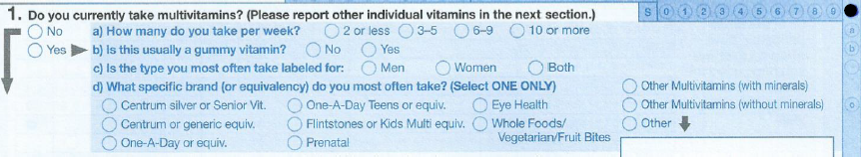

Ex. 5a
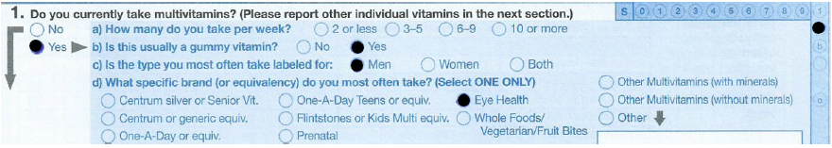

Ex. 5b
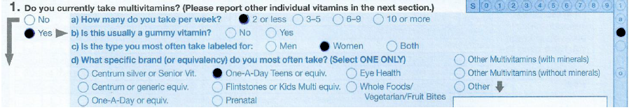

Ex. 5c
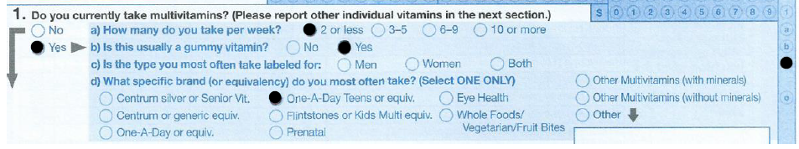

Ex. 5d
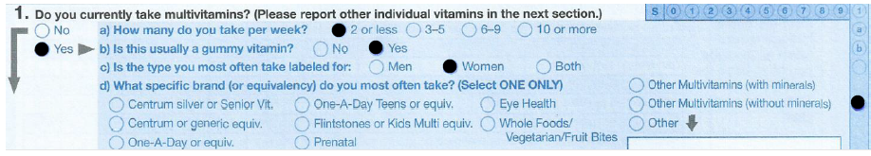

Ex. 5e
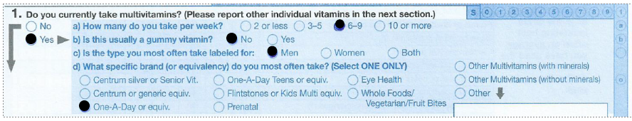

Ex. 6
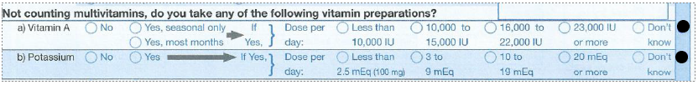

Ex. 7

Ex. 7a

Ex. 8

Ex. 9
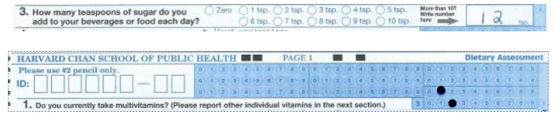

Ex. 10
Corn Flakes

Honey Bunches of Oats

Shredded Wheat
Cheerio
Raisin Bran

Frosted Mini Wheats

Special K
Granola
Ex. 11

Ex. 11a

Ex. 12
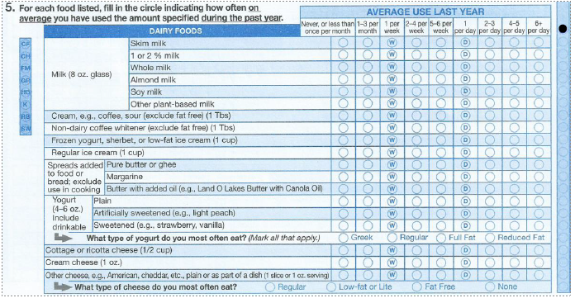

Ex. 12a
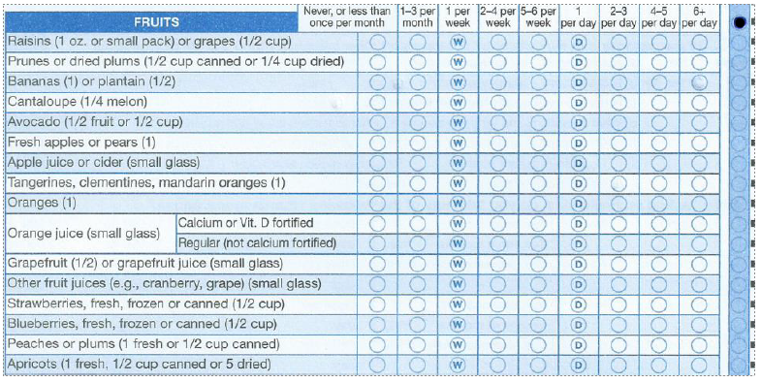

Ex. 12b
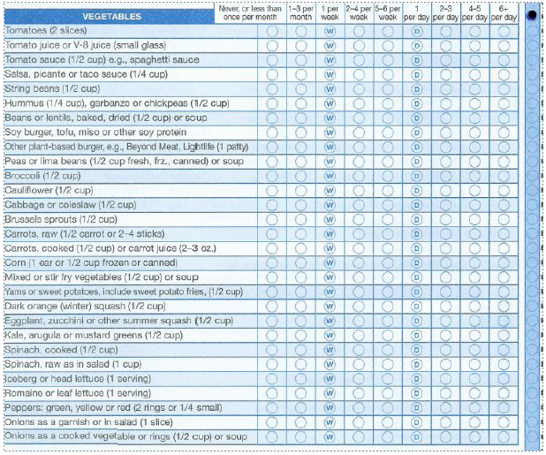

Ex. 12c
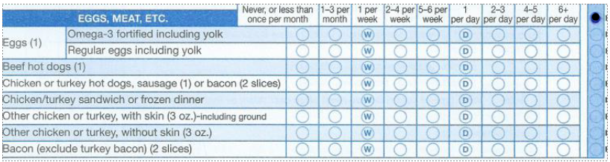
Ex. 12d
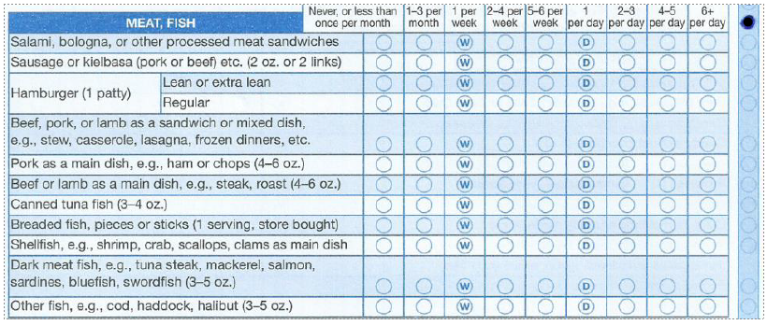

Ex. 12e
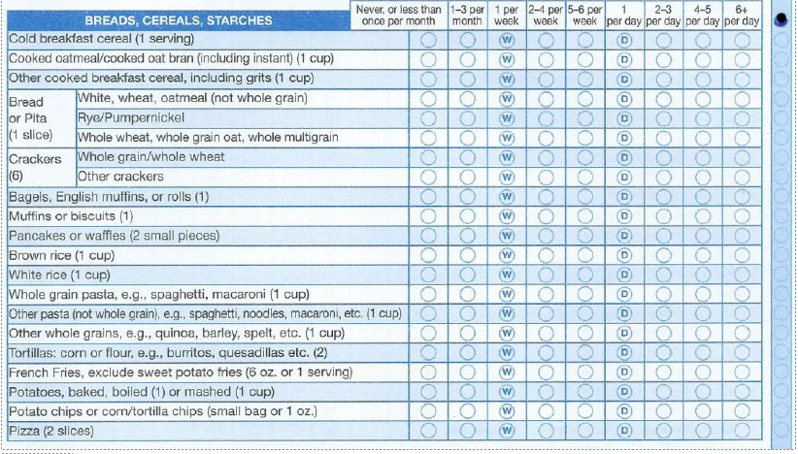

Ex. 12f
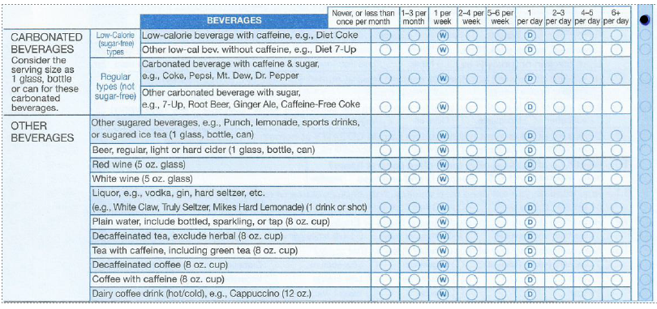

Ex. 12g
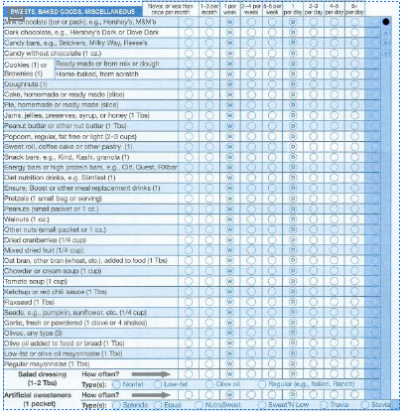

Ex. 12h (two examples)
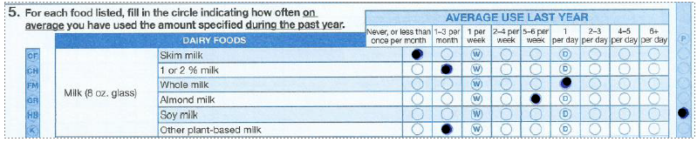

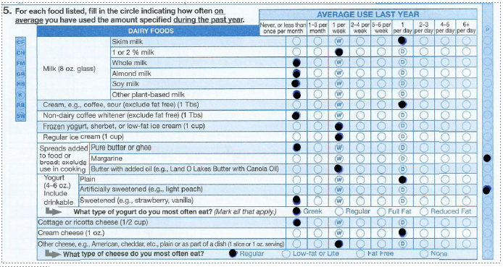

Ex. 13

Ex. 13a

Ex. 14

Ex. 14a

Ex. 15

Ex. 15a

Ex. 16

Ex. 17

Ex. 18

Ex. 19

Ex. 20
Ex. 21

Ex. 22

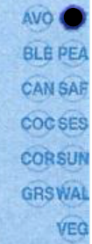
Ex. 23

Ex. 24

Ex. 25
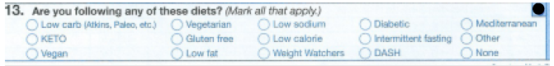

Ex. 25a
