Creating a Project in REDCap – How-To Guide

Helpful Terms

Instrument: a form or survey created for capturing data
Record ID: a unique identifier for each record in your database
Record Status Dashboard: a table that lists all existing records and their status for every data collection instrument
Data Dictionary: a csv spreadsheet containing the metadata used to construct instruments/fields.
Variable: the name of the field or answer choice that is stored in the database
Online Designer: allows you to create/modify/delete data collection instruments and fields
Branching Logic: logic that can be employed when fields in the database need to be hidden during certain circumstances.
Choice Label: Multiple choice text label
Choice (raw coded) Value: A raw value is a numerical or alphabetical value assigned to a multiple-choice text label. Each multiple-choice label must have an associated raw value.
Validation: By default, the Text field type accepts any characters. If you need a specific type of information, data validation allows you to enforce a validation standard on the field.

Logging into REDCap

Go to https://redcap.sph.harvard.edu/redcap/ and click on ‘Log in or Register for REDCap’ and then provide your GatorLink credentials.

Review the training and help resources.

Create a New REDCap Project

There are 3 main project types:

- Survey(s)
- Data Entry Forms
- Survey + Data Entry Forms

Click on the “New Project” tab:

Project Title: Enter a title for your project (this can be changed later if needed)

Purpose of this project: Use the drop down and select the purpose
- Practice/Just for Fun: use this to practice creating a project
- Operational Support: use this for tracking specific department information processes
- Research: if this is an IRB approved project, you will be prompted to enter the PI information and the IRB#
- Quality: use this for projects that help with goals and performance improvement
- Other: if you choose this option, please specify purpose

Start from scratch project or begin with a template project: it is recommended to “Create an empty project” until you become familiar with REDCap.

Once you are ready, click “Create Project”

Main Project Settings:

Use longitudinal data collection with repeating forms: Click Enable if your project will contain instruments that will be used to collect data numerous times. For an example, you are going to collect lab results over ten visits for the same participant.
Use surveys in this project: Click Enable if your project will contain surveys.
Modify project title, purpose, etc: Click this icon if you would like to change your project title or purpose.

Once you are finished with your main project settings, click “I’m done”. This will serve as a visual check mark that this section is completed. Note: You can always go back and change your settings while in Development mode.

Design your data collection instruments (forms/surveys)
Online Designer: Click Online Designer to start building your data collection instruments
Data Dictionary: Alternatively, you may upload your data dictionary via an Excel csv file in order to build your data collection instruments. Note: This is considered an advanced step and should not be used unless you are an experienced user.

Online Designer
REDCap will begin your project with a data collection instrument titled “My First Instrument”. To change the title, click the “Choose action” button.
To add additional data collection instruments, click on the Create icon. Click on Add Instrument here and enter a name for the new instrument.

To begin building your data collection instrument, click on the instrument name.

Record Identifier
The very first field in the first data collection instrument must be used as the record identifier and must be unique. The record identifiers can be automatically sequentially- generated or user-entered. The record identifier field cannot be deleted however you may rename this field by clicking on the pencil icon. It is strongly recommended to not use any PHI as the unique identifier to preserve confidentiality.

Add Fields to Your Data Collection Instruments
Click the Add Field button and select one of the several field types available:

The following pages give an explanation of each field and examples for each field.

Examples of Field Types
Text Box (Short Text) with a validation of Date (M-D-Y)
This field can be used for text, dates, numbers, email addresses, phone numbers etc. Use the Validation drop down (date format, email, phone, time, letters only, SS#, zipcode, integer, number-with/without decimals) to restrict how data should be entered.
Notes Box (Paragraph Text)
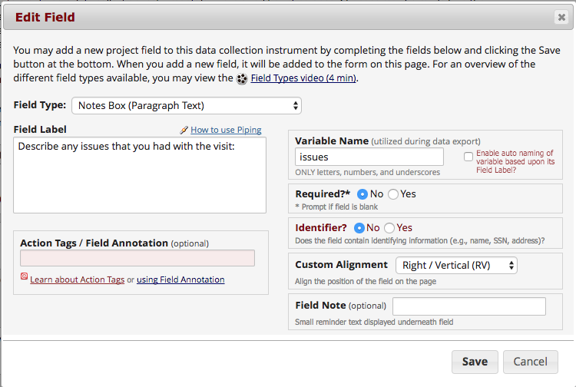

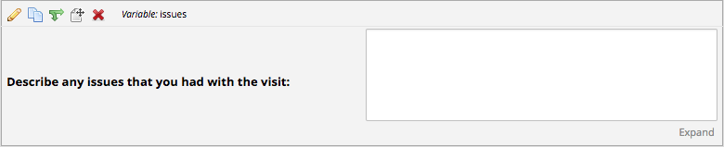

Calculated Field
This field can perform real-time calculations based on the data from other fields. For an example, you could create a calculation based off the start time and end time of a test to see how much time elapsed.
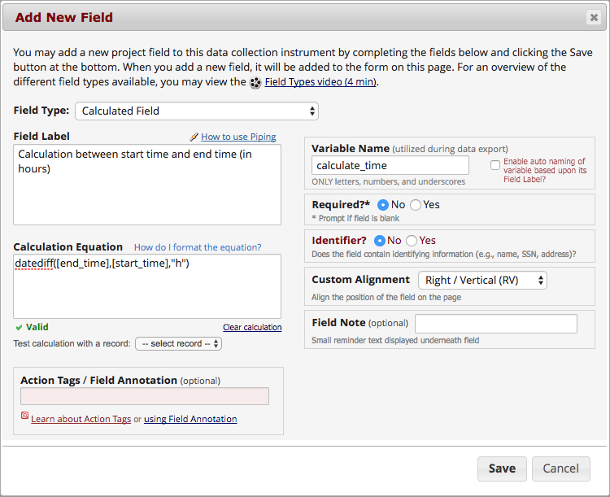

Multiple Choice – Drop Down List (Single Answer)
This field will display your answer choices as a drop-down list. When a field contains multiple answer choices, you must give each answer choice a variable name. If you do not, REDCap will automatically assign them for you.
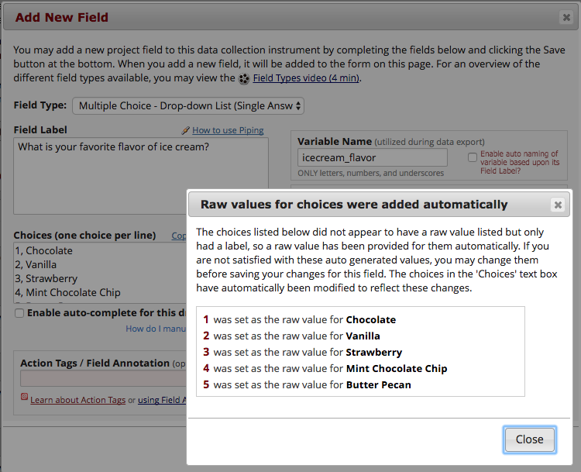

Multiple Choice – Radio Buttons (Single Answer)
This field will display your answer choices as radio buttons
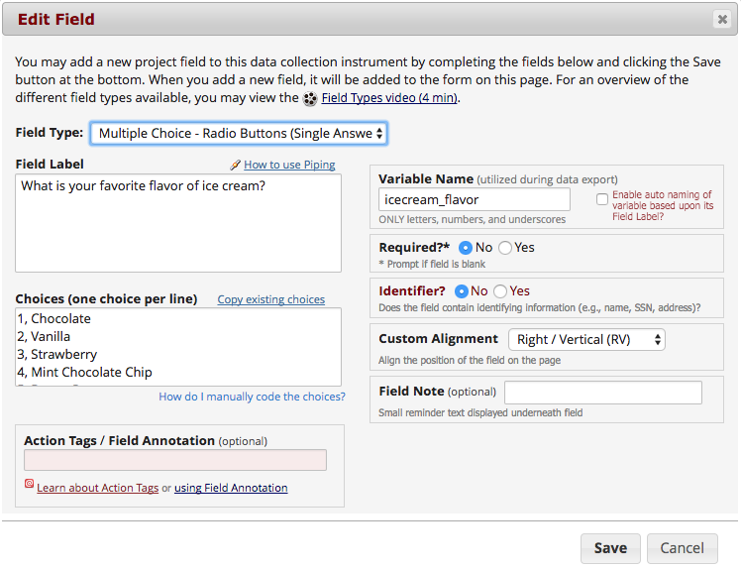

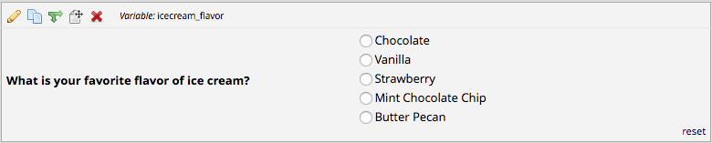

Checkboxes (Multiple Answers)
This field will display your answer choices as check boxes and will allow more than one answer. Note: I added a field note that states “Check all that apply”.
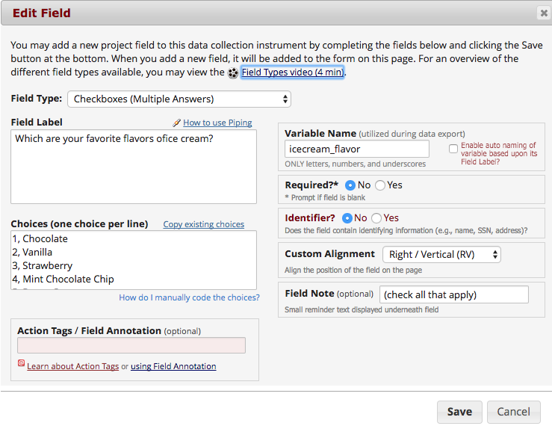
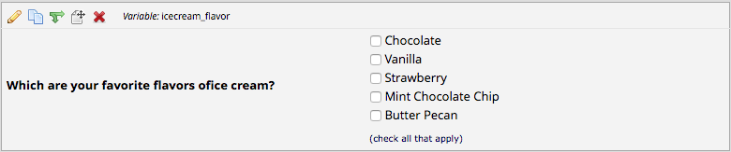

Yes–No
This field will display Yes and No as radio button answer choices.
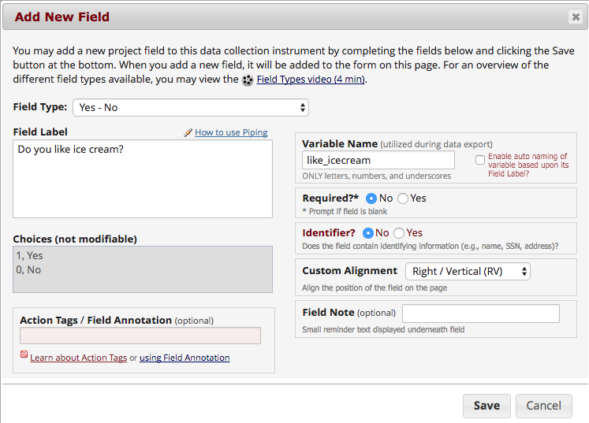

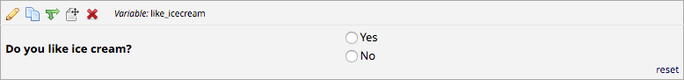

True – False
This field will display True and False as radio button answer choices.
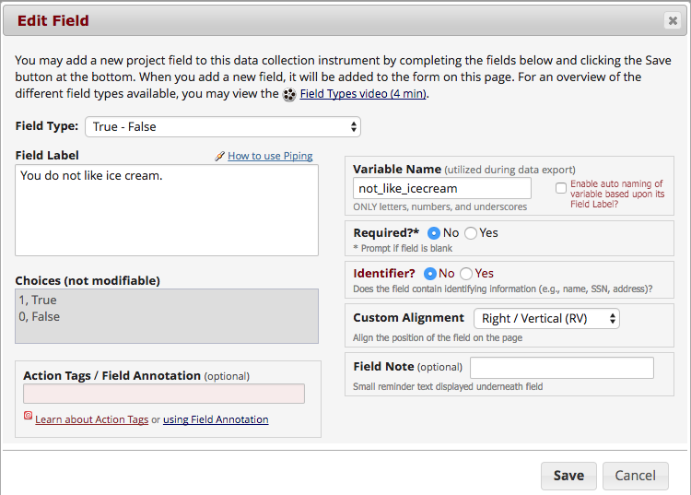

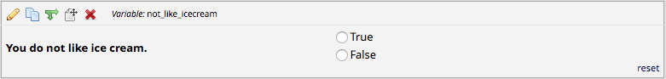

Signature (draw signature with mouse or finger)
This field will allow the participant to add their signature using their mouse or the finger (if using a tablet or touch screen device)
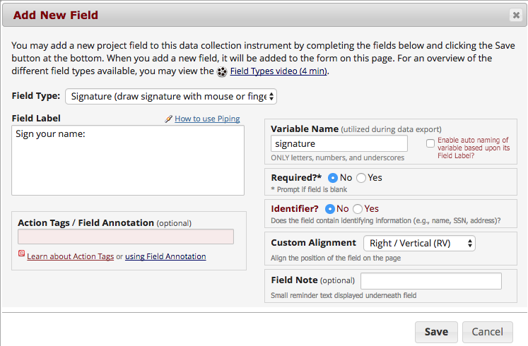

File Upload (for users to upload files)
This field gives the participant the ability to upload a file or image
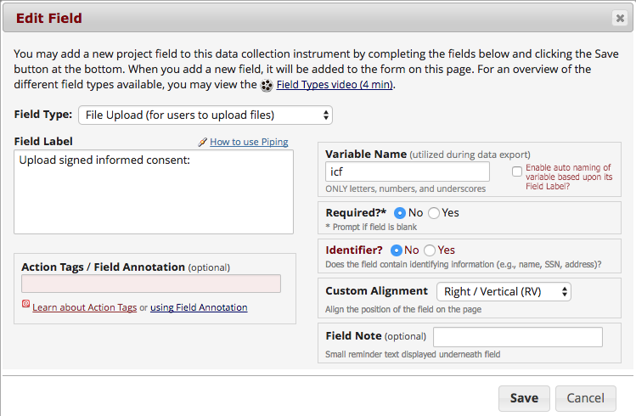

Slider Visual Analog Scale
This field gives you a scale with three answer choices. If you select “Display number value (0-100)”, it will code the answer given.
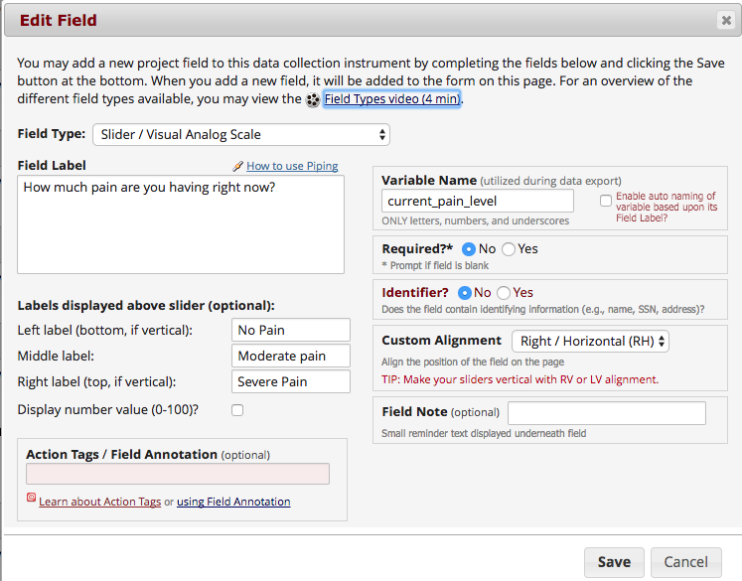

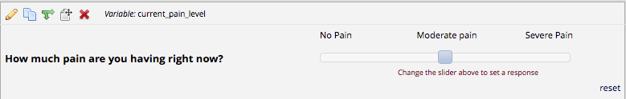

Descriptive Text (with optional Image/File Attachment)
This field will allow you to add text such as instructions or additional information. It also gives you the option to add an image as a link or as an inline image.
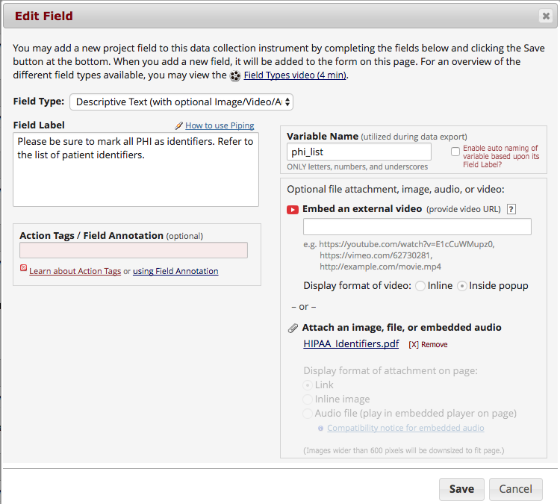

Link:
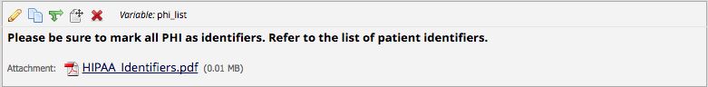
Inline Image:
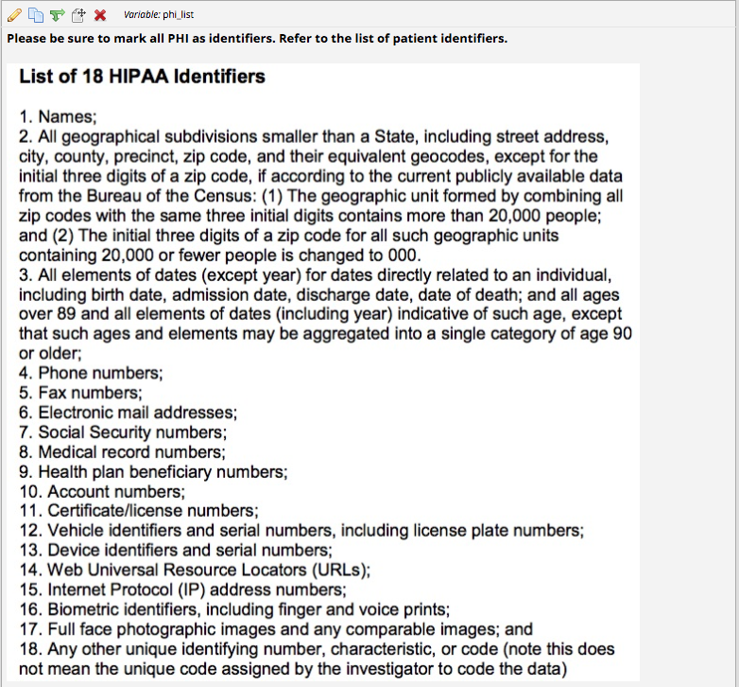
Begin New Section (with optional text)
This field is used as a section header. You can add text or leave blank.
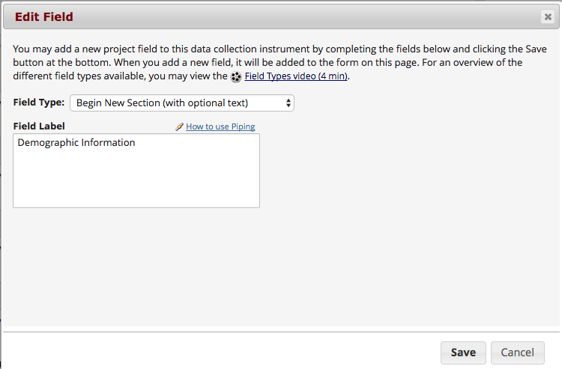
With optional text:
With no text:

Add Matrix of Fields
If you have a group of questions that all have the same answer choices, you can create a Matrix of Fields. Instead of clicking Add Field, you would click Add Matrix of Fields. You would add an optional header, your field labels and variable names, indicate which fields are required, add your answer choices and select whether these fields should be a single answer (radio button) or multiple answers (checkboxes). If you would like only one answer choice to be selected per column, enable ranking. You must also give your matrix a group name.
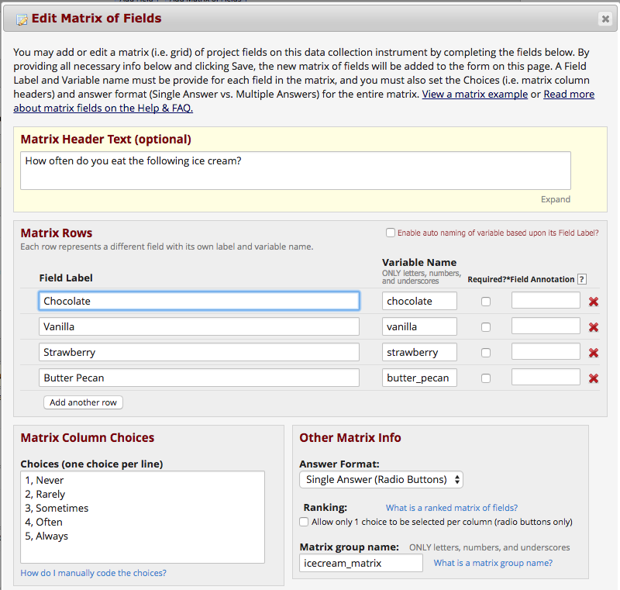
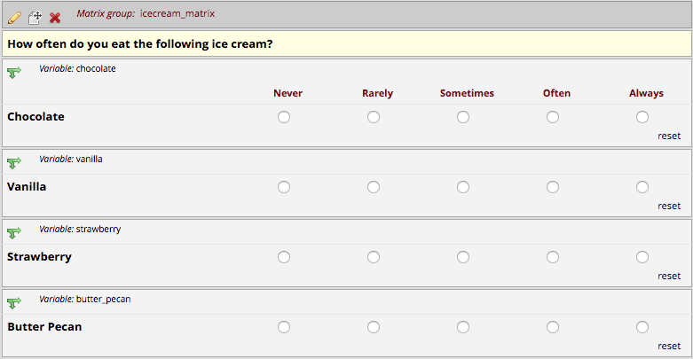

Edit/Copy/Move/Delete a Field
Edit: To edit a field, click on the pencil icon
Copy: To copy a field, click on the double paper icon
Move: To move a field, click on the paper with pointer icon. You can also move a field by click and hold field and drag the field to a different location.
Delete: To delete a field, click on the red X icon
Add Branching Logic
Branching logic is used when you have a field/question that you would only like to appear when a specific answer is given. To enable branching logic, click on the double green arrows on the field you want to hide.
For an example, I only want the “If Other, please specify” field to show if the answer to the question above it was Other.
After clicking on the double green arrows, scroll through the list of field choices and drag and drop the field you want to base your branching logic on. Click Save once finished.
The field now alerts me that branching logic exists. If I want to view or modify the existing branching logic, I would click on the double green arrows.
Add Piping Logic
Piping gives you the ability to insert answers and place it in various places within REDCap.
For an example, I have a field that asks the participant “What kind of ice cream do you like?”. I then have another field that asks the participant “How often do you eat ___ ice cream?”. I have added piping logic in my second question so that it will insert the answer from the first question.
Before:

One the participant answers the first question; the answer is then inserted into my next question.
After:

To add piping, all you have to do is add the variable name of the field you want to pipe in. The variable name must be inserted into square brackets [ ].
Piping can be used in many different places in REDCap such as:
- Field Labels
- Field Notes
- Section Headers
- Survey Instructions and Survey Acknowledgment Text
Enable Your Instrument as a Survey
Once you have enabled the “Use surveys in this project” setting under Project Setup, you will want to indicate which data collection instruments are going to be used as surveys.
For complete instructions on how to create and distribute surveys please review the Creating and Distributing a Single Survey Guide:
https://www.ctsi.ufl.edu/files/2017/06/Creating-and-Distributing-a-Single-Survey-in-REDCap-–-How-to-Guide.pdf

Enable Optional Modules and Customizations
Navigate to the Project Setup Page. To view the rest of the optional modules, click on Additional customizations.

- Auto-numbering for records
- Repeating Instruments and Events
- Scheduling Module (longitudinal projects only)
- Randomization Module
- Designate an email address to use for invitations
- Set a customs record label
- Define a secondary unique field
- Order records by another field
- Enable the field comment log or Data Resolution Workflow (data queries)
- Enable the data history widget (displays previous values, who changed value, time value was changed)
- Display the “Today/Now” button
- Require a reason when making changes to existing records
- Data Entry Trigger

User Rights and Permissions
If you would like to grant other users access to your project, click on User Rights.
For detailed information on how to add users to your project please review the Assigning Users Rights Guide.

Test Your Project Thoroughly
It is extremely important to test your project before moving it into production!
Try creating a few test records and enter some data to ensure that your data collection instruments look and behave how you expect, especially branching logic and calculations. You can do this by clicking Add/Edit Records. If you have surveys, complete the surveys as if you were a participant by using the Public Survey Link.
Once you have some test records entered, review them by going to your Record Status Dashboard; create reports and export your data and view in Excel or one of the statistical analysis packages; review your Stats.
The best way to test your project is to use it as if you were entering real production data, and it is always helpful to have colleagues (especially team members) take a look at your project to get a fresh set of eyes looking at it.
Move Your Project to Production
Move the project to production status so that real data may be collected. Once in production, you will not be able to edit the project fields in real time anymore. However, you can make edits in Draft Mode, which will then need to be approved by a REDCap administrator before taking effect.
You are strongly encouraged to test your project thoroughly before you move your project into production. Once you have ensured your project is capturing all of the fields you need and has all of the design elements, click on the Move project to production icon.
Since Development is a status that indicates to REDCap that you are still designing your project, REDCap will not keep track of any changes you make to your project while it is Development. Once you move a project to Production, REDCap will start tracking any changes you make to the project and will allow you to download the data dictionary from any point after the move to Production. This will allow you to easily revert to a version of the project prior to a change, or to even just document the changes you made.
Although it is tempting to keep a project in Development in order to be able to keep full control and flexibility over the design and ability to change your project, it is important to move the project into production before collecting real data. Moving your project to Production once you start collecting study data ensures you're maintaining data accuracy and integrity. The post-production change control process provides an additional check to ensure that data which has already been collected is not deleted, re-coded or overwritten unintentionally.

Best Practices

Attention to detail at the start of a project can save many hours of work further down the line. This document provides some tips that could save effort later.
Record ID: Record ID is the first field of the first form. The Record Identifier field cannot be deleted; however, you may rename the field.
Protected Health Information (PHI): Use the REDCap identifiers function. There are 18 pieces of information that must be marked as identifiers as per HIPAA policies. You can also use the “Check for Identifiers” module found under “Design your data collection instrument” in the Project Setup tab.
Research Project: if your project is a research study, enter the PI’s Name, Email Address and the IRB Protocol # to help easily identify it.
Data Validation: By default, the Text field type accepts any characters. If you need a specific type of information, data validation allows you to enforce a validation standard on the field. When you use data validation, the user is prompted to provide correctly formatted data. Validations prevent users or participants from entering data in the incorrect format. Date formats, number validations, etc. are called “hard validations” because REDCap will not let you save the data if it fails to match the validation format. Range checks are called “soft validations” because REDCap will warn you that the value entered is out of the expected range, but it will still allow you to save the data.
Variable Names: Variable names are critical in the data analysis process. If you export your data to a statistical software program, the variable names are what you or your statistician will use to conduct the analysis.
Follow these principles when naming variables:
1. Keep it short and simple – In most cases, variable names should not exceed 26 characters (most stats packages will truncate variable field names to a max of 26 characters).
2. Make it meaningful – Variable names should be clear enough that your statistician will be able to understand which question you are referring to.
3. Keep it consistent – Avoid inconsistencies by noting how you named previous variables. If you have a large number of variables, you may want to consider starting each one with a prefix to indicate what instrument the variable came from or what section of the project it belongs to. For example, all of your demographic data might begin with dem_ , all of your bloodwork with bw_ , all of your physical exam data with phys_ , etc.
4. When you copy a field in the Online Designer, be sure to change the default variable name.
We always recommend reviewing your variable names with a statistician or whoever will be analyzing your data. This is especially important if this is the first time you are building a database.
Free Text Fields: Minimize the use of free text fields because these can be difficult to analyze. Use categorical response field types (i.e. dropdown, radio button, checkbox) instead of free text fields (i.e. text box and notes box). You can add a free text field after to capture additional information.

Numerical Codes: Be consistent when assigning numerical codes. For example, if “unknown” is coded as 99 in one response, it should be coded as 99 wherever it appears in the database. The numerical code does not affect the order that choices are displayed in the REDCap data entry form.
A code of 99 is recommended for “Other” to leave room for later changes.
A code of 98 is recommended for “None of the Above”, “Unknown” like answers.
A code of 1 is recommended for “Yes” answers
A code of 0 is recommended for “No” answers
A code of 1 is recommended for “Male” answer
A code of 0 is recommended for “Female” answer
Race/Ethnicity: Consider recording race and ethnicity according to the current NIH guidelines. Ethnicity categories are “Hispanic or Latino” and “Not Hispanic or Latino.” Racial categories are “American Indian or Alaska Native,” “Asian,” “Native Hawaiian or Other Pacific Islander,” “Black or African American,” and “White.”
Field Annotation/Field Note: Do not assume that data entry personnel know the expected units or format. Units for measurement should be clearly identified in the field label and/or field note. The field label should be used so the statistician can see the units when the dataset is exported. The field note does not export, but may be more salient to the data entry personnel. Never mix different units in one data entry field.
Calculations: Reduce the use of calculated fields. REDCap has the ability to make real-time calculations on data entry forms. Calculated fields should only be used when it is necessary to know the calculated value while on that page or the following pages, or when the result of the calculation affects data entry workflow. It is recommended that calculations be performed in a statistical analysis package after exporting the data from REDCap.
It is strongly recommended that you do not use “today” in calculated fields. This is because every time you access and save the form, the calculation will run.
Inexact Dates: For inexact dates, enter day, month, and year separately. Most people will be able to tell you their date of birth. However, very few of them will be able to tell you the date they first noticed symptoms of a particular disease. However, they might be able to tell you the month and year they noticed symptoms.
Standard Measures/Instruments: Don’t develop standard measures from scratch if you can use existing ones. Using standard measures will allow your findings to be compared meaningfully with those of others, and will allow you to reuse your datasets later. Of course, it is vital that these instruments not be modified, or they will no longer be “validated” or comparable. Use the REDCap Shared Library as one resource for standard instruments and already designed data collection forms (demographics, AEs, etc.). Some instruments/forms have branching logic and/or calculations built-in.
Some example instruments: Neuro-QOL, PRISM, PHQ, PROMIS, WHOQOL-BREF, AE Form with Branching Logic

