Project Setup Page – Information Guide

The ‘Project Setup’ page contains a checklist of items to be completed before moving the project into Production (going live). The steps are shown and described below and do not have to be done in the order shown but some steps, such as the ‘Define your events and designate instruments for them,’ will not appear unless you click on ‘Enable’ under ‘Main project settings.’
1
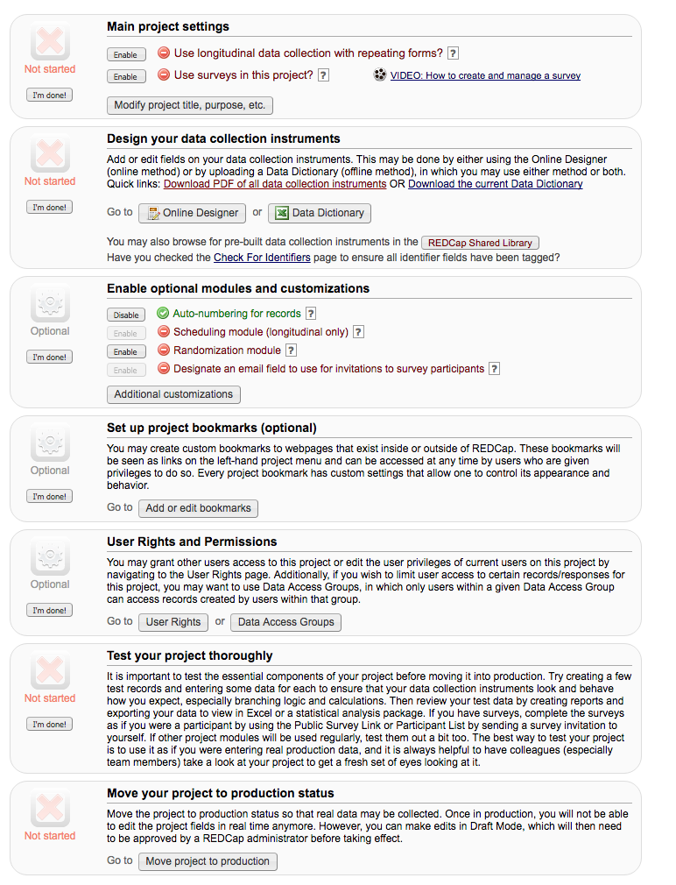
7
6
5
4
3
2

1 - Main Project Settings (required if using surveys or collecting data longitudinally)
Click on ‘Enable’ next to ‘Use longitudinal data collection with repeating forms’ if your project is longitudinal. * Click on ‘Enable’ next to ‘Use surveys in the project’ to set up some or all of your data collection form(s) as surveys. Clicking on these options does not make your project longitudinal or make your data collection form(s) become surveys. Clicking these options only creates the template for your project to collect data in this way, it does NOT make your form(s) surveys or allow you to collect data longitudinally. It’s not until you create an event table on the ‘Define My Events’ page and/or ‘Enable’ a specific form(s) as a survey(s) on the ‘Online Designer’/’Edit Instruments’ page that these features become available. If you do not plan to use these features, it is recommended that you do not enable these features since it will create unnecessary data fields in your project and can cause problems upon data export.

2 – Design your Data Collection Instruments (required)
Click on Online Designer or Data Dictionary to add or edit fields on your data collection instruments (survey and/or forms). This may be done by either using the Online Designer (online method – preferred for new users) or by uploading a Data Dictionary (offline method – faster but experience required), in which you may use either method or both. Once created, you may then enable your form(s) to be used as surveys in the Online Designer.

How to use the Data dictionary training video: https://redcap.vanderbilt.edu/consortium/videoplayer.php?video=form_editor_upload_dd02.flv&referer=redcap.ctsi.ufl.edu&title=The%20Online%20Form%20Editor%20and%20Data%20Dictionary%20Upload

How to use the Online designer training video:
https://redcap.vanderbilt.edu/consortium/videoplayer.php?video=form_editor_upload_dd02.flv&referer=redcap.ctsi.ufl.edu&title=The%20Online%20Designer

3 – Enable Optional Modules and Customizations (optional)
- Auto-numbering for records - This option will remove the ability for users to name new records manually and will instead provide an ‘Add New Record’ button that will auto-generate a new unique record name, which will be numerical and will increment from the highest numerical record value in the project. If no records exist, it will begin with '1.'
Q: How can I set the default auto-numbering to start at a particular number such as 2000?
You can disable auto-numbering and add the first record using the ID number as the start value. Once this record is saved, you can enable the auto-numbering customization.

- Scheduling module (longitudinal only) - The scheduling module can generate schedules for your project calendar that are auto-generated from project-defined events (e.g., visits, time-points). Scheduling is only available for projects using longitudinal data collection.

- Randomization module - Randomization is a process that assigns participants/subjects by chance (rather than by choice) into specific groups, typically for clinical research and clinical trials. The randomization module in REDCap will help you implement a defined randomization model within your project, allowing you to randomize your subjects (i.e. records in your project). In this module, you first define the randomization model with various parameters. Based on the defined parameters, the module creates a template allocation table, which you can use to structure the randomization table you will import. The module also monitors the overall allocation progress and assignment of randomized subjects.
User privileges can be set to allow only certain users to be able to set up the randomization, perform the randomization, or view the allocation dashboard to view progress. If someone is given 'Randomize' privileges, they will be able to view and modify any existing data already collected for the randomization strata fields (if stratification is used) when they are performing the randomization, even if they do not specifically have form-level rights to view the form on which a strata field exists. Thus Randomize rights trumps form-level rights in this way, but only for the randomization strata fields.

- Designate an email field to use for invitations - You can capture email addresses for sending invitations to your survey participants by designating a field in your project. If a field is designated for that purpose, then any records in your project that have an email address captured for that particular field will have that email address show up as the participant's email address in the Participant List (unless an email address has already been entered for that participant in the Participant List directly).
Using the designated email address field can be especially valuable when your first data collection instrument is not enabled as a survey while one or more other instruments have been enabled as surveys. Since email addresses can only be entered into the Participant List directly for the first data collection instrument, the designated email field provides another opportunity to capture the email address of survey participants.
NOTE: If the participant's email address has already been captured directly in the Participant List, then that email address will supersede the value of the email field here when survey invitations are sent to the participant.

- Set a customs record label - You may append other data and/or static text to any record name (e.g., Study ID) as the record is displayed on your data collection instruments, such as inside the drop-down lists when choosing a record and at the top of the page after being selected. Simply provide the text you wish to display below, and place any variable names inside square brackets [ ], after which the data collected for those variables for that record will replace the variable in the text.
Example: if ([last_name], [first_name]) where entered, then for record '102' it would display '102 (Doe, John)'.

- Define a secondary unique field - Specify a field as your secondary unique field, whose value will be displayed next to the record name when selecting or viewing records/responses in order to more easily identify a record/response. When entering data for the secondary unique field on a form or survey, its value will be checked in real time to ensure it does not duplicate the value from another record. Only 'text' fields may be used.

- Order records by another field - The default setup is that all records are ordered by their record name (e.g., Study ID) when displayed in the drop-down lists on your data collection instruments, but you may alternatively order the drop-down lists by the values of another field in the project (e.g., last name), if desired.

- Enable the Field Comment Log or Data Resolution Workflow (Data Queries) – default is enabled.
You may enable either the Field Comment Log or Data Resolution Workflow (also known as the Data Queries module). The Field Comment Log (enabled by default) allows users to leave comments for any given field on a data entry form by clicking the balloon icon next to the field. All comments can also be viewed, searched, and downloaded on the Field Comment Log page. Alternatively, if the Data Resolution Workflow is enabled, users will be allowed to open a workflow for documenting the process of resolving issues with data in the project (i.e. opening, responding to, and closing data queries).
This data resolution workflow, often called 'data queries' in clinical trials and studies, can be utilized either on a data entry form (clicking the balloon icon next to the field) or on the Data Quality page when finding data discrepancies. The Data Quality module will then display a new 'Resolve Issues' tab, which will allow users to view all resolved and unresolved data queries and thus resolve any queries that are still open. Different user privileges may be given to users that control whether or not users can view, open/close, or respond to data queries.
For a brief overview, view the Data Resolution Workflow video: https://redcap.vanderbilt.edu/consortium/videoplayer.php?video=data_resolution_workflow01.swf&title=Data%20Resolution%20Workflow&referer=redcap.ctsi.ufl.edu

- Enable the Data History widget for all data collection instruments? – default Is enabled.
If enabled, an icon will appear next to every field on a data collection instrument. When the icon is clicked, the history of all data entered into that field for that record will be listed chronologically and will display all previous values, who changed the value at each instance, and the time it was changed.

- Display the Today/Now button for al date and time fields on forms/surveys? – default is enabled.
If enabled, a 'Today' button will be displayed to the right of all date fields, and a 'Now' button will be displayed to the right of all time, datetime, and datetime_seconds fields. Clicking the button will automatically set the field's value with the current date or time.

- Require a ‘reason’ when making changes to existing records - Require users to enter a reason (200 character max) in a text box when making any data changes to an already existing record on a data collection instrument. The prompt is triggered when clicking the Save button on the page. Any 'reasons' entered can then be viewed anytime afterward on the Logging page.

- Data Entry Trigger - The Data Entry Trigger is an advanced feature. It provides a way for REDCap to trigger a call to a remote web address (URL), in which it will send a HTTP POST request to the specified URL whenever any record or survey response has been created or modified on any data collection instrument or survey in this project (it is not triggered by data imports - including API imports and Mobile App imports - but only by normal data entry on surveys and data entry forms). Its main purpose is for notifying other remote systems outside REDCap at the very moment a record/response is created or modified, whose purpose may be to trigger some kind of action by the remote website, such as making a call to the REDCap API.

4 – Set up Project Bookmarks (optional)
You may create custom bookmarks to webpages that exist inside or outside of REDCap. These bookmarks will be seen as links on the left-hand project menu and can be accessed at any time by users who are given privileges to do so. Every project bookmark has custom settings that allows one to control its appearance and behavior.

5 – User Rights and Permissions (required)

This page may be used for granting users access to this project and for managing the user privileges of those users. You may also create roles to which you may assign users (optional). User roles are useful when you will have several users with the same privileges because they allow you to easily add many users to a role in a much faster manner than setting their user privileges individually. Roles are also a nice way to categorize users within a project. In the box below you may add/assign users or create new roles, and the table at the bottom allows you to make modifications to any existing user or role in the project, as well as view a glimpse of their user privileges. Additionally, if you wish to limit user access to certain records/responses for this project, you may want to use Data Access Groups, in which only users within a given Data Access Group can access records created by users within that group.

How to set up Data Access Groups training video: https://redcap.vanderbilt.edu/consortium/videoplayer.php?video=data_access_groups02.flv&referer=redcap.ctsi.ufl.edu&title=Data%20Access%20Groups

6 – Test your project thoroughly (required)
It is important to test the essential components of your project before moving it into production. Try creating a few test records and entering some data for each to ensure that your data collection instruments look and behave how you expect, especially branching logic and calculations. Then review your test data by creating reports and exporting your data to view in Excel or a statistical analysis package. If you have surveys, complete the surveys as if you were a participant by using the Public Survey Link or Participant List by sending a survey invitation to yourself. If other project modules will be used regularly, test them out a bit too. The best way to test your project is to use it as if you were entering real production data, and it is always helpful to have colleagues (especially team members) take a look at your project to get a fresh set of eyes looking at it.
7 – Move your project to production status (required)
Move the project to production status so that real data may be collected. Once in production, you will not be able to edit the project fields in real time anymore. However, you can make edits in Draft Mode, which will then need to be approved by a REDCap administrator, before taking effect, if the edits will affect existing data.

Moving your project to Production once you start collecting study data ensures you're maintaining data accuracy and integrity. The post-production change control process provides an additional check to ensure that data which has already been collected is not deleted, re-coded or overwritten unintentionally. While in Development mode there is no warning about what will happen to your existing data. If you accidentally delete a question or an event, re-code your answer choices, change field types, or change the variable name of a field that contains data YOUR DATA IS GONE (or disassociated/mismatched) WITHOUT WARNING!!

