REDCap Data Export – User Guide
Step 1: Under Data Export Tool, choose either Simple Data Export (export entire data set) or Advanced Data Export (allows for custom choices for data).
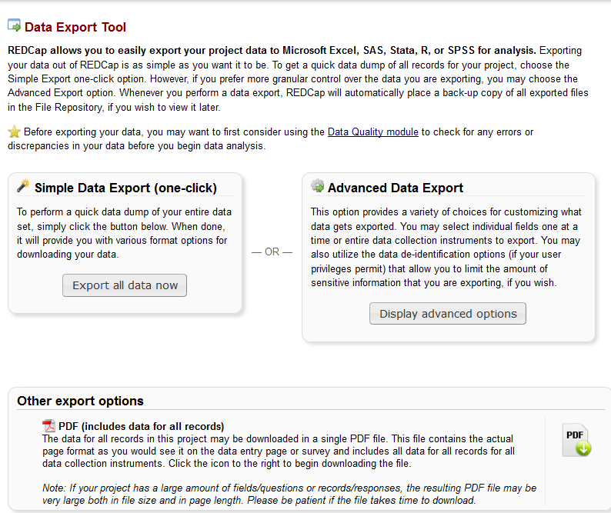

Step 2: You can choose to either select every field in the project, or every field on different forms. Or, you can choose specific fields across all the forms in the project.
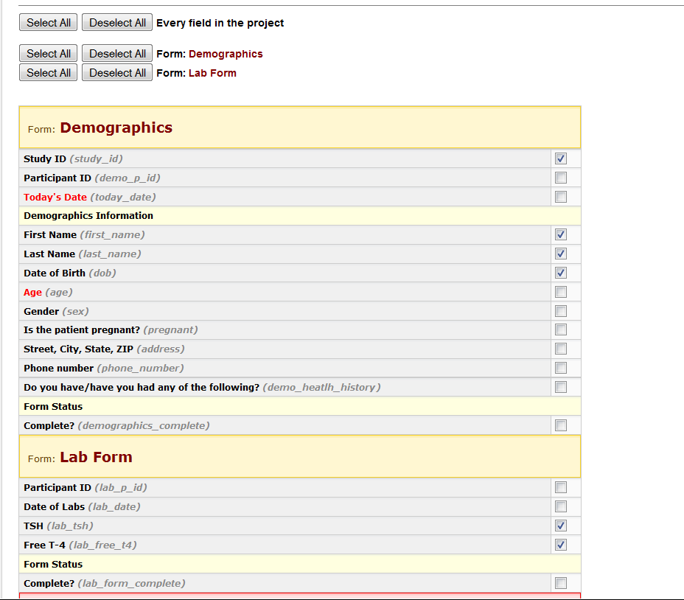

Step 3: There are optional De-Identification options as well.
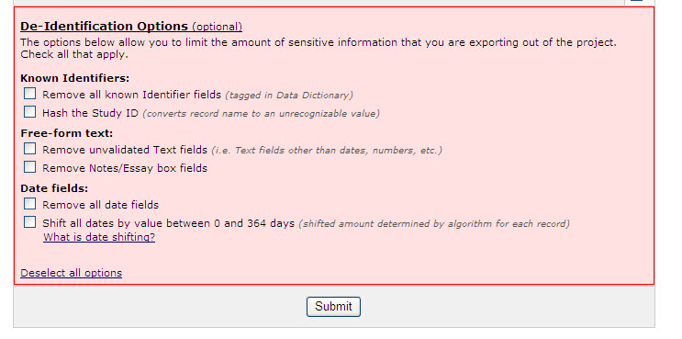
Step 4: This is what the data looks like in Excel
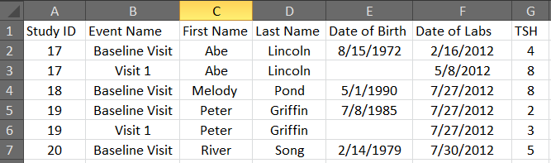

Step 4: Choose Excel or one of four statistical packages with which to view your data.
