***Warning: altering a database that is in Production can cause data loss. Major changes to your project should be done BEFORE submitting your project for Production. Hence, making changes to a project that is in Production should only be done as a last resort. ***
If a Production database must be modified, follow these rules to protect your data:
(1) Do not change existing variable names (e.g. demo_date, labs_calcium, survey_firstname), or data stored for those variables will be lost. To restore data that has been lost in this way, revert to the previous/original variable name(s).

(2) Do not change existing form names (e.g. Demographics, Labs, Survey) via a data dictionary upload or form completeness data will be lost. Form names may be changed within the Online Designer without data loss.

(3) Do not modify the codes (numbers before the answer choices) and/or answer choices for existing Multiple Choice – Drop-down List (Only One Answer), Multiple Choice – Radio Buttons (Only One Answer), or Checkboxes (Check All That Apply) fields or existing data will be lost and/or disassociated.

Example:
(old values) 1, Married (new/changed values) 1, Married
2, Single 2, Single
3, Divorced 3, Separated
4, Separated 4, Divorced

Because the new value of “Divorced” is now ‘4,’ any previous subject data that was entered as “4, Separated” will now be given the value of “4, Divorced” because REDCap only looks at the codes (1, 2, 3, 4, etc.) and not the answers after the codes.

Example: (changing from a Yes – No field type to a Multiple Choice – Drop-down list (Only One Answer) or Multiple Choice – Radio Buttons (Only One Answer) field type)

(old values:) 0, No (new/changed values) 1, Yes
1, Yes 2, No
77, NA

Because the new value of “No” is now ‘2,’ any previous “0, No” answers will now be disassociated because “0, No” no longer exists (see example above). To retain the data for the subject’s with “No” as the answer to this question/variable, one has to recode “No” as ‘0.’ Or, for each subject that had “No” as the answer, one has to re-enter the data for each of these subjects. Those with “Yes” answers do not need to be re-entered.

(4) It is only acceptable to add choices (answers) to Multiple Choice – Drop-down List (Only One Answer), Multiple Choice – Radio Buttons (Only One Answer), or Checkboxes (Check All That Apply) fields.

(5) Changing from a Text Box (Short Text) or Notes Box (Paragraph Text) to any other type of field will result in a loss of your existing data in those fields.

Steps for Making Changes to a Project in Production
- Download a copy of the Current Data Dictionary and a copy of the project’s existing data via a data export (‘Data Exports, Reports, and Stats’).
- Select ‘Online Designer’ on the Project Setup page (Figure 1).
- Click on Enter Draft Mode (Figure 2).
- Click on the form(s) that need changes made and make the changes just as you would while in Development mode (Figure 3).
- After making all of the changes, go back to the Online Designer page and click on “Submit Changes for Review” (Figure 4).
- If you want to view all of your changes before you submit them click on “View detailed summary of all drafted changes.” If you want to remove the changes you made, click on “Remove all drafted changes” (Figure 4).
- If the changes will not affect existing data in any way, the changes will be automatically applied once you submit them.
- Otherwise, the REDCap Team will receive a copy of your changes and contact you about them. If you want to know why the changes did not get automatically approved by REDCap, click on “Why weren’t my changes made automatically?” (Figure 5).

Figure 1:
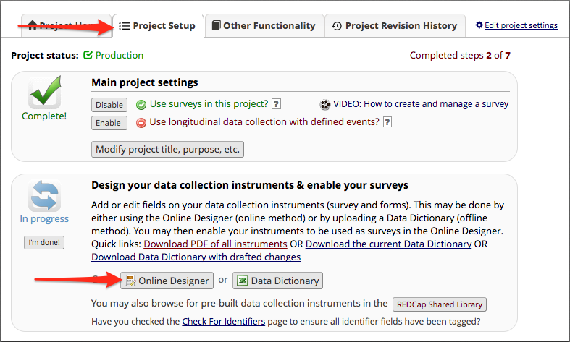
Figure 2:

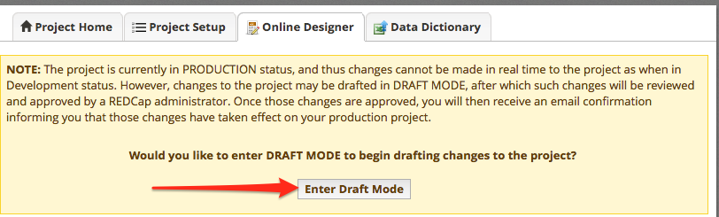

Figure 3:

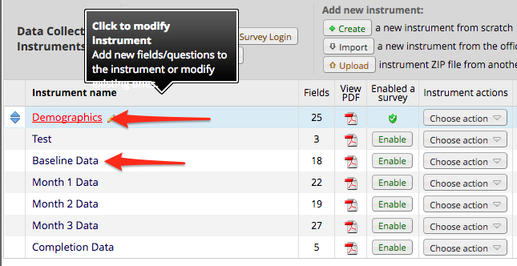
Figure 4:

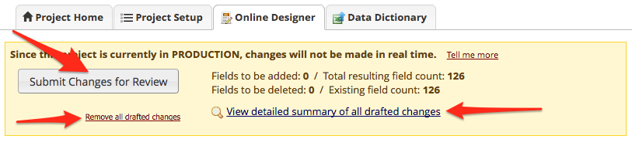

Figure 5:

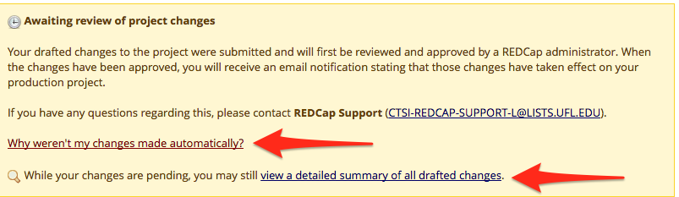

View of the detailed summary of drafted changes:
