Assigning User Rights: Guidance and Troubleshooting
***It is the responsibility of the project manager or PI to assign users to their project and give them the appropriate rights/permissions. ***
Tip: There should always be at least two users (including yourself) on your project just in case you are on vacation or sick leave and the project needs to be accessed in your absence.
Steps for creating a new user:
- Ensure the new user has requested for a REDCap account and the project has received IRB review/approval.
- After the new user has been registered for a REDCap account, go to the project you would like to add them to. A list of your projects can be found under “My Projects.”
- Once you are in your project, go to “User Rights” which is listed on the left hand side bar under Applications (see graphic to the left).
- Once you have gone into “User Rights,” you will see a list of users that already have access to your project (if
applicable) and which permissions they have (see below).
- To add a new user, type their user name into the “New user name” field (shown below) and hit the
Tab key.
Example: for the user John Doe, if their email is: john.doe@hsph.harvard.edu, their user name would be
jdoe (do not add the @hsph.harvard.edu when entering in their user name).

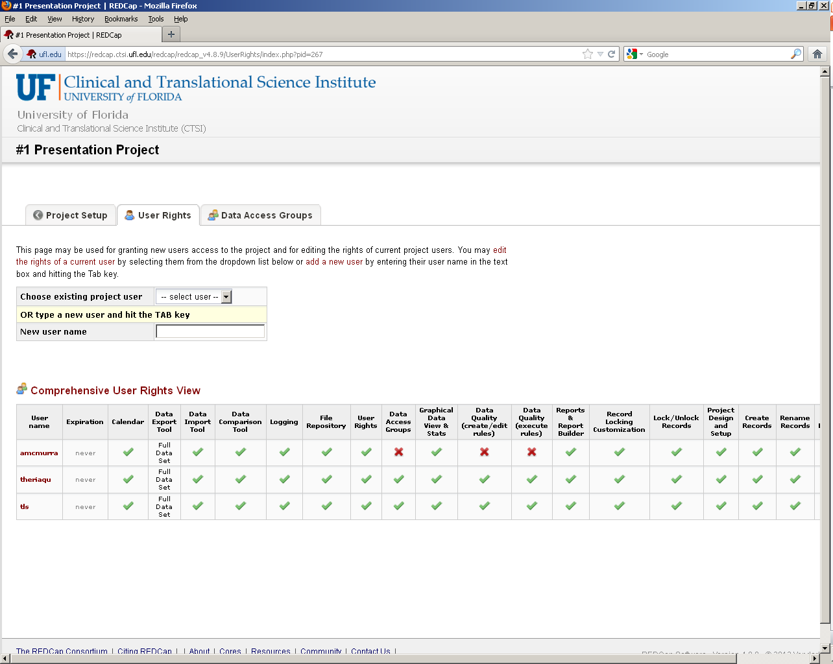

- Once you have entered in the new user’s Gatorlink user name and hit the Tab key, another screen will appear that lists all of the rights that are available (see below). Now you are ready to assign this user rights! The default settings for each new user are shown below.
Guide for Assigning Individuals Certain Rights (based on roles):
- You know your project best so think carefully about what permissions you want individuals to have. A guide is listed below, but again, you know your project best and any roles/premissions you decide to grant are up to you.

- Typically a clinical research project has individuals who preform different duties and will therefore have different roles, such as a PI, co-PI, project administer(s), study/project coordinator(s), those doing data entry, statistician(s), etc.
REDCap  Project Role | Invite Participants (for surveys only) | Calendar | Data Export Tool (select one) |  |  | Data Import Tool | Data Comparison Tool | Logging | File Repository | Data Access Group Name (if applicable) | Graphical Data View & Stats | Data Quality |  | Reports & Report Builder | Project Design and Setup | Record Locking Customization | Lock/Unlock Records |  | Database Records
 |  |  | No Access | De-Identified | Full Data Set |  |  |  |  |  |  | Create & Edit Rules | Execute Rules |  |  |  | Disabled | Locking / Unlocking | Create Records | Rename Records | Delete Records
Principal Investigator | x | x |  |  | x | x | x | x | x | x | x | x | x | x | x | x |  |  | x | x
Project Administrator | x | x |  |  | x | x | x | x | x | x | x | x | x | x | x | x |  |  | x | x | x
Project Coordinator | x | x |  | x |  | x |  |  | x |  |  |  |  |  |  | x |  |  | x
Data Coordinator | x | x |  | x |  | x | x | x |  |  |  | x | x |  | x |  | x |  | x
Statistician |  | x |  | x |  |  |  |  |  |  |  | x | x |  |  |  | x
Project Staff | x | x |  | x |  | x |  |  | x |  |  |  |  |  |  |  | x |  | x
Data Entry |  |  | x |  |  |  |  |  |  |  |  |  |  |  |  |  | x |  | x

Summary of Basic User Rights:
Calendar – Allows user to view calendar and schedule patients (internally only, not connected to EPIC) using the scheduling module and the Calendar Application.

Data Export Tool – Allows user to export data into Excel, SPSS, SAS, R and Stata.
No Access – No data exporting can be performed.
De-identified – Can only export data that is not classified as PHI in the project.
Full Data Set – All data can be exported, including PHI, from the project.

Data Import Tool – Allows user to import data into project using the data import template (Excel).
Logging – Allows user to view all project activity (which users have done what) under ‘Applications.’

File Repository – Allows user to view and open the files that are stored in the file repository under ‘Applications.’

User Rights – Allows user to assign and change user rights for all those assigned to the project, including themselves.

Data Access Groups – For multi-site studies, only users within a given Data Access Group can access records created by users within that group.

Graphical Data View & Stats – Allows user to view all project data in aggregate graphical format and as descriptive statistics.

Data Quality - Allows user to execute data quality rules upon project data to check for discrepancies in the data, such as missing values, field validation errors, and outliers.

Reports & Report Builder – Allows user to build and save custom reports, which will query the project in real time and display the resulting data in a table format.

Project Design and Setup – Allows user to change the set up and design of the project, such as creating events, making the project longitudinal, adding a survey, or renaming the project.

API* – An interface that allows external applications to connect to REDCap remotely, and is used for programmatically retrieving or modifying data or settings.
*This function is not currently working in REDCap.

Record Locking Customization – Allows user to have access to the Record Locking Customization Application, used for customizing the Record Locking option and E-signature option on data collection instruments.

Lock/Unlock Records – Allows user to lock (and unlock) individual records so they cannot be altered.
Disabled – User cannot lock or unlock records
Locking/Unlocking – User can lock and unlock records
Locking/Unlocking with E-Signature Authority** - User can lock and unlock records a gives them e-signature privileges to apply an e-signature to forms.
**This function is not currently working in REDCap
Allow locking of all forms at once for a given record – Allows user to lock all records across the project for an individual subject.

Create Records – Allows user to create new records and add new subjects to project.

Rename Records – Allows user to rename records, such as assigning a subject a new Study ID number.

Delete Records – Allows users to delete subjects from the project.

Expiration Date – Gives user access up until a specified date. Used mostly for temporary employees, such as students performing data entry.

Data Entry Rights:
- The Data Entry Rights section allows you to control access to individual
forms.
- The default setting is that all new users will have access to view and edit
every form in the project but this can be changed by selecting either “No
Access” or “Read Only” for each form.
No Access – User cannot view or edit the form at all.
Read Only – User can view the form but cannot change or add data
to the form.
Examples for using this application:
- If you do not want the PI to be able to see PHI that is located on the
Demographics form when they access the project, do not give them access
to this form (“no access”).
- If you have someone who will only be entering in laboratory data, only give
that person access to that particular form (“view and edit”).

To View What Rights an Assigned User Already Has:
- Go to “User Rights” under ‘Applications’ (as described on page 1)
- Once there, a list of users on the project and their permissions are shown in a table format (see example below).
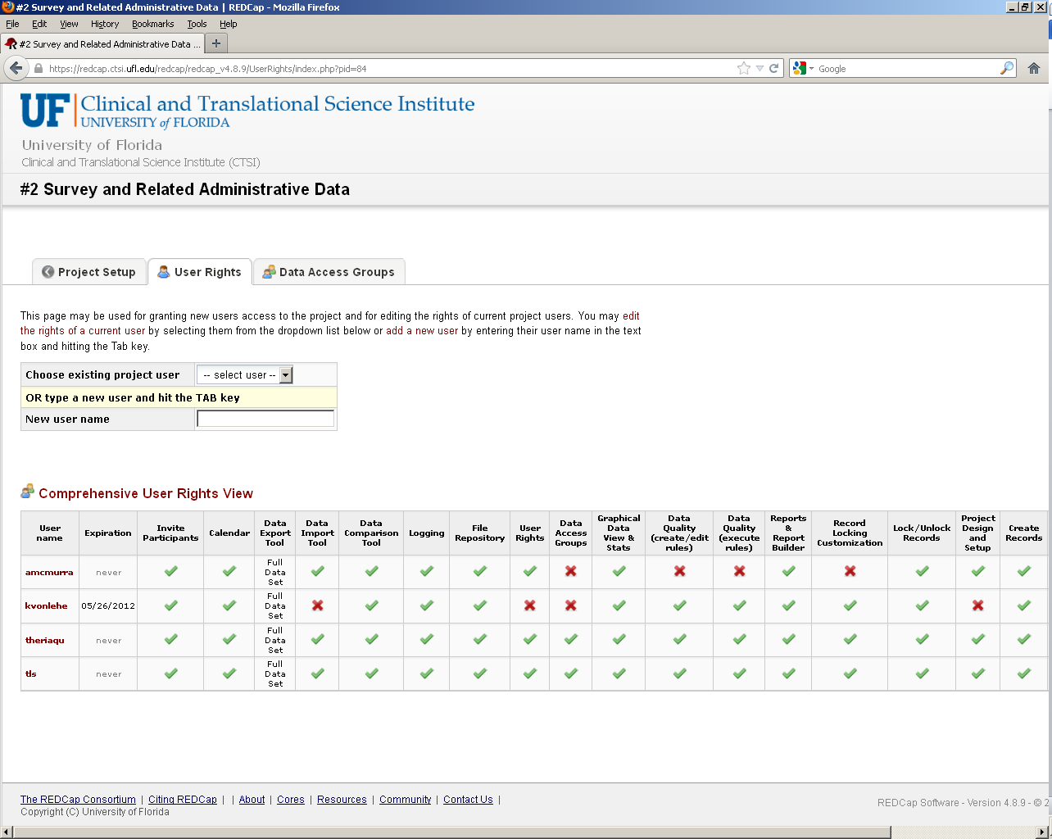

To Change an Exisitng User’s Rights:
- Click on the user’s name or use the scroll down menu next to “Choose existing project user” and select the user you want to change the rights for. This will take you to the list of user rights that are avialable.
- You can now check or uncheck the permissions you want to change for that user.
- Click on “Save Changes” once you are finished (see right).
To delete a user so they no longer have access to the project, click on the user’s name and then click on “Delete User” (see right) and hit “OK” when the dialogue box appears asking if you’re sure you want to delete this user.
or
- If you have students or other non-permanent employees who are going to be entering data, you may want to enter in an “expiration date” so there access to the project runs out when they leave (see below).
OR
- Expiration dates are entered in the format of: yyyy-mm-dd.
- Once you have saved the changes, this expiration date will appear under the “Expiration” column in the user right’s table (see next page).

Trouble Shooting:
If a user cannot access a project, it’s most likely one of these items listed below is the issue:
- Has the user registered for a REDCap account at: afagan@hsph.harvard.edu
- Has the user been added to the project?
- Was the user’s user name correctly entered into the “Add a New User” field? - see ‘Steps for Creating a New User’ section above for further details.
- Was the user added to the correct project?
- Was the user given an expiration date for project access that’s expired?
If this does not solve the problem, please contact the REDCap Admin at: afagan@hsph.harvard.edu

