Welcome Adam Haber
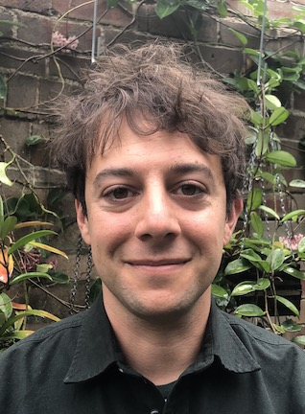
Dr. Adam Haber joins the MIPS faculty from the Broad Institute of MIT and Harvard where he was a postdoctoral associate. He received a BS in applied mathematics and nanoscience, and took honors in physics from the University of Sydney, Australia. He then completed his Ph.D. in computer science at the University of New South Wales, Australia. He was a research assistant at the Yale School of Public Health before coming to the Broad Institute.
Dr. Haber’s research applies and develops novel computational methods to analyze high-dimensional data, particularly single-cell RNA-sequencing. His research focuses on the role of airway epithelial cells in the pathogenesis and maintenance of asthma in response to environmental exposures to triggers such as air pollution and allergens. His work has uncovered two previously unknown subtypes of tuft cells present in both mouse airway and small intestine, and led to the first extensive single-cell characterization of the small intestinal epithelium in mice. Dr. Haber’s study of the airway epithelium also identified the pulmonary ionocyte, a new cell type that will have implications for understanding the regulation of mucus secretion and its role in asthma and cystic fibrosis. As a graduate student, Dr. Haber worked on cognitive software architectures to guide and control autonomous rescue robots. He plans to use machine learning approaches to extract insights from population-level observations regarding indoor environmental exposures in asthma initiation and exacerbations. Dr. Haber received an Australian Postgraduate Award and a University of New South Wales Research Excellence Award.

