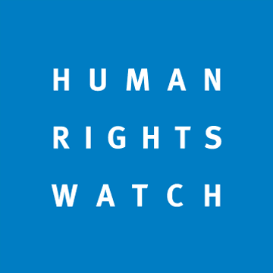
SEPTEMBER 21, 2017 9:55PM EDT

India: Key UN Rights Recommendations Ignored
Act on Concerns Raised at Universal Periodic Review
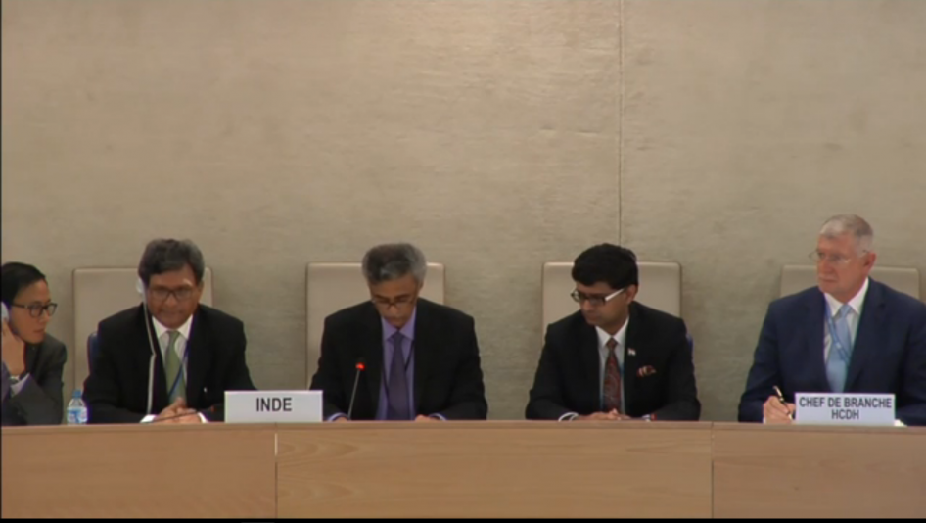
The Indian Delegation at the third Universal Period Review in Geneva, September 21, 2017.
© 2017 UN
(Geneva, September 22, 2017) – The Indian government did not accept a number of key human rights recommendations on September 21, 2017, at its United Nations review in Geneva, Human Rights Watch said today. The government should promptly act on the recommendations raised by UN member countries during the UN Human Rights Council’s Universal Periodic Review (UPR) process.
India’s government responded on September 21 to the recommendations made by other UN member countries on May 4 during India’s third periodic review. The Indian government was unwilling to accept important recommendations for greater accountability of its security forces, ensuring freedom of expression and peaceful assembly, repealing the law criminalizing consensual adult same-sex relations, and abolishing the death penalty.
“In the face of countless attacks on free speech and threats to marginalized communities, the Indian government has chosen to be in denial,” said Meenakshi Ganguly, South Asia director at Human Rights Watch. “India should show leadership on the world stage by taking the human rights concerns of other countries seriously and adopting concrete steps to address them.”
At the May 4 session, 112 countries made a total of 250 recommendations. On September 21, the government accepted 152, including commitments made toward sustainable development goals aimed at alleviating poverty, improving access to safe drinking water and sanitation, and strengthening protections for children and women.
In the face of countless attacks on free speech and threats to marginalized communities, the Indian government has chosen to be in denial.

Meenakshi Ganguly
South Asia Director
Thirty countries called on India to ratify the UN Convention Against Torture, a treaty it signed two decades ago but never ratified. Even as the Indian government denied the existence of torture at the May meeting, saying “the concept of torture is completely alien to our culture and it has no place in the governance of the nation,” it said it remained committed to ratifying the treaty. However, India made a similar commitment at the last UPR cycle in 2012 when the recommendation was made by 17 countries, and yet failed to take any steps to fulfill it. In a recent report on deaths in police custody, Human Rights Watch found that torture is frequently used to gather information or coerce confessions.
At the UPR outcome meeting, India’s National Human Rights Commission pointed to the country’s failure to implement several recommendations adopted in the previous UPR cycle.
Regarding several pressing human rights concerns, the government’s outcome report merely “noted” the recommendations, drawing criticism from several countries and domestic and international rights groups. In the past, the Indian government has consistently ignored recommendations that it only noted. For instance, concerns over the Armed Forces Special Powers Act (AFSPA), a law that provides soldiers who commit abuses effective immunity from prosecution, was also “noted” in previous UPR sessions. But the government has refused to repeal the law despite recommendations from numerous independent commissions in India.
Similarly, at the 2012 review, the government said it noted the concerns raised over the Foreign Contribution Regulation Act (FCRA), a law regulating foreign funding to nongovernmental organizations, but failed to take any action to address it. Instead, since 2014, the Indian government has increasingly used the law to harass, intimidate, and shut down foreign funding for nongovernmental organizations that criticize the government, its actions, or policies. During this UPR, at least 10 countries raised concerns over restrictions to freedom of assembly and association, including the FCRA, but the Indian government merely “noted” the recommendations.
Mob attacks by extremist Hindu groups affiliated with the ruling Bharatiya Janata Party (BJP) against minority communities, especially Muslims and Dalits, have become a serious threat. In the first seven months of 2017, there were 26 attacks, and seven people were killed over rumors that they sold, bought, or killed cows for beef. The government has failed to prosecute those responsible for such attacks, and at the same time several BJP leaders have made incendiary remarks against minorities, and in support of Hindu nationalism. Fifteen countries raised concerns over such increasing violence, recommending that India should better protect these vulnerable populations and freedom of religion, and prosecute attacks against them. However, the Indian government was unwilling to make any commitments.
More than 30 countries raised concerns over violence and discrimination against women, and 10 asked India to criminalize marital rape. The Indian government accepted recommendations to protect women from violence, but did not accept recommendations regarding marital rape.
Several countries also called on India to repeal section 377 of the penal code, which criminalizes consensual same-sex relations, and to end discrimination against lesbian, gay, bisexual, and transgender people, a recommendation made and only noted in 2012 and again during the 2017 review. This is despite an Indian Supreme Court ruling in August saying the law had a chilling effect on “the unhindered fulfilment of one’s sexual orientation, as an element of privacy and dignity.”
“The Indian government’s claims of respect for the UPR process mean nothing if it simply brushes aside important recommendations at a time when the country’s long cherished freedoms and its poor and vulnerable are at great risk,” Ganguly said.
Source URL: https://www.hrw.org/news/2017/09/21/india-key-un-rights-recommendations-ignored
Links
[1] https://www.hrw.org/view-mode/modal/309301
[2] https://www.hrw.org/india
[3] https://www.hrw.org/news/2017/05/01/submission-human-rights-watch-universal-periodic-review-india
[4] https://www.hrw.org/about/people/meenakshi-ganguly
[5] https://documents-dds-ny.un.org/doc/UNDOC/GEN/G17/193/56/PDF/G1719356.pdf?OpenElement
[6] https://www.hrw.org/report/2016/12/19/bound-brotherhood/indias-failure-end-killings-police-custody
[7] https://www.hrw.org/news/2014/08/24/india-replace-afspa-better-rights-respecting-law
[8] https://www.hrw.org/news/2016/11/08/india-foreign-funding-law-used-harass-25-groups
[9] https://www.hrw.org/news/2017/04/27/india-cow-protection-spurs-vigilante-violence
[10] http://www.indiaspend.com/cover-story/26-cases-of-cow-related-violence-in-7-months-of-2017-equalling-2016-as-worst-year-21119
[11] https://www.hrw.org/news/2016/01/19/indian-govt-should-repeal-section-377-more-lives-are-lost
[12] https://www.hrw.org/news/2017/08/24/indias-supreme-court-upholds-right-privacy
[13] https://twitter.com/intent/tweet?text=India%3A%20Key%20UN%20Rights%20Recommendations%20Ignored%20https%3A//www.hrw.org/news/2017/09/21/india-key-un-rights-recommendations-ignored
[14] https://www.facebook.com/sharer.php?u=https%3A//www.hrw.org/news/2017/09/21/india-key-un-rights-recommendations-ignored
[15] whatsapp://send?text=India%3A%20Key%20UN%20Rights%20Recommendations%20Ignored%20-%20https%3A//www.hrw.org/news/2017/09/21/india-key-un-rights-recommendations-ignored
[16] mailto:?subject=India%3A%20Key%20UN%20Rights%20Recommendations%20Ignored&amp;body=https%3A//www.hrw.org/news/2017/09/21/india-key-un-rights-recommendations-ignored
[17] http://www.linkedin.com/shareArticle?mini=true&amp;url=https%3A//www.hrw.org/news/2017/09/21/india-key-un-rights-recommendations-ignored&amp;title=India%3A%20Key%20UN%20Rights%20Recommendations%20Ignored
[18] https://plus.google.com/share?url=https%3A//www.hrw.org/news/2017/09/21/india-key-un-rights-recommendations-ignored
[19] http://reddit.com/submit?url=https://www.hrw.org/news/2017/09/21/india-key-un-rights-recommendations-ignored&amp;title=India: Key UN Rights Recommendations Ignored
[20] https://telegram.me/share/url?url=https://www.hrw.org/news/2017/09/21/india-key-un-rights-recommendations-ignored&amp;text=India: Key UN Rights Recommendations Ignored

