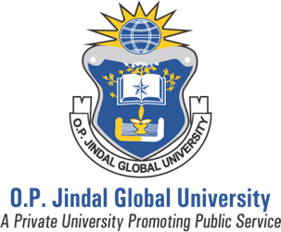
Summer School on Human Rights and
Development
2019

Reading Assignments for Understanding Human Rights
(Wednesday, July 3, 2019)

Prof. M. Adrian

1. The Case of S.A.S v France

- Read paragraphs 10-14
- Skim: paragraphs 15-52
- Read: paragraphs 53-61
- Skim: paragraphs 62-68
- Read: paragraphs 69-85
- Read (very carefully): paragraphs 106-159

2. On the European Court of Human Rights

Please read the following short pieces on the European Court of Human Rights:

The ECHR in brief

ECHR Q&A

The ECHR in 50 Questions

Simplified ECHR and protocols

The ECHR in facts and figures

