Supplementary Figure Legends:
Supplementary W-S1. Scatter plot of LCL and PBL of sample 10 to 39
Supplementary W-S2. Scatter plot of PBL, Artery and Atrium of sample 10 to 14
Supplementary W-S3. Scatter plot of PBL - LCL of sample 10 to 39
Supplementary W-S4. Scatter plot of Artery - PBL, Atrium - PBL and Atrium - Artery of sample 10 to 14
Supplementary W-S5. Scatter plot of LCL, PBL and predicted PBL (LM, SVM) of sample 10 to 39
Supplementary W-S6. Scatter plot of PBL, Artery and predicted Artery (LM, SVM) of sample 10 to 14
Supplementary W-S7. Scatter plot of PBL, Atrium and predicted Atrium (LM, SVM) of sample 10 to 14
Supplementary W-S8. Scatter plot of PBL, Artery and predicted Artery (LM, SVM) of sample 10 to 14
Supplementary W-S9. Scatter plot of PBL, Atrium and predicted Atrium (LM, SVM) of sample 10 to 14
Supplementary W-S10. Scatter plot of LCL, PBL and predicted PBL (LM, SVM) of sample 10 to 39

Supplementary W-S1-1. Scatter plot of LCL and PBL of sample 10 to 18

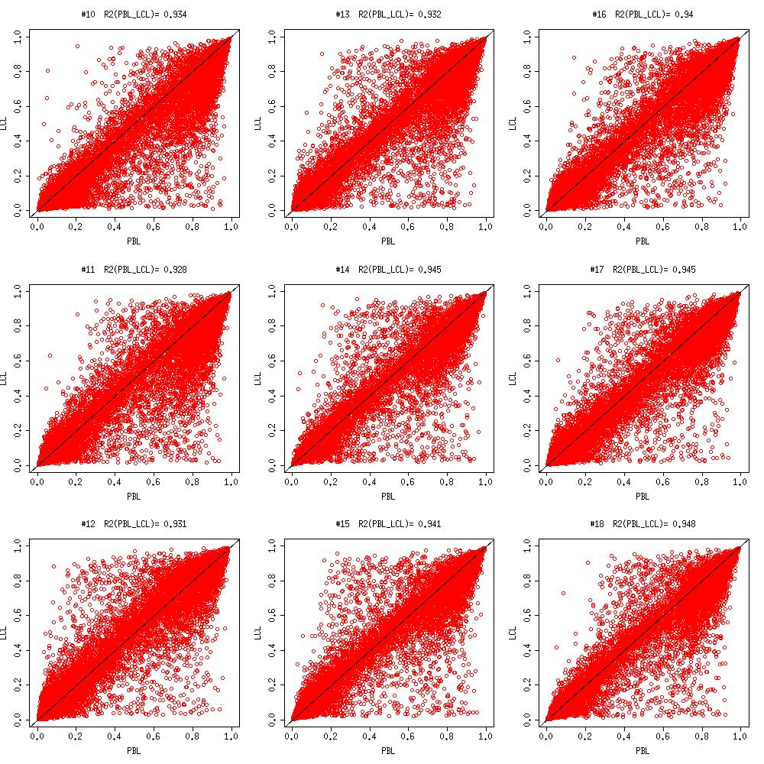

Supplementary W-S1-2. Scatter plot of LCL and PBL of sample 19 to 27

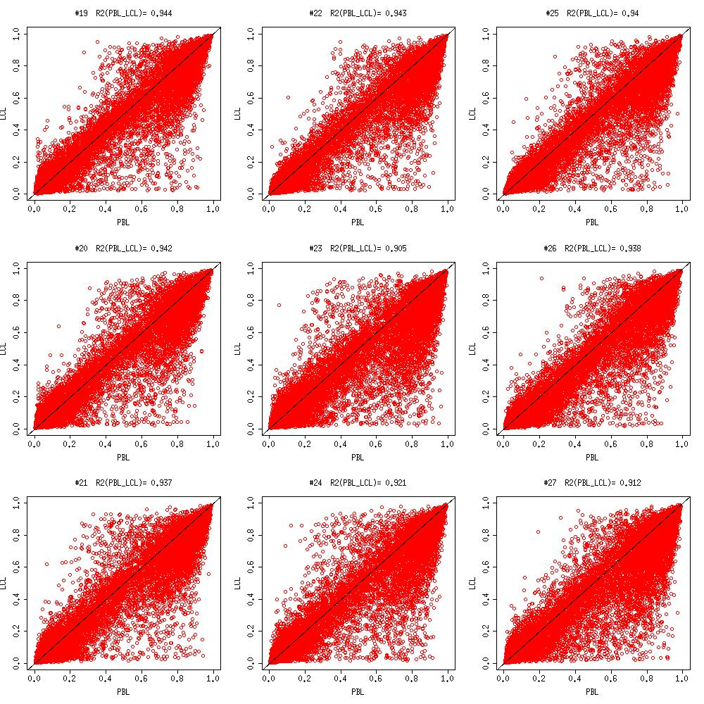

Supplementary W-S1-3. Scatter plot of LCL and PBL of sample 28 to 36

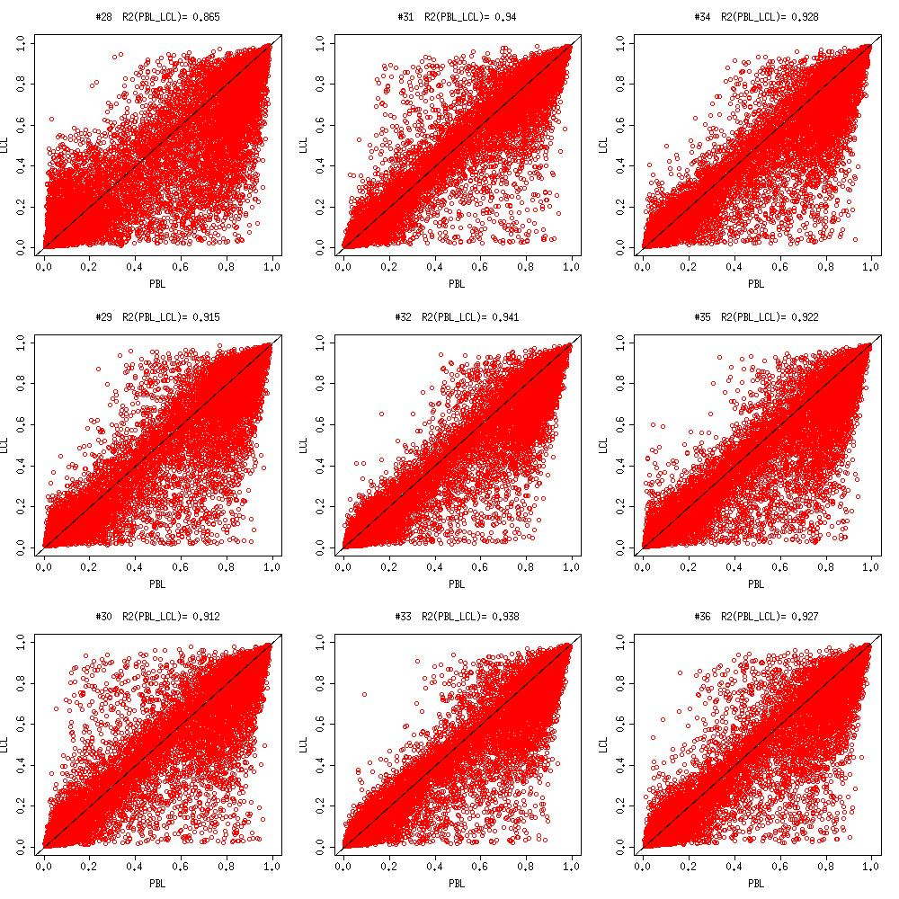

Supplementary W-S1-4. Scatter plot of LCL and PBL of sample 37 to 39

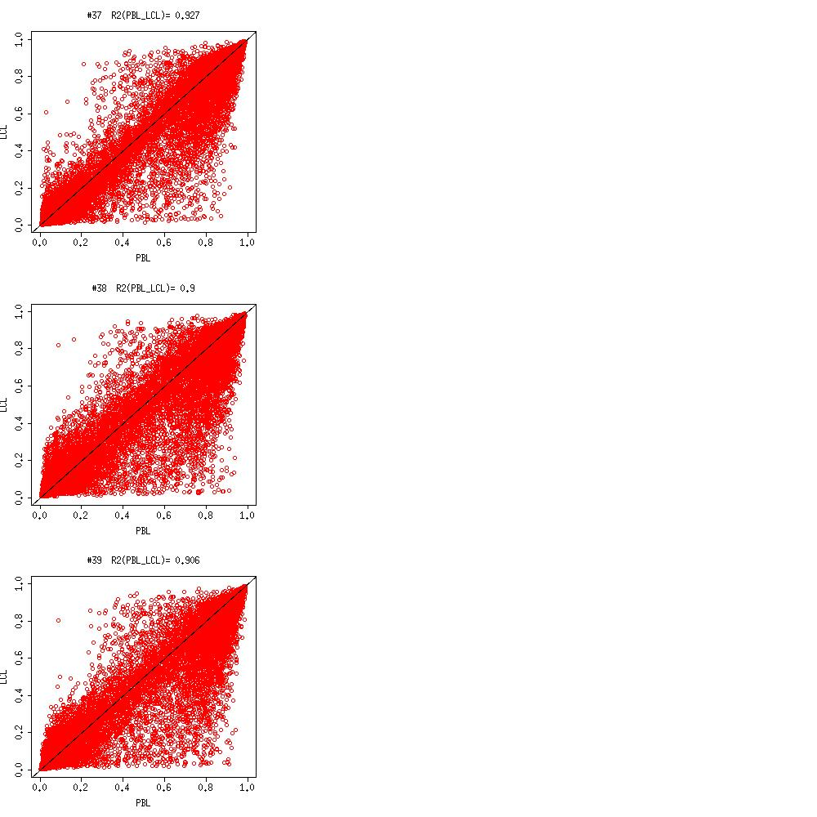

Supplementary W-S2a. Scatter plot of PBL and Artery of sample 10 to 14

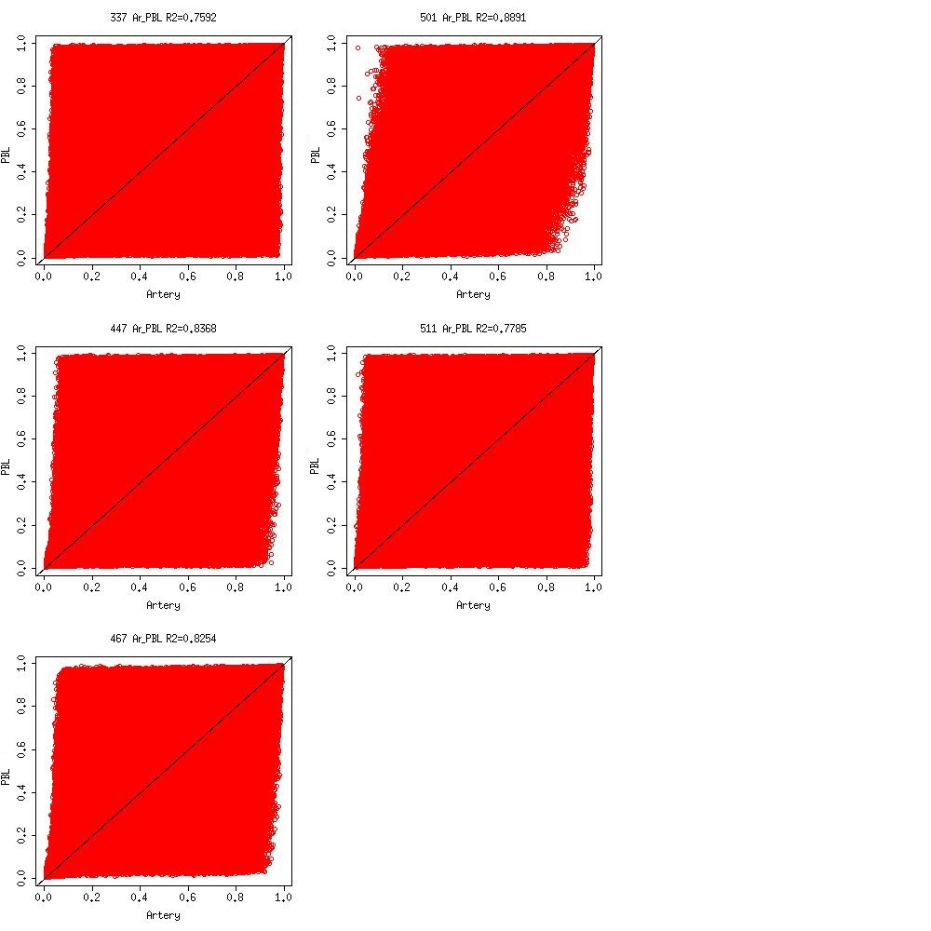

Supplementary W-S2b. Scatter plot of PBL and Atrium of sample 10 to 14

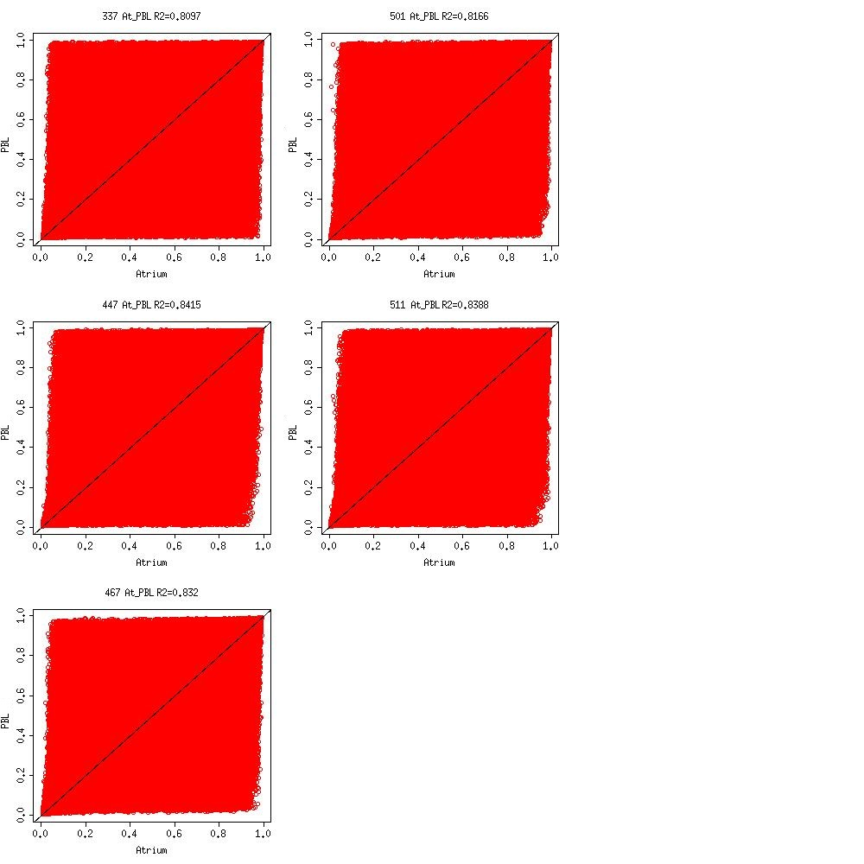

Supplementary W-S2c. Scatter plot of Atrium and Artery of sample 10 to 14

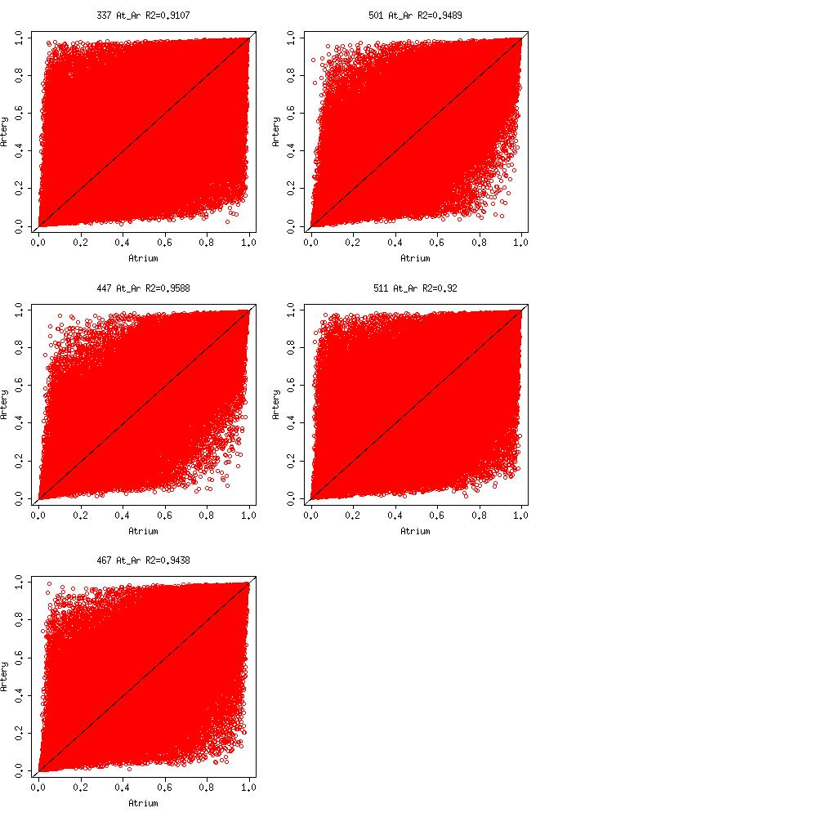

Supplementary W-S3-1. Scatter plot of PBL - LCL of sample 10 to 18

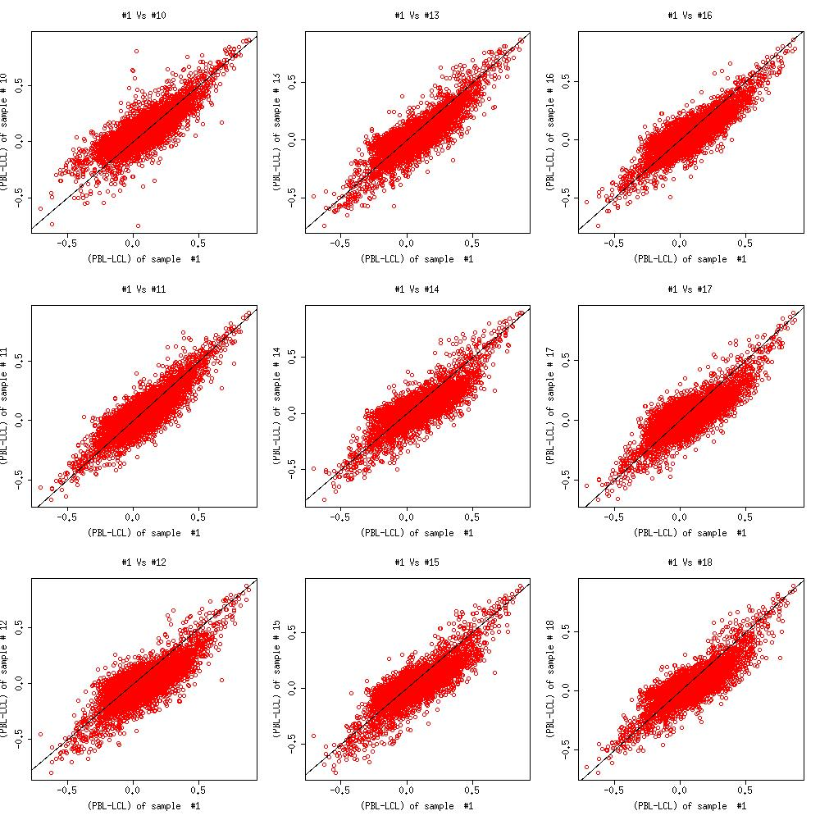

Supplementary W-S3-2. Scatter plot of PBL - LCL of sample 19 to 27

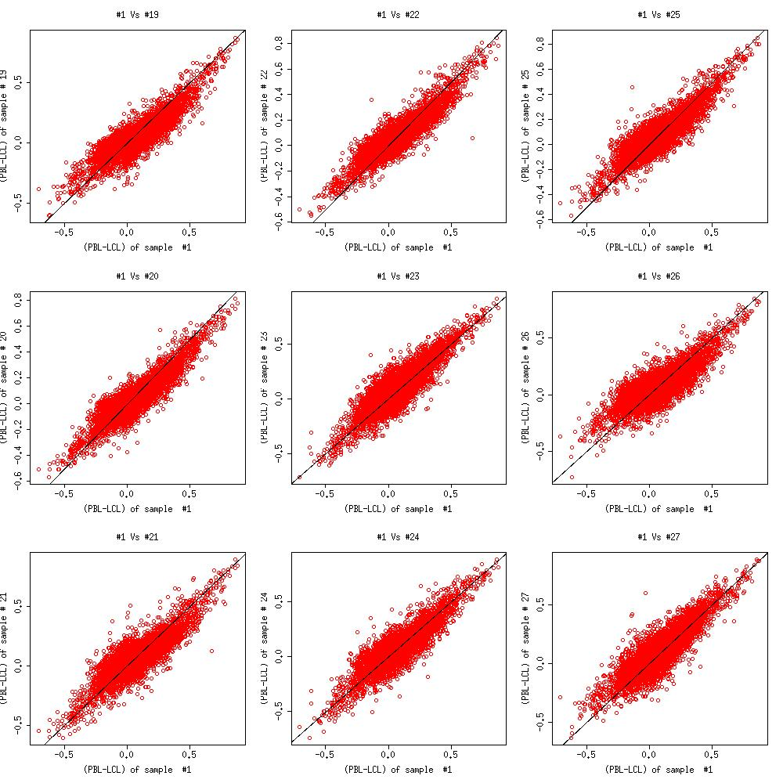

Supplementary W-S3-3. Scatter plot of PBL - LCL of sample 28 to 36

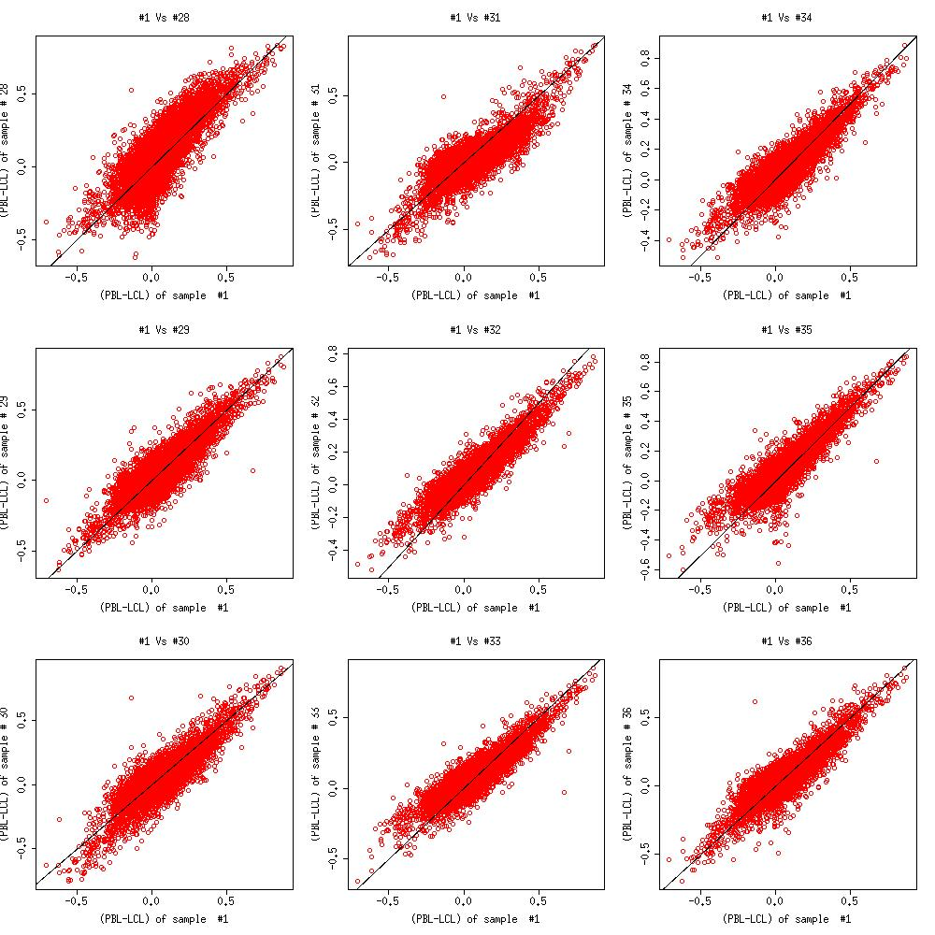

Supplementary W-S3-4. Scatter plot of PBL - LCL of sample 37 to 39

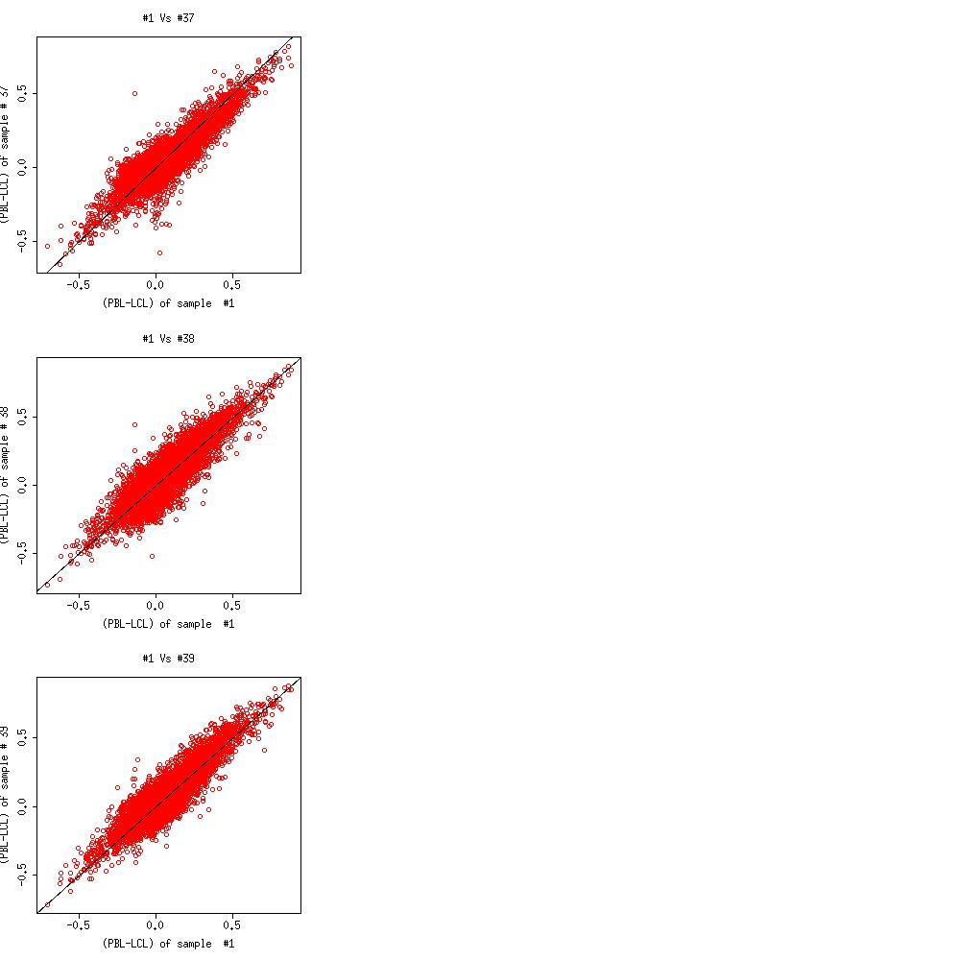

Supplementary W-S4a. Scatter plot of Artery - PBL of sample 10 to 14

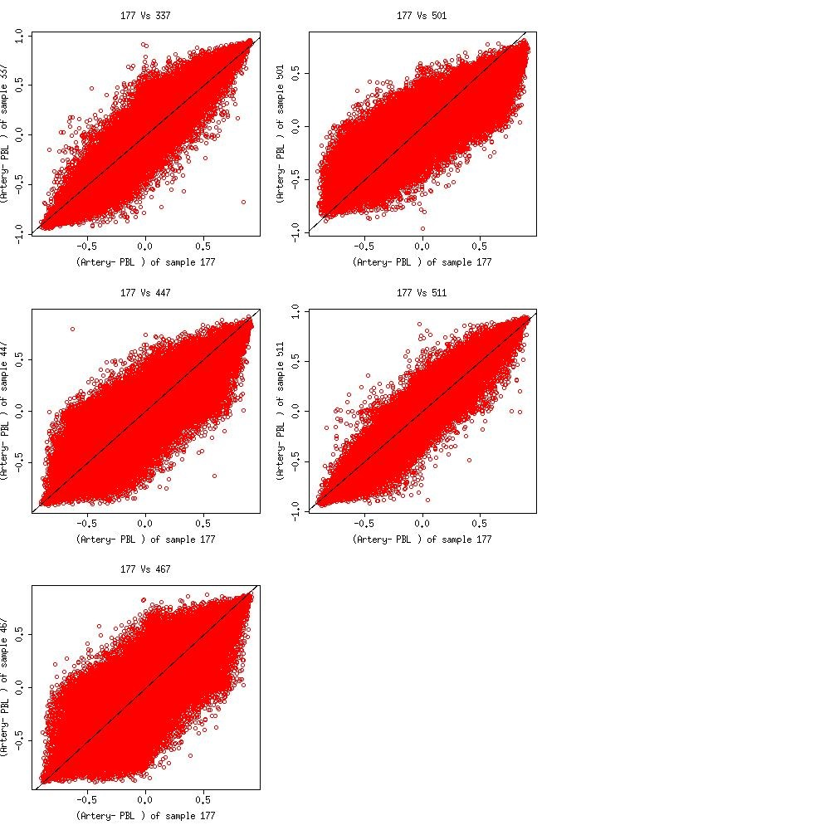

Supplementary W-S4b. Scatter plot of Atrium - PBL of sample 10 to 14

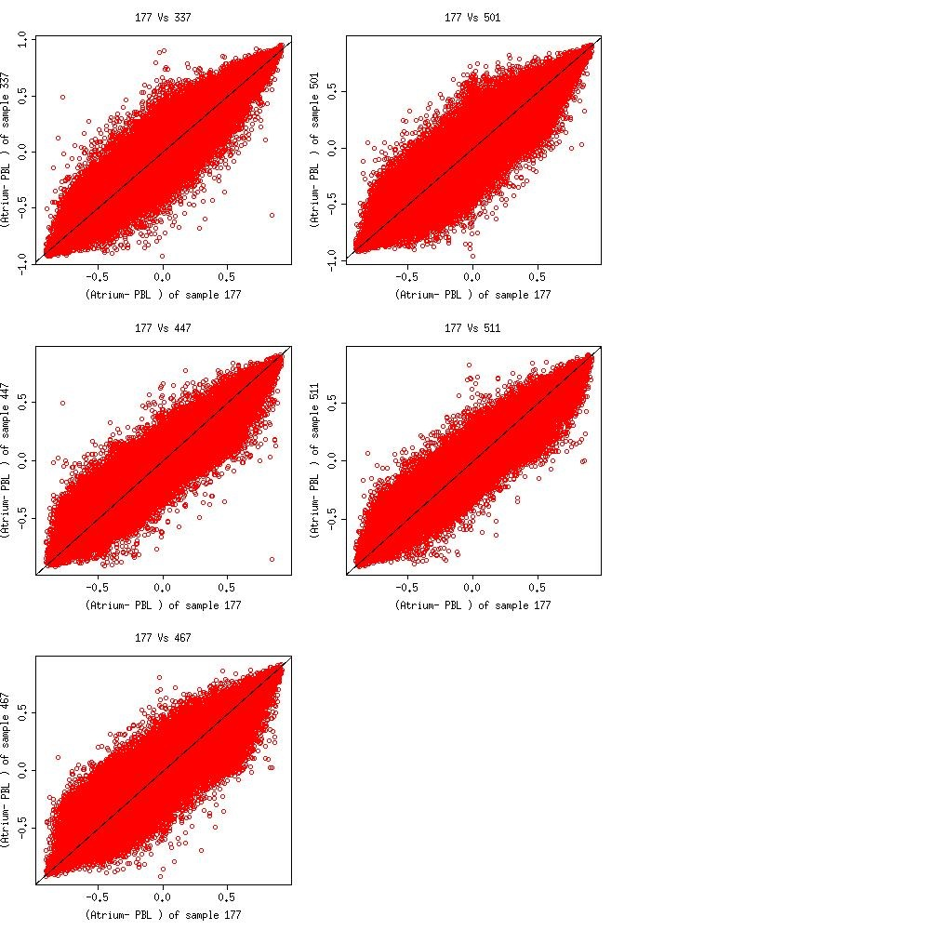

Supplementary W-S4c. Scatter plot of Atrium - Artery of sample 10 to 14

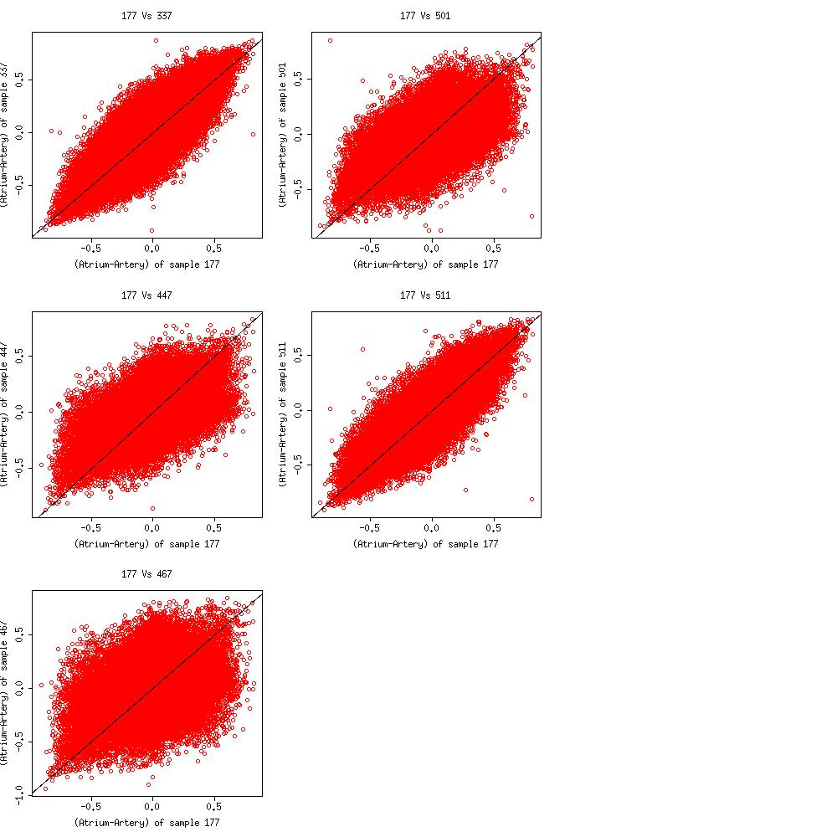

Supplementary W-S5a-1. Scatter plot of LCL, PBL and predicted PBL (LM) of sample 10 to 18

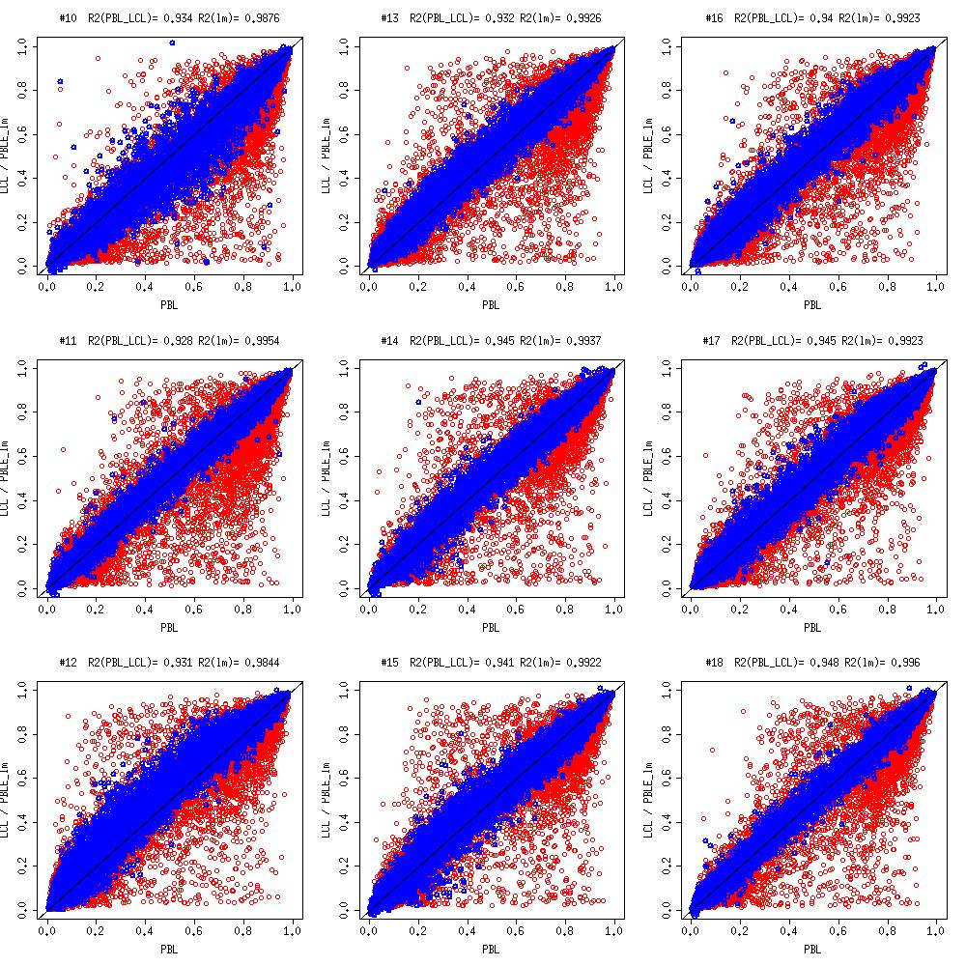

Supplementary W-S5a-2. Scatter plot of LCL, PBL and predicted PBL (LM) of sample 19 to 27

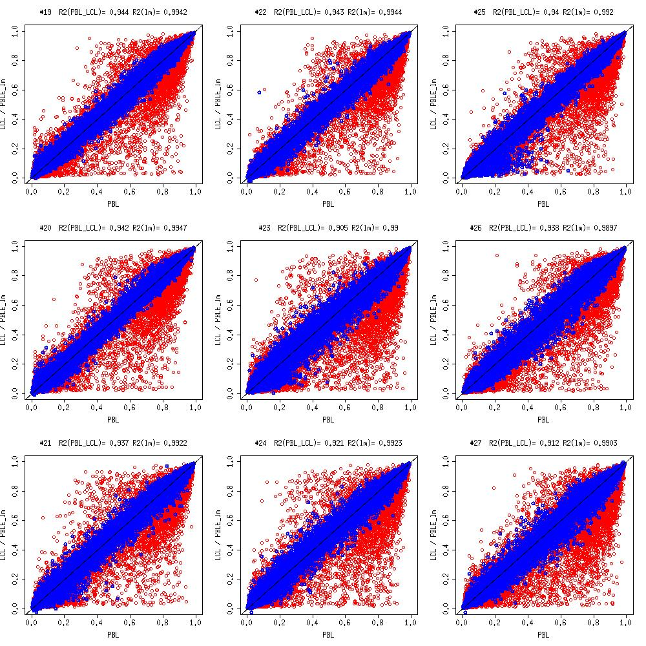

Supplementary W-S5a-3. Scatter plot of LCL, PBL and predicted PBL (LM) of sample 28 to 36

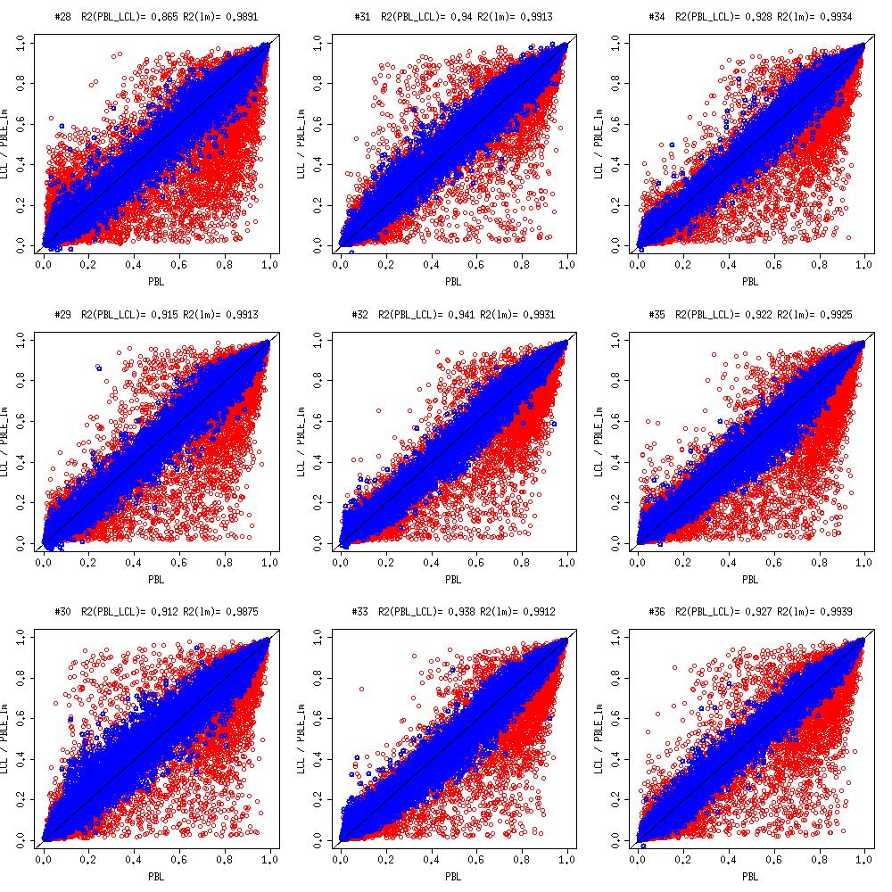

Supplementary W-S5a-4. Scatter plot of LCL, PBL and predicted PBL (LM) of sample 37 to 39

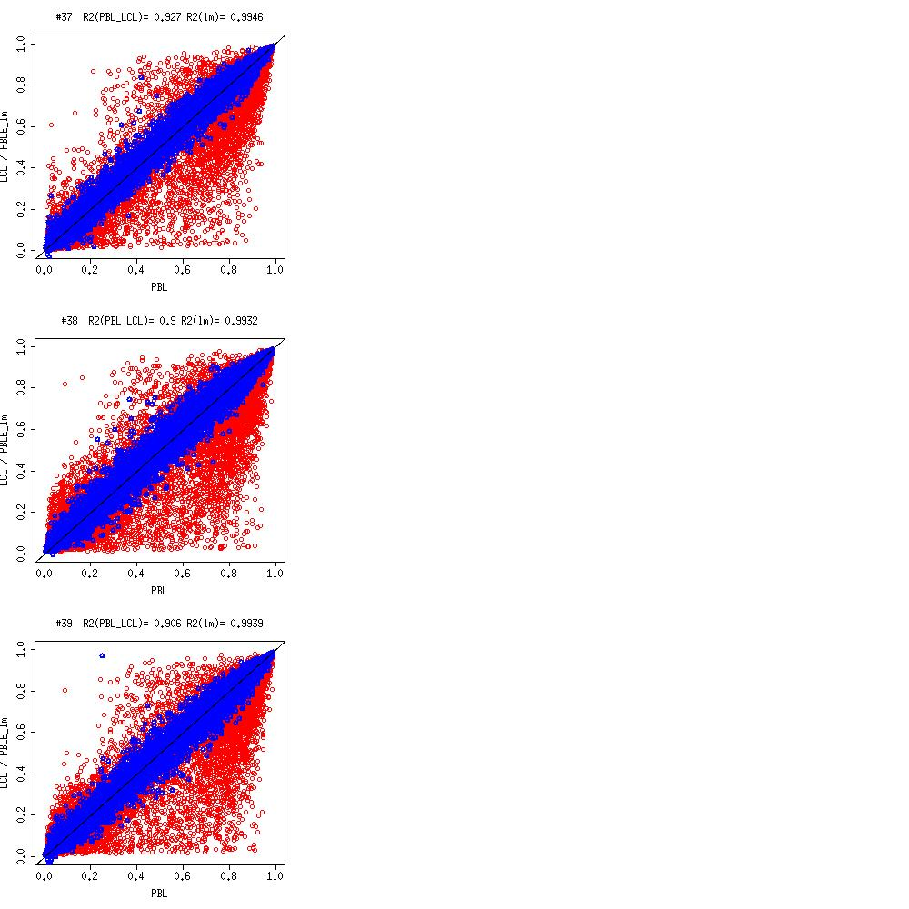

Supplementary W-S5b-1. Scatter plot of LCL, PBL and predicted PBL (LM, SVM) of sample 10 to 18

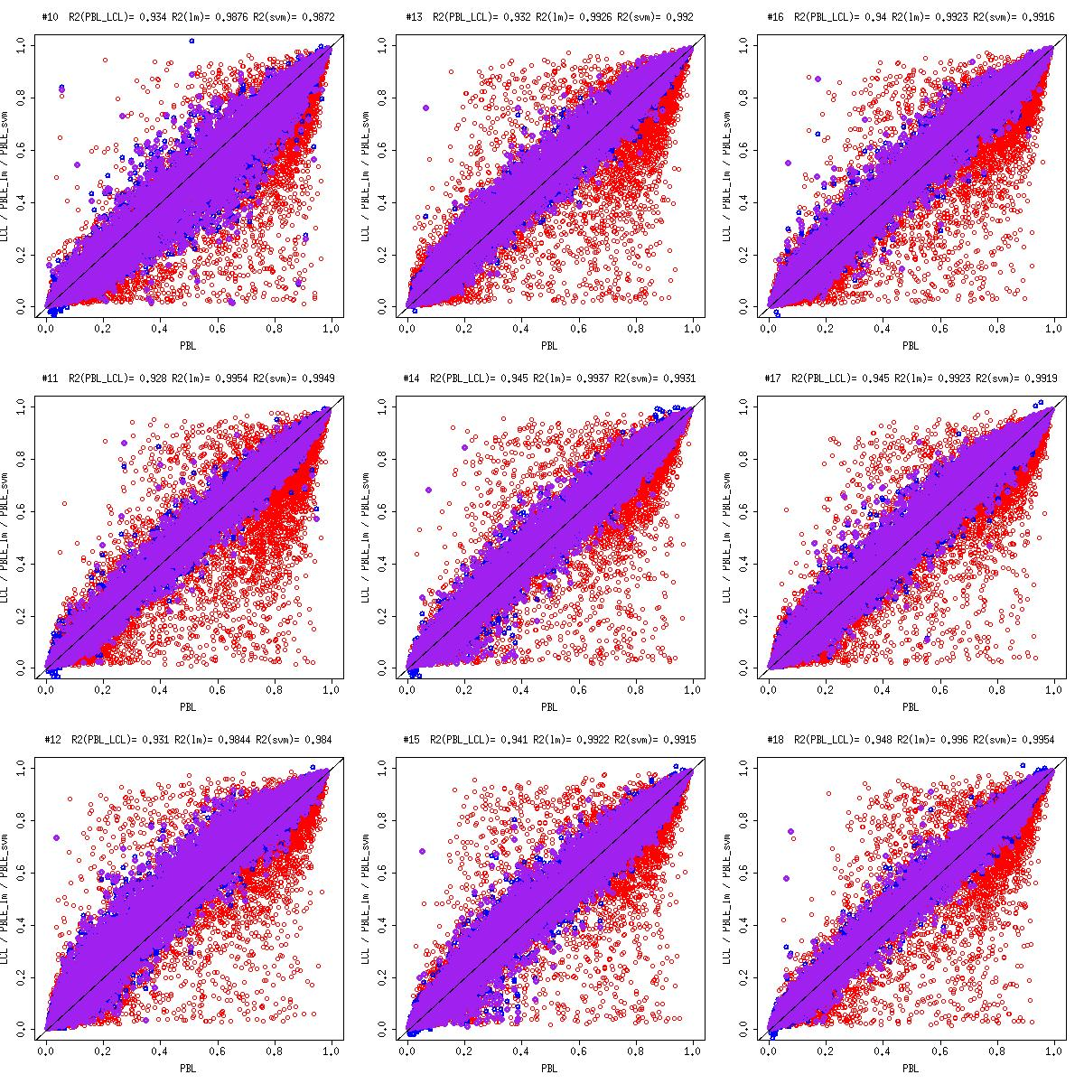

Supplementary W-S5b-2. Scatter plot of LCL, PBL and predicted PBL (LM, SVM) of sample 19 to 27

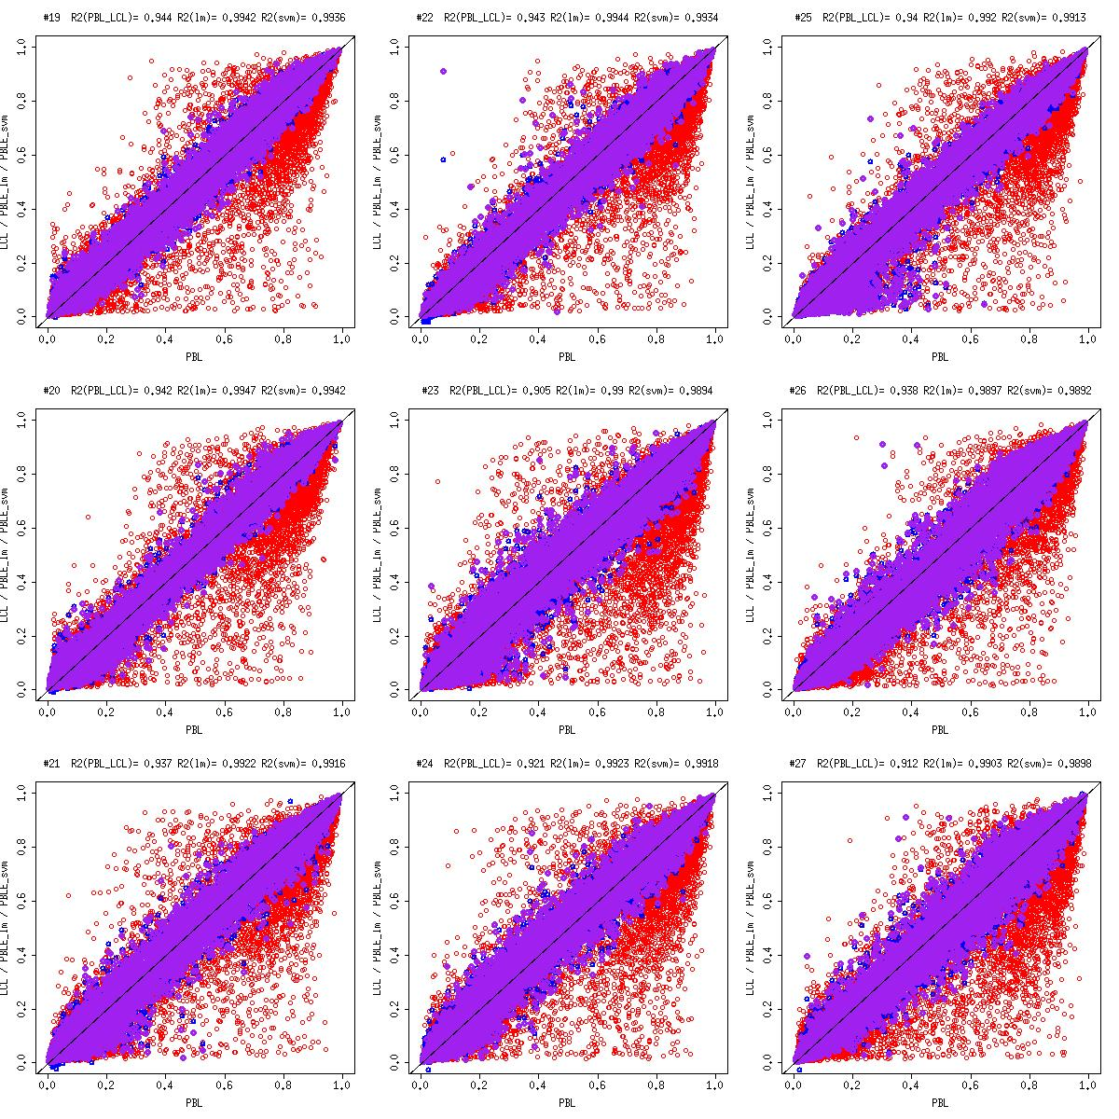

Supplementary W-S5b-3. Scatter plot of LCL, PBL and predicted PBL (LM, SVM) of sample 28 to 36

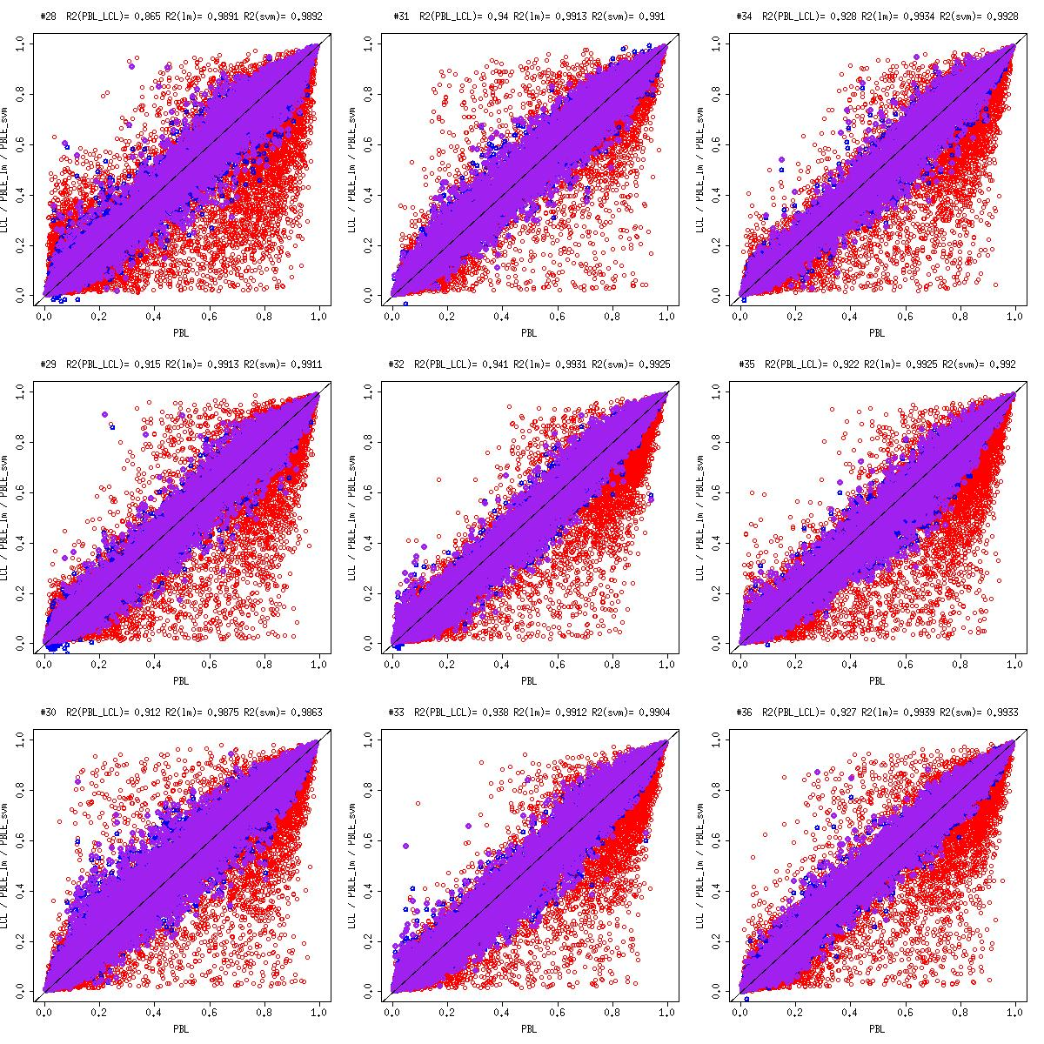

Supplementary W-S5b-4. Scatter plot of LCL, PBL and predicted PBL (LM, SVM) of sample 37 to 39

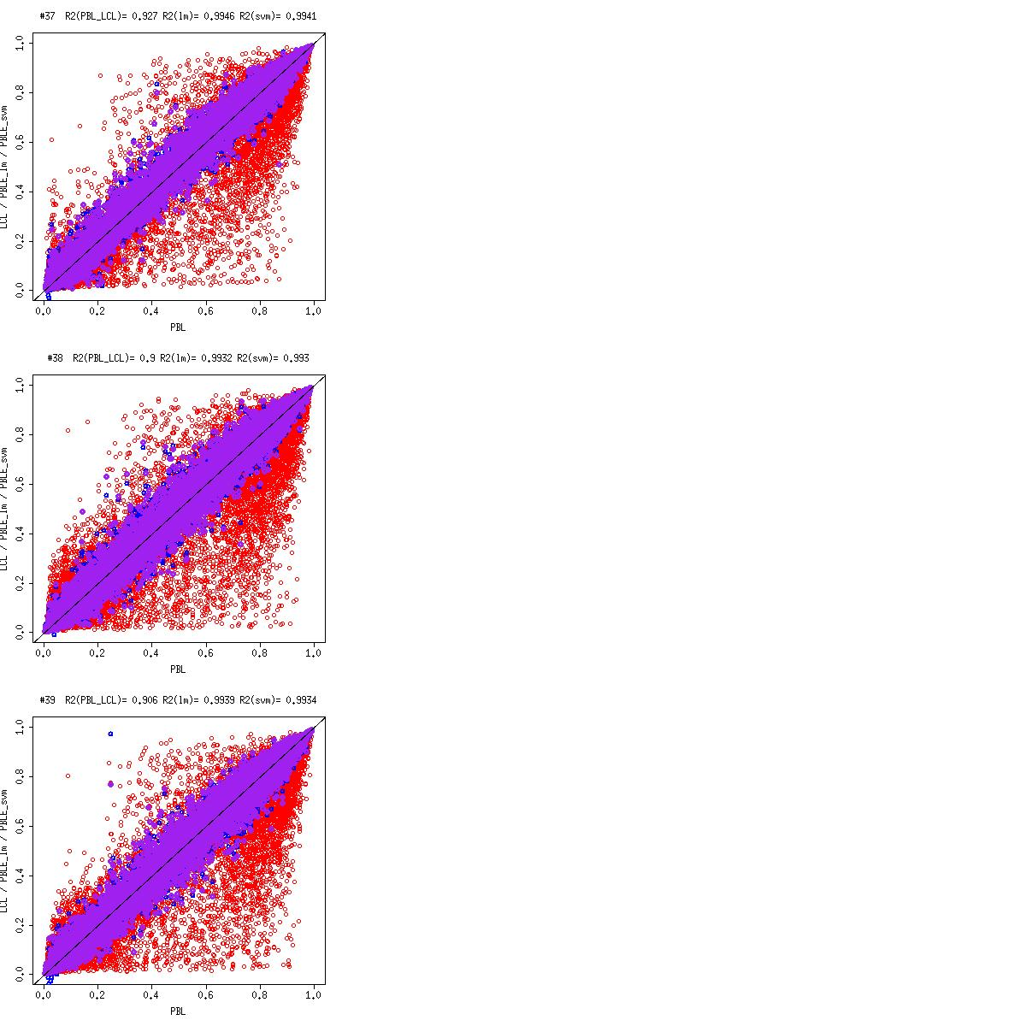

Supplementary W-S5c-1. Scatter plot of PBL - LCL, PBL - predicted PBL (LM) of sample 10 to 18
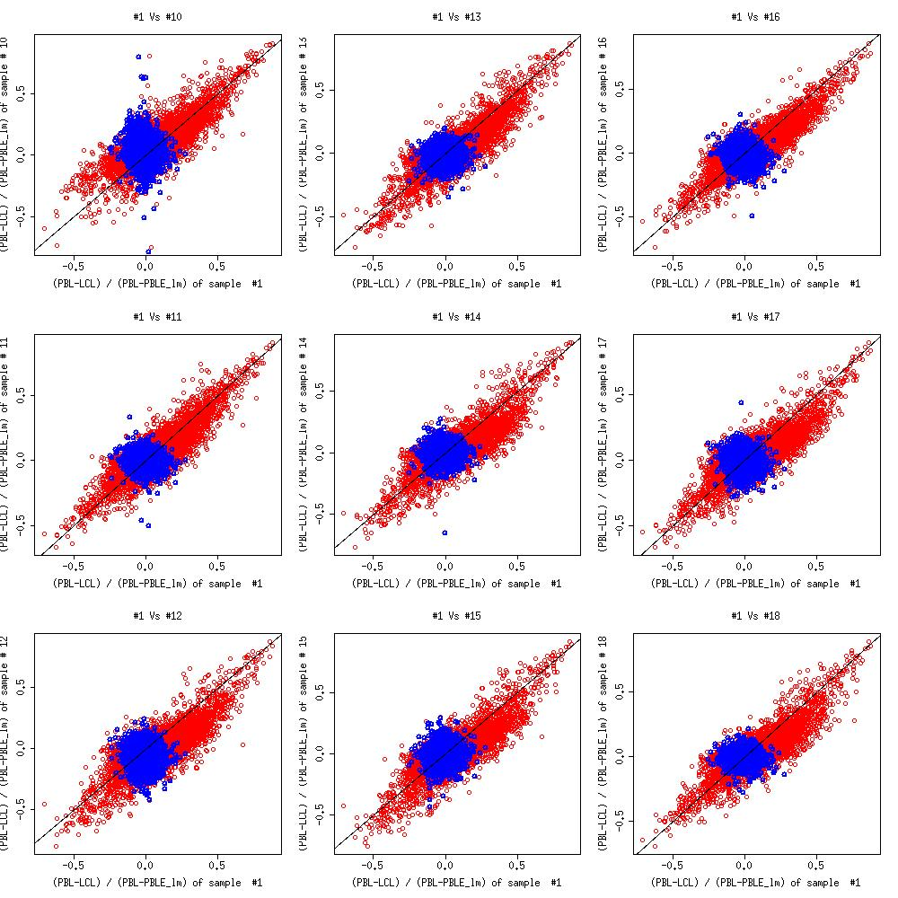

Supplementary W-S5c-2. Scatter plot of PBL - LCL, PBL - predicted PBL (LM) of sample 19 to 27

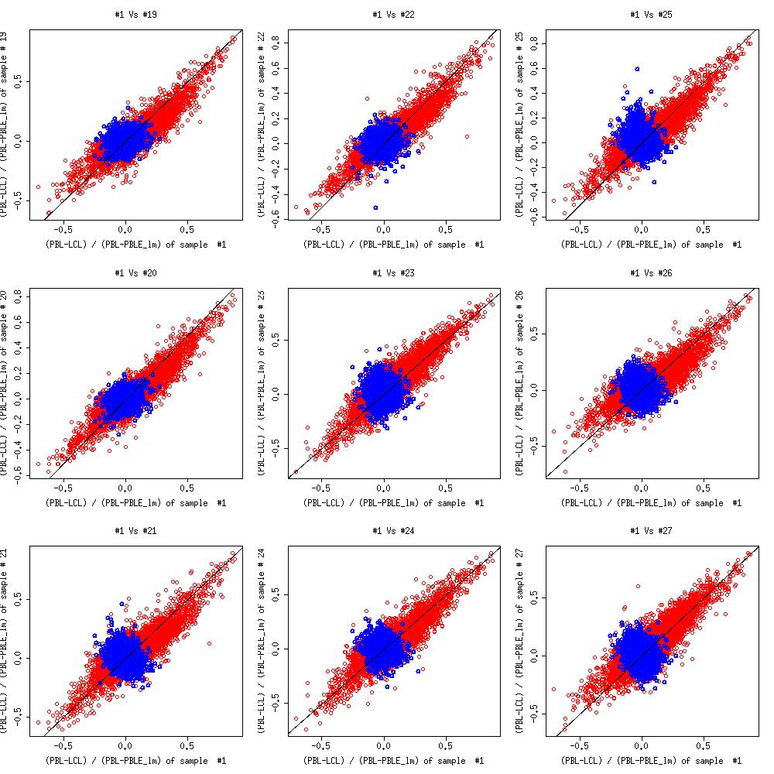

Supplementary W-S5c-3. Scatter plot of PBL - LCL, PBL - predicted PBL (LM) of sample 28 to 36

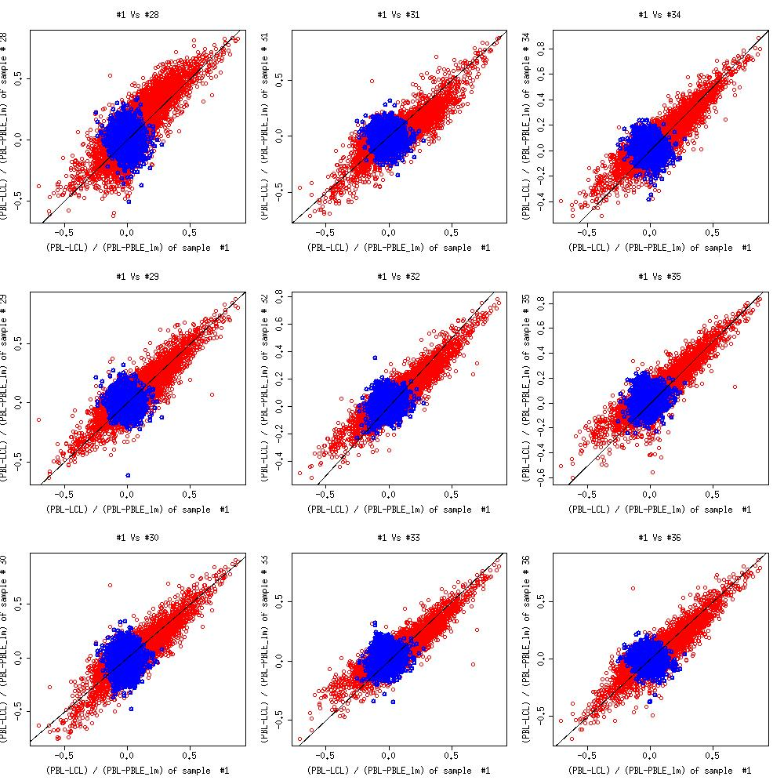

Supplementary W-S5c-4. Scatter plot of PBL - LCL, PBL - predicted PBL (LM) of sample 37 to 39

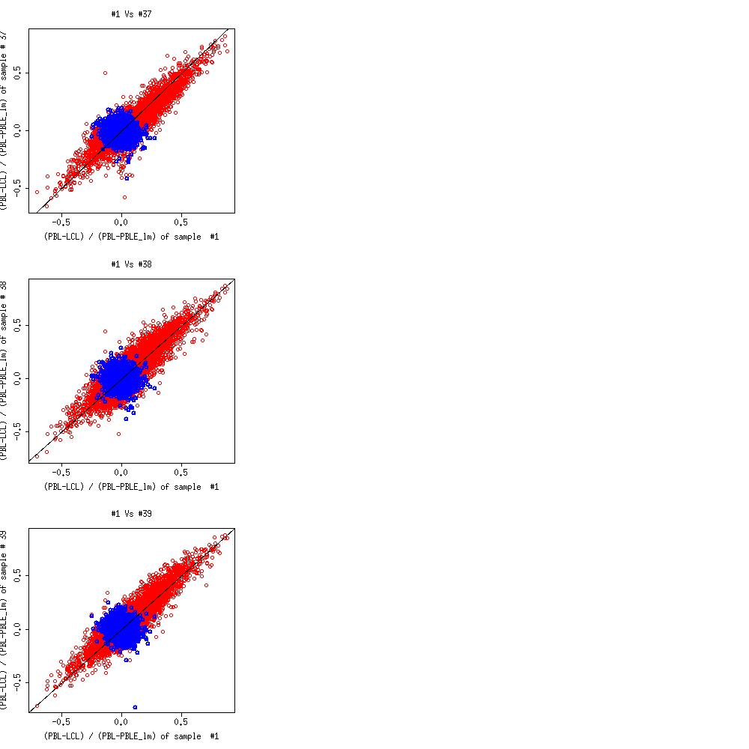

Supplementary W-S5d-1. Scatter plot of PBL - LCL, PBL - predicted PBL (LM, SVM) of sample 10 to 18
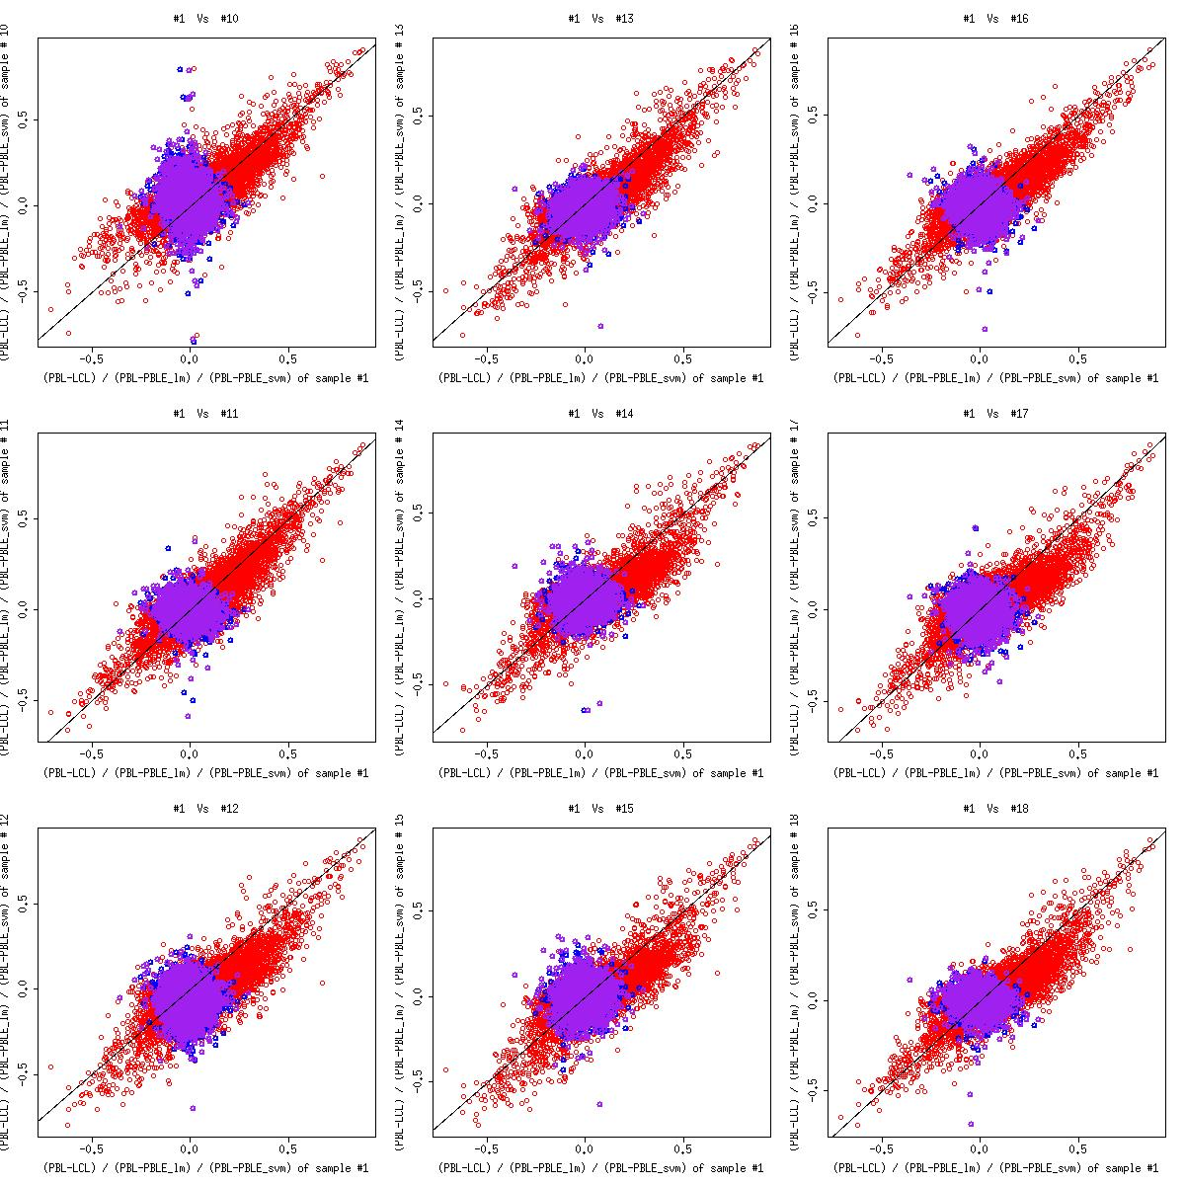

Supplementary W-S5d-2. Scatter plot of PBL - LCL, PBL - predicted PBL (LM, SVM) of sample 19 to 27

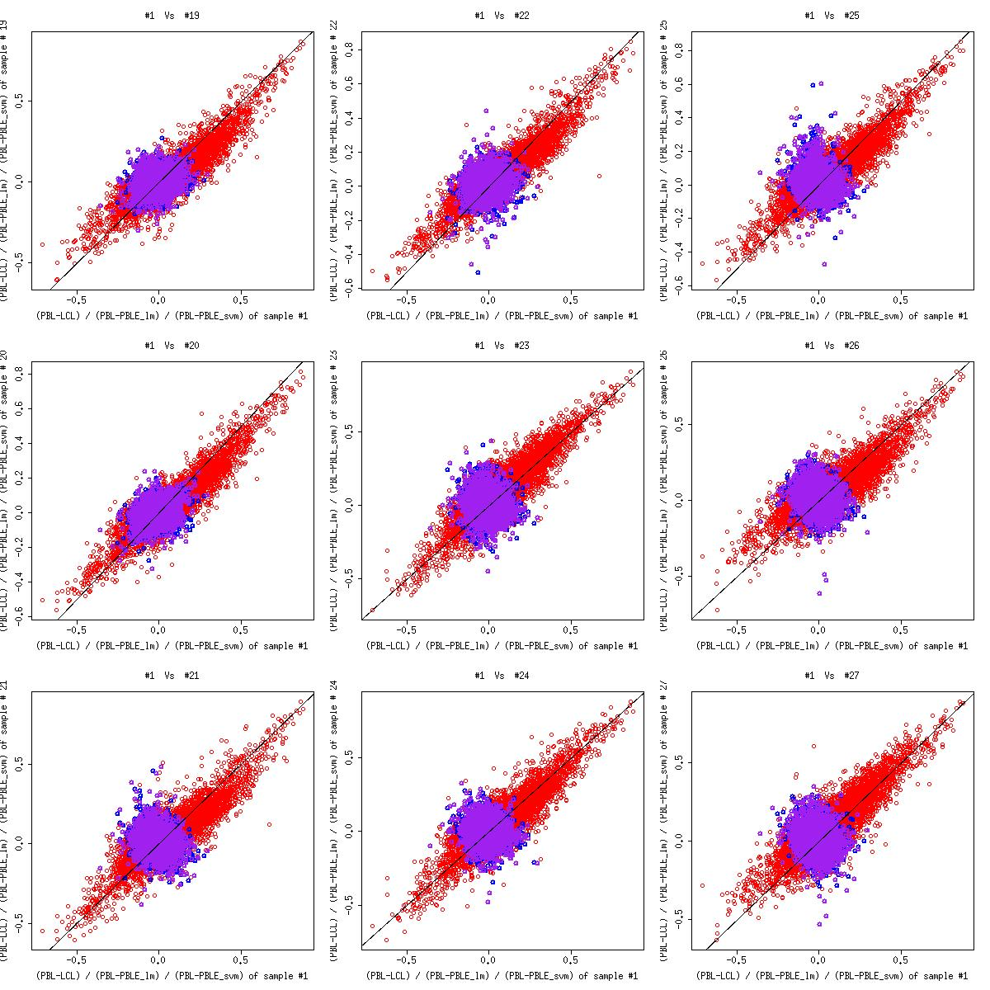

Supplementary W-S5d-3. Scatter plot of PBL - LCL, PBL - predicted PBL (LM, SVM) of sample 28 to 36

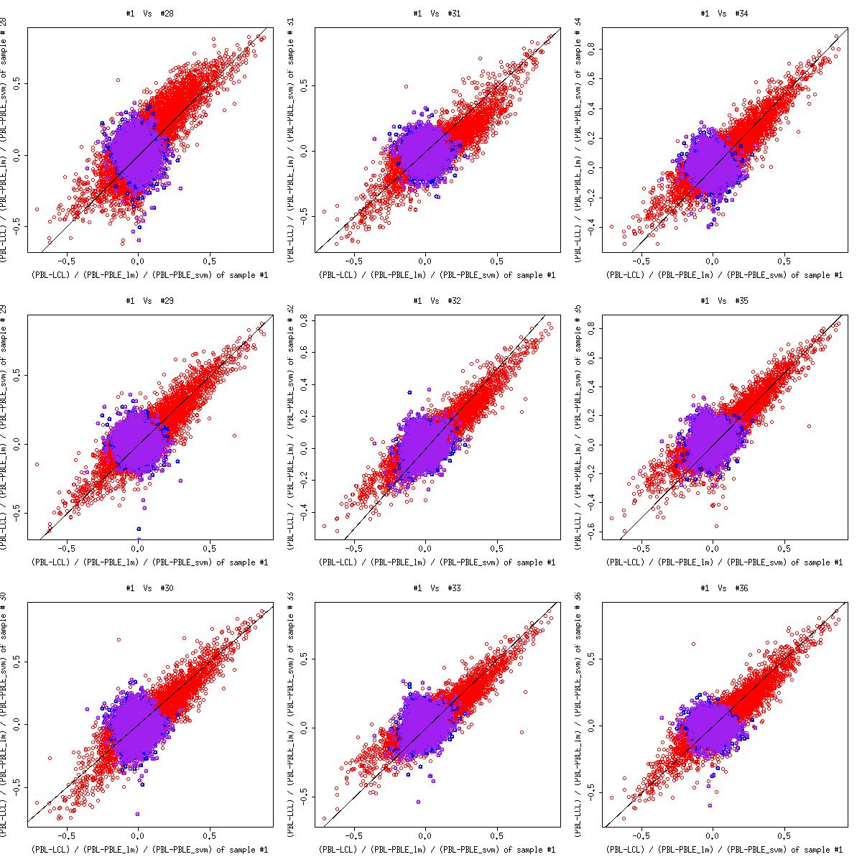

Supplementary W-S5d-4. Scatter plot of PBL - LCL, PBL - predicted PBL (LM, SVM) of sample 37 to 39

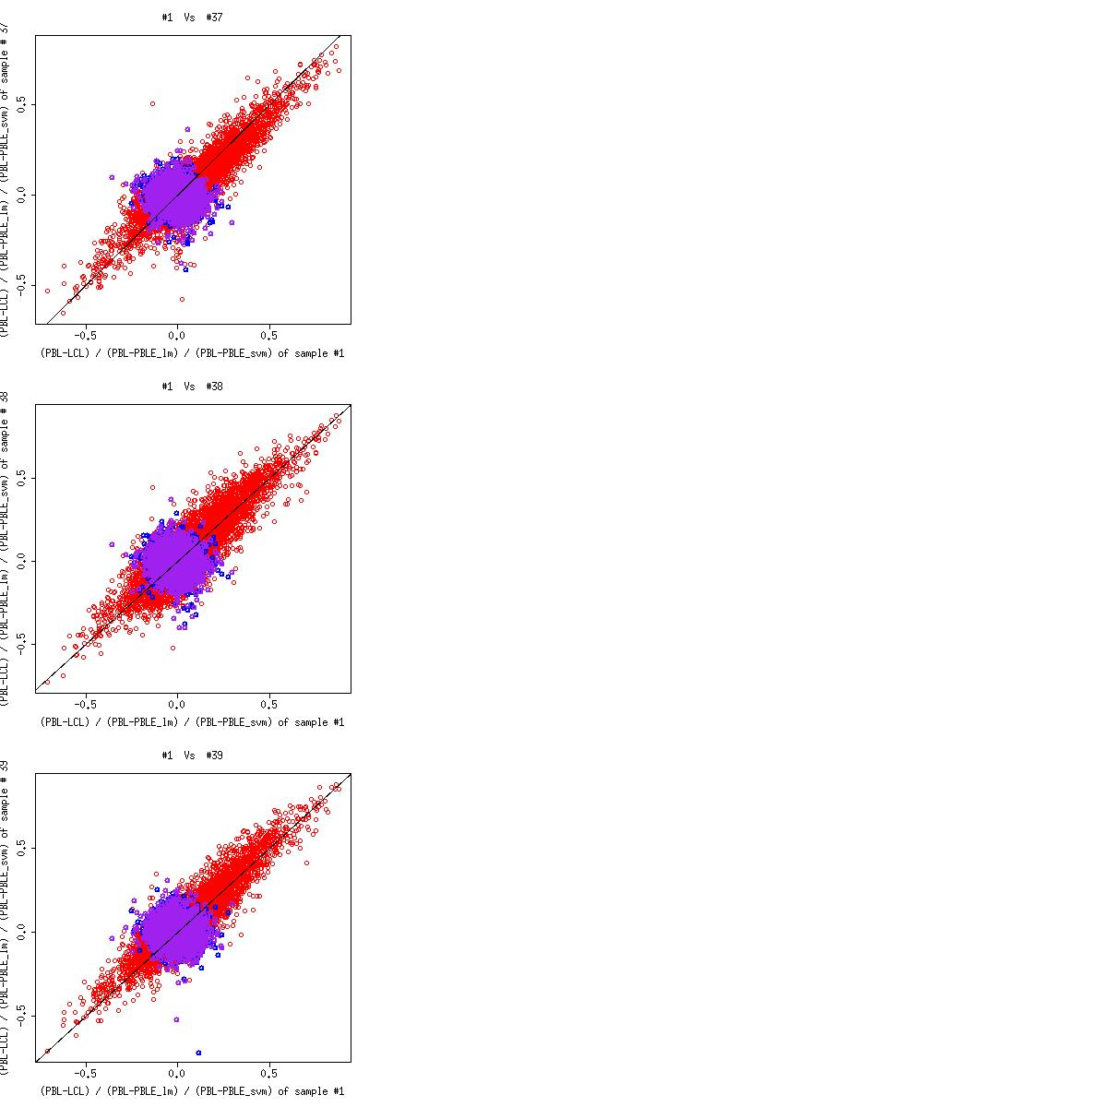

Supplementary W-S6a. Scatter plot of PBL, Artery and predicted Artery (LM) of sample 10 to 14

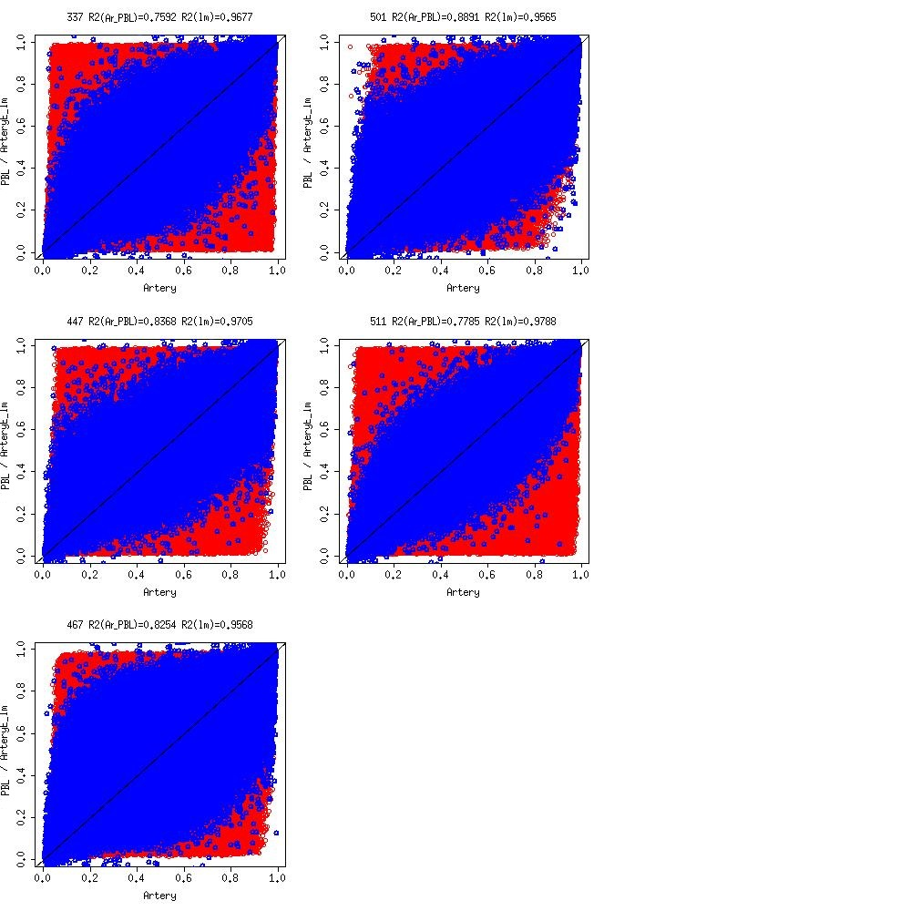

Supplementary W-S6b. Scatter plot of PBL, Artery and predicted Artery (LM, SVM) of sample 10 to 14

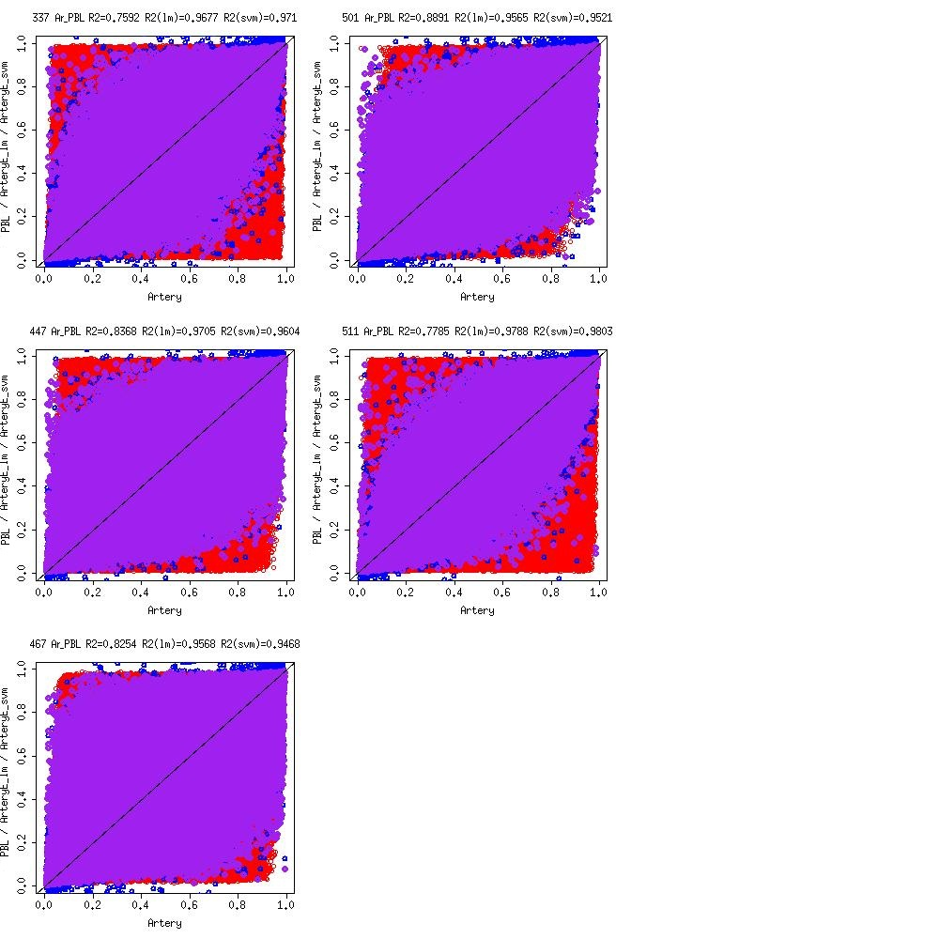

Supplementary W-S6c. Scatter plot of Artery - PBL, Artery - predicted Artery (LM) of sample 10 to 14

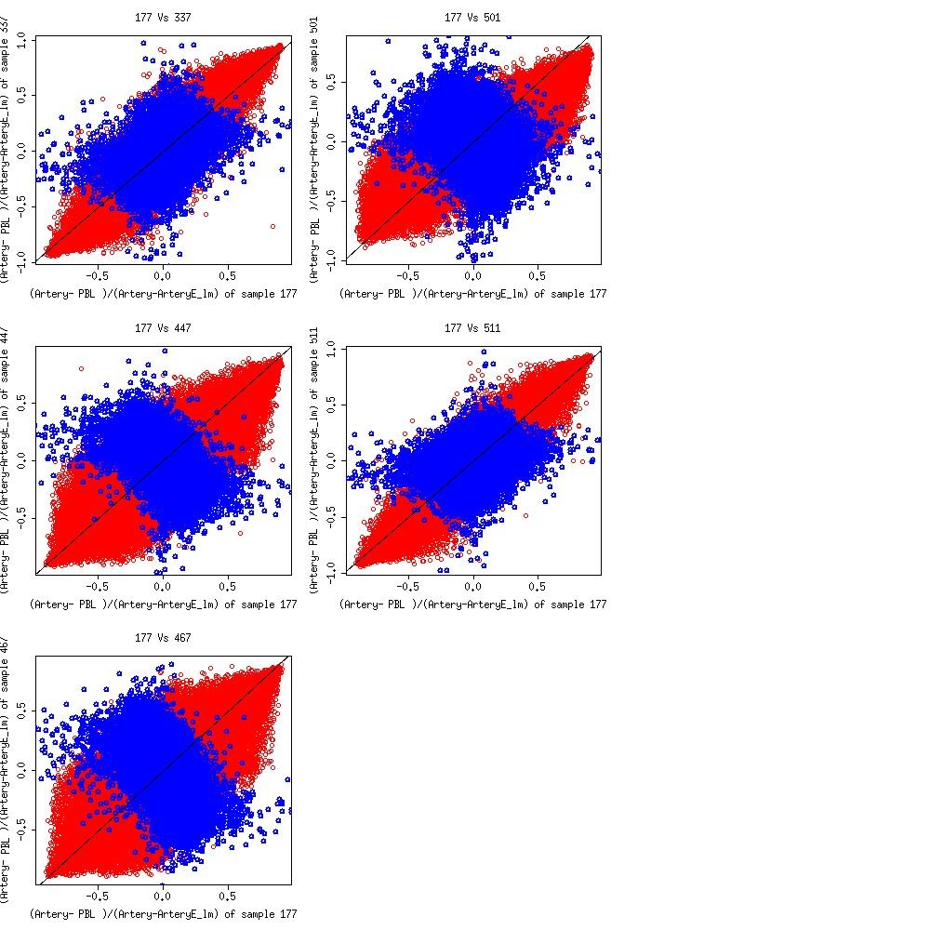

Supplementary W-S6d. Scatter plot of Artery - PBL, Artery - predicted Artery (LM, SVM) of sample 10 to 14

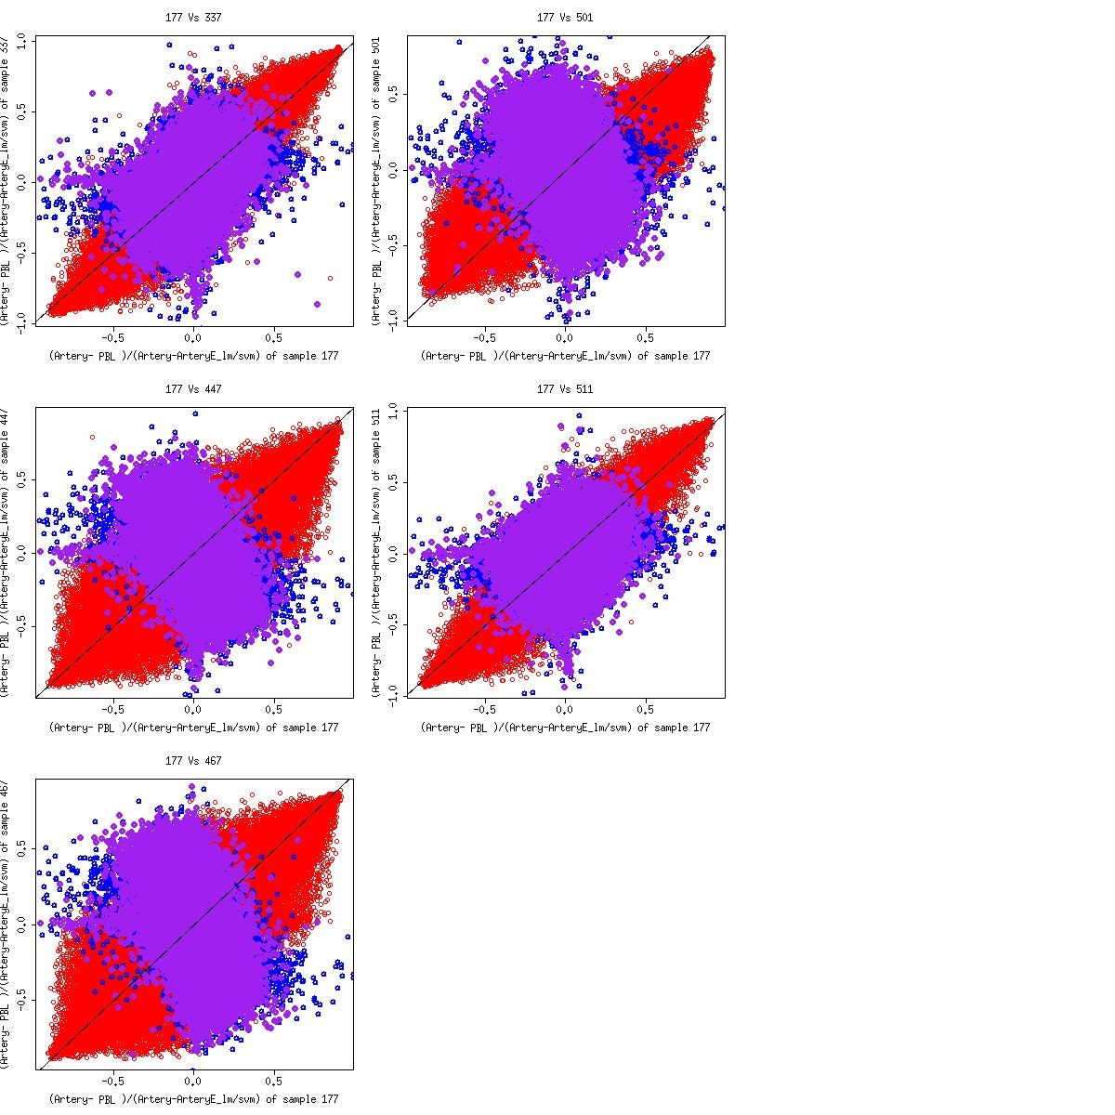

Supplementary W-S7a. Scatter plot of PBL, Atrium and predicted Atrium (LM) of sample 10 to 14

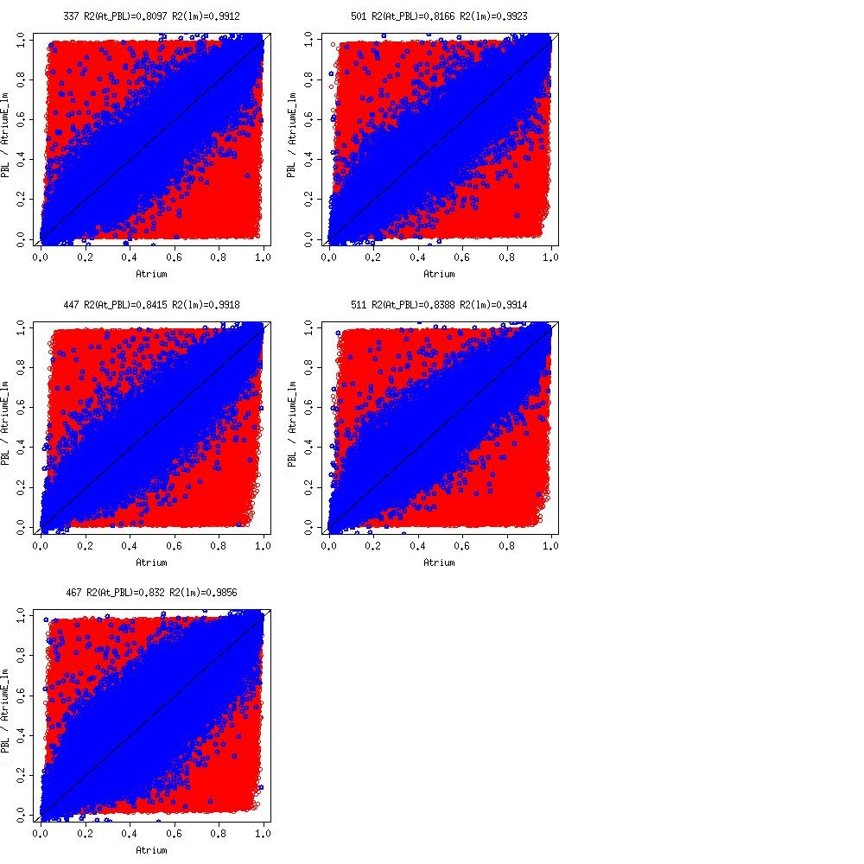

Supplementary W-S7b. Scatter plot of PBL, Atrium and predicted Atrium (LM, SVM) of sample 10 to 14

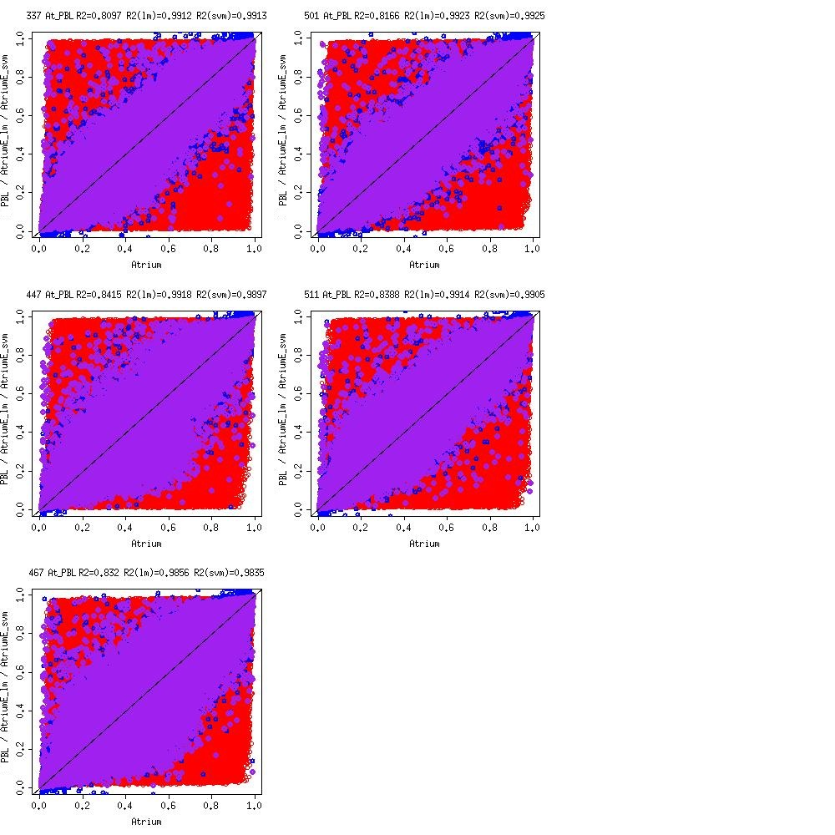

Supplementary W-S7c. Scatter plot of Atrium - PBL, Atrium - predicted Atrium (LM) of sample 10 to 14
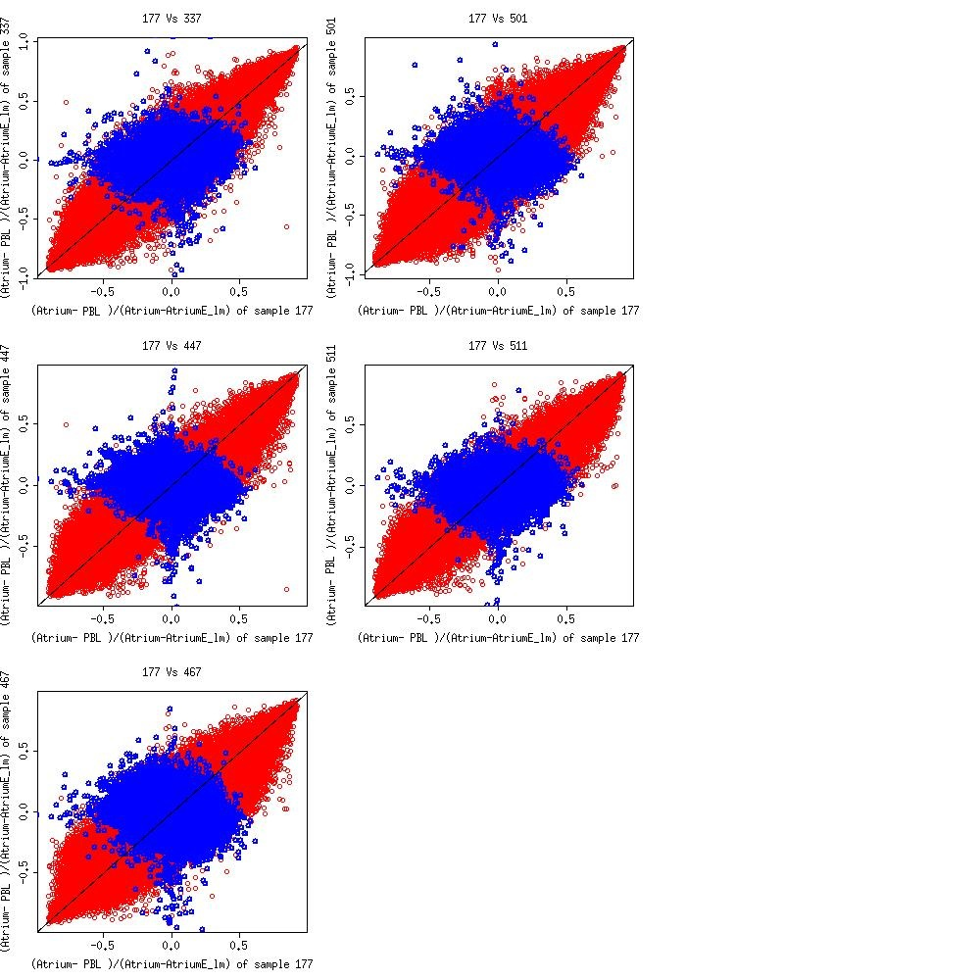

Supplementary W-S7d. Scatter plot of Atrium - PBL, Atrium - predicted Atrium (LM, SVM) of sample 10 to 14
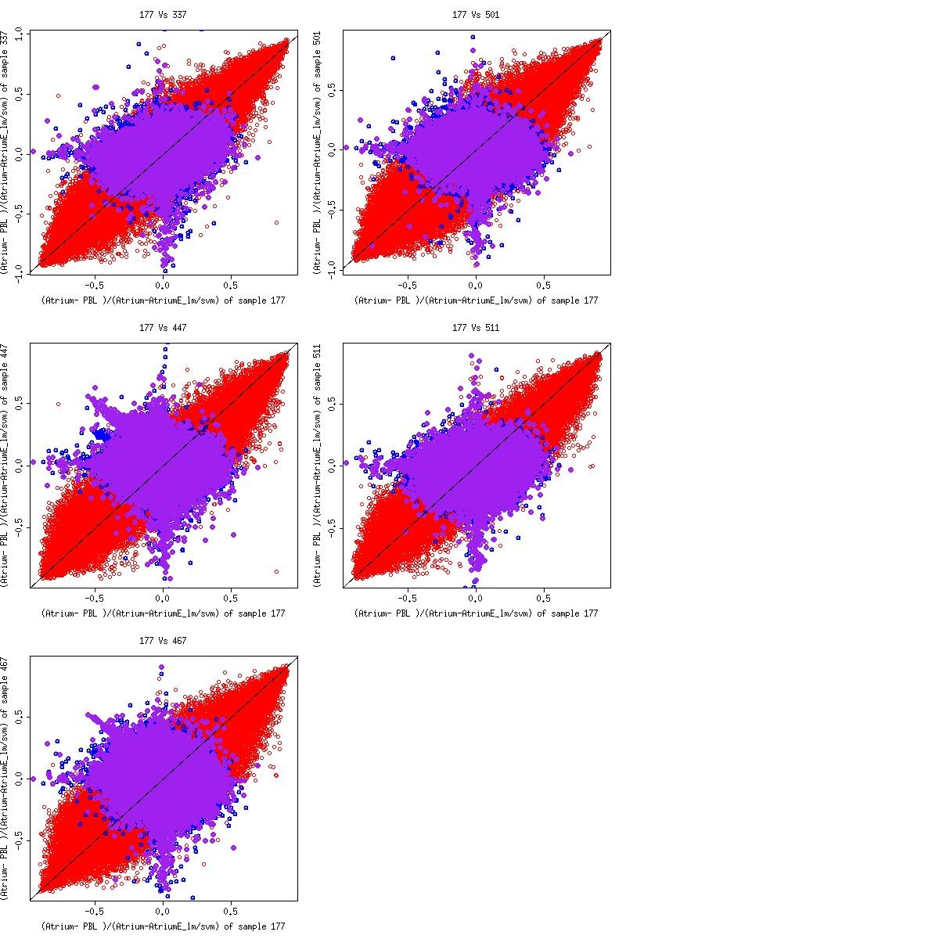

Supplementary W-S8. Scatter plot of PBL, Artery and predicted Artery (LM, SVM) of sample 10 to 14

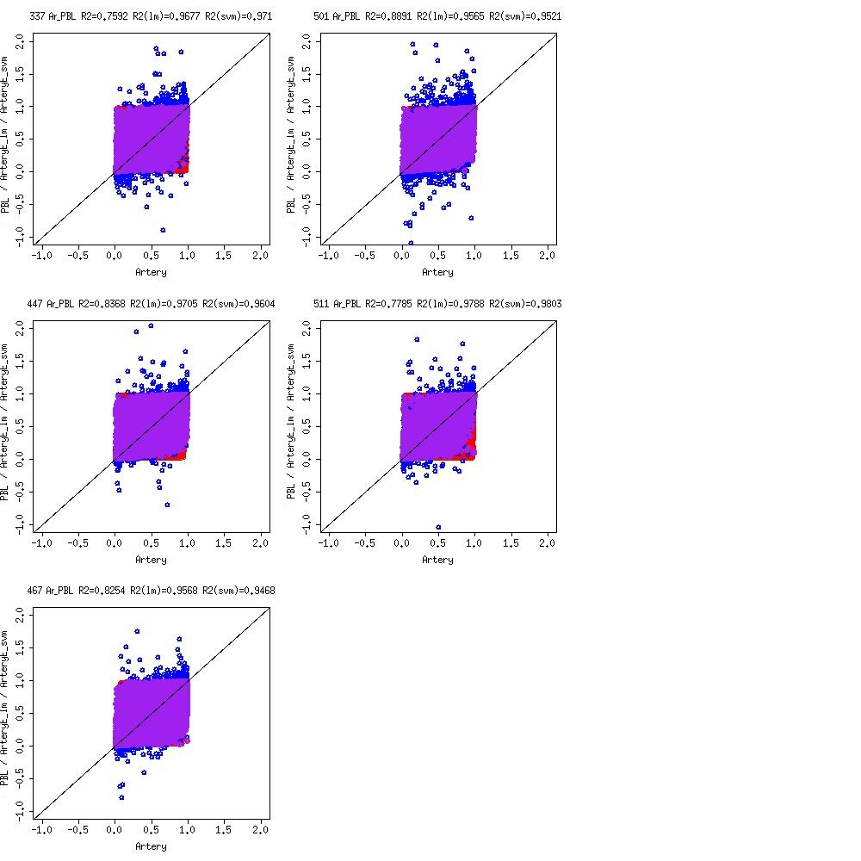

Supplementary W-S9. Scatter plot of PBL, Atrium and predicted Atrium (LM, SVM) of sample 10 to 14

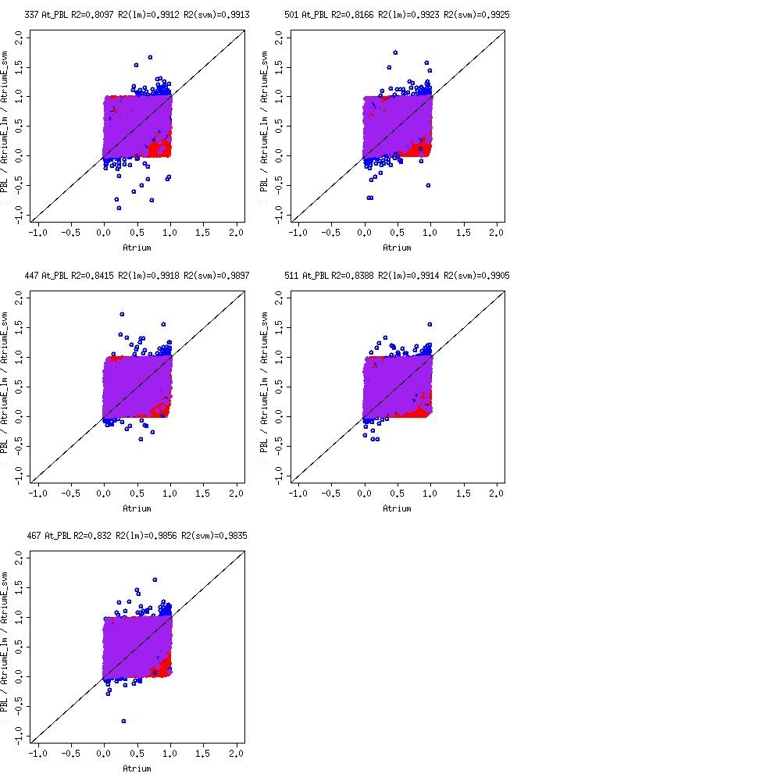

Supplementary W-S10-1. Scatter plot of LCL, PBL and predicted PBL (LM, SVM) of sample 10 to 18

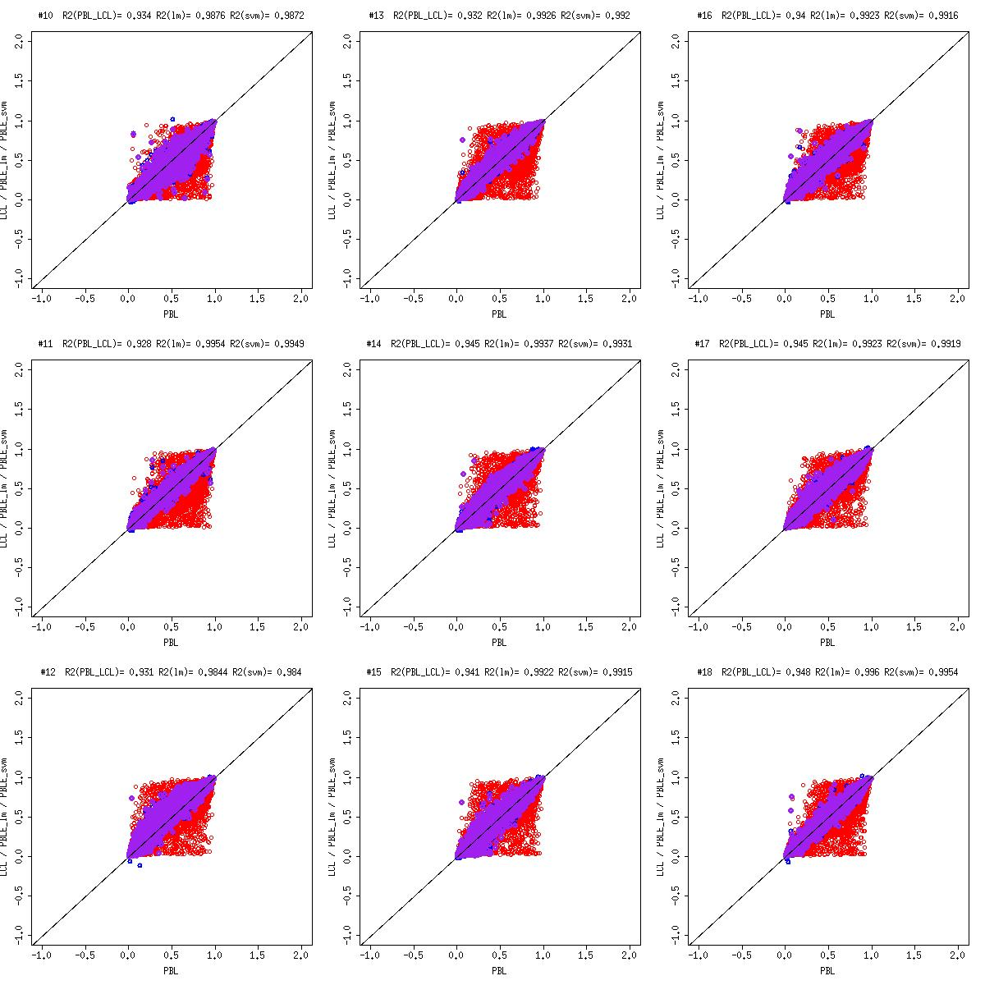

Supplementary W-S10-2. Scatter plot of LCL, PBL and predicted PBL (LM, SVM) of sample 19 to 27

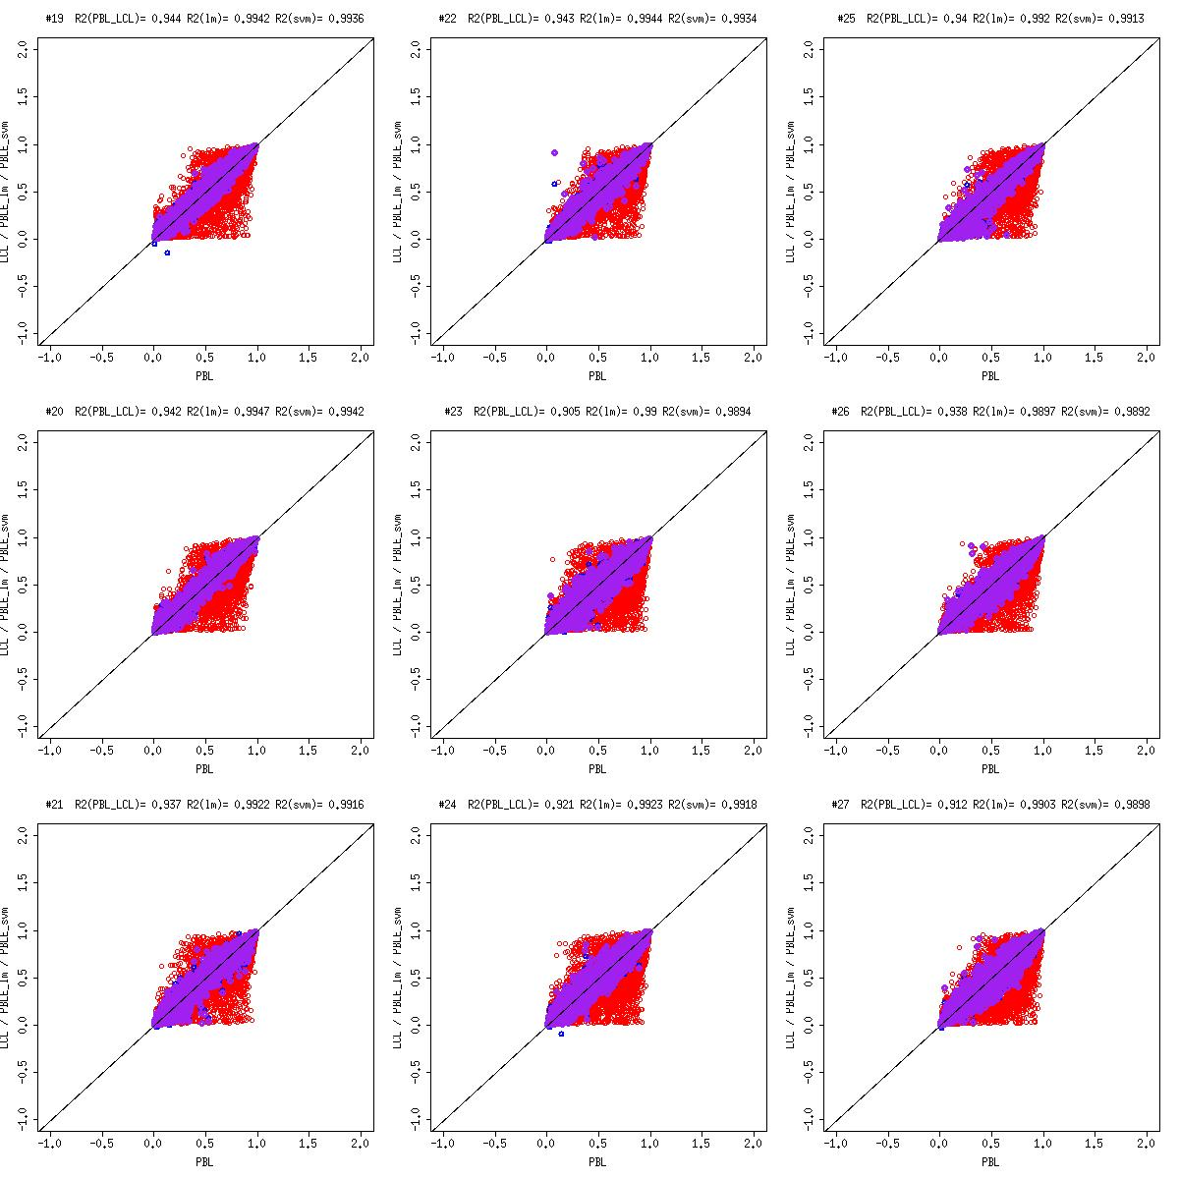

Supplementary W-S10-3. Scatter plot of LCL, PBL and predicted PBL (LM, SVM) of sample 28 to 36

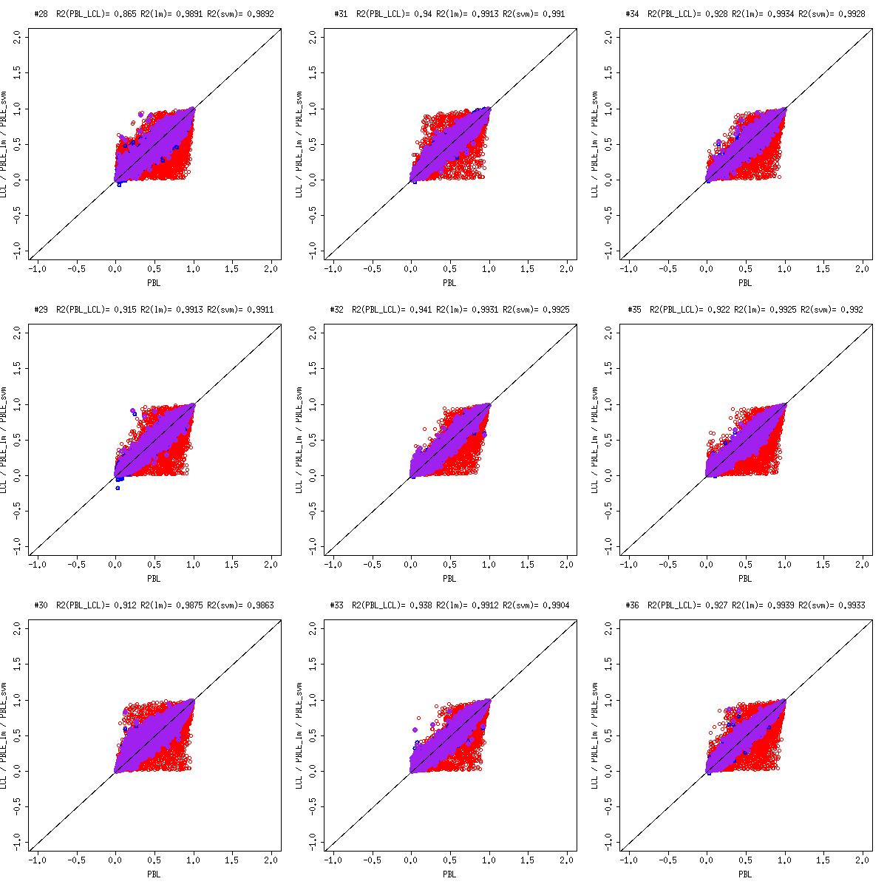

Supplementary W-S10-4. Scatter plot of LCL, PBL and predicted PBL (LM, SVM) of sample 37 to 39

